Committee: Social, Humanitarian and Cultural Committee (GA3)
Topic: Reassessing the Legal Framework on the Protection of Cultural Heritage Sites in Conflict Zones
Student Officer: Miranda Maria Georgiou
Position: Co-Chair
PERSONAL INTRODUCTION
Dear Delegates,
My name is Miranda Maria Georgiou and by the time the conference takes place, I will be a student in grade ten, at the American Farm School of Thessaloniki. I am delighted to serve as Co-Chair of the Social, Cultural and Humanitarian Committee (GA3), in the 9th Deutsche Schule Thessaloniki Model United Nations.
I would like to start by congratulating all delegates on joining this MUN, and welcoming you to the 9th DSTMUN and especially to our committee.
By debating the committee’s two topics, you will have the opportunity to expand your knowledge on the two vital issues we are discussing, Forced Labour in Cyber-Scam Networks and the Reassessment of the Legal Framework on the Protection of Cultural Heritage Sites in Conflict Zones. You are going to work alongside your peers to find valuable and consequential solutions, socialise and interact with other delegates, while creating everlasting memories.
The second topic of SOCHUM’s agenda is the following; “Reassessing the Legal Framework on the Protection of Cultural Heritage Sites in Conflict Zones”. This study guide provides substantial information on the matter, allowing you to engage in our productive debates. However, I would encourage you to conduct some research on your own, to help you better understand the topic and your country’s stance.
If you have any questions regarding the topic, the committee, or the conference, please do not hesitate to contact me at my email, at mirandageorgiou0@gmail.com.
I look forward to meeting you all and I wish you an eventful conference!
Best Regards,
Miranda Maria Georgiou

TOPIC INTRODUCTION
In times of war, human safety is what should be prioritised. Human lives are not the only thing that ought to be protected. Human safety includes the protection of cultural property and heritage, which can eventually assist in the creation of better and safer communities worldwide. An individual’s access to their property, cultural or personal, is a human right protected under Article 17 of the Universal Declaration of Human Rights. [UN]
United Nations Educational, Scientific and Cultural Organisation (UNESCO)’s World Heritage List, includes 1273 properties in 173 State Parties. [UNESCO] The specifically-targeted destruction of said sites does not only harm countries, cultures and their people in terms of beauty, but it damages the historical background and identity of a state. The deliberate ruination of such sites, known as cultural genocide, represents not only the destruction of civilian and cultural property, but also the destruction of a cultural artifact. This can be done to undermine certain cultures using the demolition of Cultural Heritage Sites as a mechanism to establish ethnic superiority. For example, the Israeli government’s planned attacks against Christian churches located in occupied portions of Lebanon and Palestine serve as a stark illustration of how such actors can be used to erase cultural identities.
Governments and Non-Governmental Organisations (NGOs), employ two approaches in protecting cultural heritage in the event of war, both concerning the legislative aspect of the property’s conservation. The first one is based on International Humanitarian Law (IHL), which demands the protection of civilian property be applied. The second one is the recognition of the 1954 Hague Convention, with 138 Member States being party to, and calls for the protection of cultural property during armed conflict. The 1954 Hague Convention recognises cases where deliberate attacks are legal, when cultural property has turned into military objective, or is required by imperative military necessity, making a new debate come to light. [UNESCO]
Not only is this law being violated, but military operations have found ways to abuse international law, finding loopholes in the legal framework, which is why it calls for a reassessment. Over the span of the last centuries, many works of art, sites and fundamental components of a nation’s identity have been destroyed in war. For instance, the Bamiyan Valley located in Afghanistan, the most monumental expression of the western Buddhism. Due to their values, the monuments have suffered damage at different times, including the deliberate destruction by the Taliban in 2001 [UNESCO]. The deliberate destruction of sites began shortly after World War II. Since that time, states have prompted the United Nations and the international community to act on the manner and immediately provide specific legal protection on Cultural Heritage Sites in times of warfare.
Despite the 1954 Convention, which established a clear legal framework on the issue, attacks continue to happen. The ineffective international treaty relies on a State Party’s compliance, therefore making its implementation much more challenging. The framework is constantly collapsing, mostly due to the numerous loopholes associated with it. Moreover, heritage sites are damaged during periods of warfare, as illustrated in the destruction by ISIS, who in 2015 committed assaults on monuments of the city of Palmyra, Syria. [Harvard University] At the same time, military operations and officials exploit periods of conflict to illicitly export movable cultural objects, to which the return and restoration of is substantial, since it furthermore contributes to limiting deliberate attempts to diminish an ethnicity or culture.
As conflicts and occupation continue worldwide, protecting cultural heritage remains essential for preserving collective memory, identity and historical continuity.
DEFINITION OF KEY TERMS
Article 17 of the Universal Declaration of Human Rights
Adopted in 1948 by the United Nations General Assembly, the Universal Declaration of Human Rights which states the human rights that must be recognised everywhere and applied for everyone, despite their external or internal differences, contains a section specifying the right of property and is written below:
- Everyone has a right to own property alone as well as in association with others
- No one shall be arbitrarily deprived of their property [UN]
In short, every individual has a right to owning their property either alone (personal) or in cooperation with others (cultural).
Article 27 of the Universal Declaration of Human Rights
A section of the Universal Declaration of Human Rights which was adopted by the United Nations General Assembly in 1948, includes Article 27, which revolves around a person’s right to their culture, and is written below:
- Everyone has the right to freely participate in the cultural life of the community, to enjoy the arts and to share in scientific advancement and its benefits.
- Everyone has the right to the protection of the moral and material interests resulting from any scientific, literary or artistic production of which he is the author. [UN]
Briefly, this Article states that every individual has the right to a culture that cannot be deprived, and creators have the protection to illustrate their works without fear of them being destroyed.
Cultural Genocide or Cultural Cleansing
It refers to the intentional and systematic eradication of a culture and it highlights the ethical concerns surrounding the destruction or alteration of another group's cultural practices without their consent [EBSCO]
Cultural Heritage
“The legacy of physical artifacts, traditions, and practices that are passed down through generations within a community. It encompasses both tangible elements, such as monuments and artworks, and intangible aspects like folklore and rituals” [UNESCO]
Cultural Heritage Sites
A historical site, a building, or an area of the unspoilt natural environment, considered to be important to a country or area’s heritage, recognised by UNESCO and therefore added to the World Heritage List. [UNESCO]
Cultural Property
Movable or immovable property of great importance to the cultural heritage of every person, such as monuments of architecture, art or history, whether religious or secular and other objects of artistic, historical or archaeological interest. [UNESCO]
Ethnocentrism
The tendency of a person to evaluate different cultures and beliefs, based on one’s own. This can result in misperceptions of superiority. [EBSCO]
Iconoclasm
The Oxford English Dictionary (OED) defines iconoclasm as:
- The doctrine or practice of attacking settled briefs or institutions, especially religious ones, or the rejection or destruction of established images, icons, or symbols regarded as heretical or false
- The rejection or destruction of religious images as heretical; historically associated with periods such as the Byzantine Iconoclasm
It generally refers to the belief in the importance of the destruction of movable or immovable monuments or icons, often for religious or political reasons. [OED]
Law of Armed Conflict (LOAC)
The body of international law that regulates behaviour during armed conflict, that includes the protection of civilians and their properties, but is only responsible for a conflict’s conduct and not its legality. [ICRC]
World Heritage
“The designation for places on Earth that are of outstanding universal value to humanity and as such, have been inscribed on the World Heritage List to be protected for future generations to appreciate and enjoy”. [UNESCO]
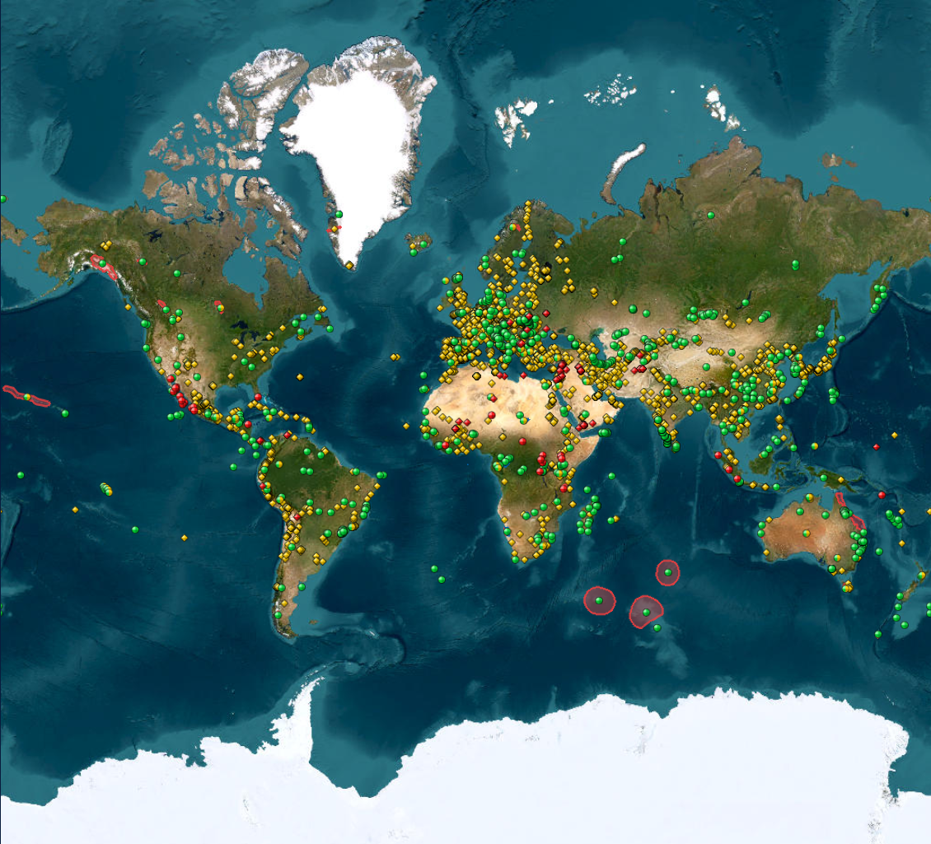
Figure 1: Map of the UNESCO-verified Cultural Heritage Sites [UNESCO]
BACKGROUND INFORMATION
The Three Essential Elements that Bind All States during Armed Conflicts
Besides acknowledging the legal framework on the matter, all Member States of the United Nations must apply the four main elements of peace-keeping in Cultural Heritage Sites that were established throughout multiple resolutions and conventions. First is the obligation of each party of the conflict to respect cultural property. As settled in numerous previous UN resolutions and treaties, all parties and military operations must take special care in order to avoid damaging or harming sites and artworks important for another party’s religion, science, art or education, unless they are essential military objectives, approved by representatives and officials. Next, each party of a conflict must protect its own cultural properties. ‘The property of municipalities, that of institutions dedicated to religion, charity and education, the arts and sciences, even when State property, shall be treated as private property.’ [ICRC] Last, is the obligation of the occupying power to prevent illicit export of cultural property and to return such properties to the occupied territory. Under international law and ethical standards, an occupying power must actively prevent the unauthorized export of cultural heritage from occupied land, ensuring these treasures remain protected and eventually restored to their original form.
Law of Armed Conflict
The Law of Armed Conflict (LOAC) is a unique branch of international law which governs the conduct in hostilities, but is only responsible for the conduct in hostilities, and not their legality. The Law of Armed Conflict seeks to strike balance between the desires of a state. These could be the achievement of a state’s goal of defeating the enemy, as well as the need to mitigate the suffering of war as much as possible.
The 1954 Hague Convention
The 1954 Hague Convention was established more than sixty years ago, but still managed to establish a clear legal framework. Under it, each Member State promised to safeguard its own properties against armed attacks through multiple measures, such as avoiding placing military objectives nearby, but also took responsibility upon punishing offenders and enforcing their provisions in case of a violation. [SGUN] With 135 State parties, it is one of the most widely adopted cultural heritage protection regimes worldwide. The 1954 Hague Convention also recognises cases where deliberate attacks are legal, when cultural property has turned into military objective, or is required by imperative military necessity, making a new debate come to light. Military necessity may override cultural conservation, whereas international intervention can be justified in order to protect cultural property.
Loopholes and Limitations Associated with the 1954 Hague Convention
However, this ‘universality’ is also its greatest weakness, since it does not provide sufficient visibility to cultural heritage sites, nor help military operations and field commanders. Additionally, the Convention does recognise instances where such attacks are legal, usually when it has been turned into a military objective, and was required by imperative military necessity. This Convention, albeit fundamental, creates numerous limitations for National Security Agencies (NSAs). For several years, the linkage between antiquities looting and security threats had received less attention, until the rise of ISIL in 2013 and reports of large-scale looting of archaeological sites, primarily in eastern Syria. [PHR] National security and cultural heritage protection are connected in several ways. Cultural policy as a component of security policy plays a crucial role in promoting social cohesion, diplomatic relations, international cooperation, and regional stability.
The System of Enhanced Protection Under the 1999 Second Protocol to the 1954 Hague Convention
A measure developed to ensure full and effective protection of specifically designated cultural property in the event of armed conflict, which expands the provisions of the Hague Convention, therefore providing greater protection than before and offers a wider scope, ease of access and strong legal protection. Enhanced Protection requirements are much more inclusive than the ones of Special Protection, increasing the number of potential cultural sites eligible for inscription. Thanks to Enhanced Protection, movable sites may also be eligible, including significant works of art. Additionally, the location requirement introduced by Special Protection, is now eliminated. With financial and technical assistance available for parties in periods of both war and peace, Member States’ involvement has been significantly streamlined. Requests for Enhanced Protection may also not be blocked or rejected by dissenting State parties. Since control is sufficient, the legitimacy of territorial claims is not automatically called into question.
Strong Legal Protection Under the System
Under the System of Enhanced Protection, the use of protected sites and their surroundings in support of military actions is prohibited, and is not justified even by the most acute military necessity. The ‘principle of military necessity’ permits measures which are actually necessary to accomplish a legitimate military purpose and are not otherwise prohibited by international humanitarian law. In the case of an armed conflict the only legitimate military purpose is to weaken the military capacity of the other parties to the conflict, putting the ruining of a nation’s cultural heritage as a weapon of war in question. Cultural property is no longer compromised by demolition, no matter the operation, and sites gain immunity from all attacks.
Challenges Faced by the System of Enhanced Protection
The System of Enhanced Protection Under the 1999 Second Protocol to the 1954 Hague Convention, was introduced to address several shortcomings of the original convention and its first protocol. However, the system faced both conceptual and practical challenges in its implementation. Along with its limited scope and accessibility, there was also a lack of universal ratification. The enforcement and compliance issues also expose the absence of a strong international enforcement mechanism to hold violators accountable and the lack of respect for the sites that are being violated. Additionally, key terms were permeated by ambiguity. The terms ‘military necessity’ and ‘imperative civilian defense’ were interpreted in various ways by each nation. This was a result of limited awareness and training, since many military personnel and professionals were unaware of the system’s existence.
Practical Effectiveness
Despite the system’s deficiencies, its practical effectiveness remains significant. The system managed to introduce framework improvements to the 1954 Hague Convention, and had symbolic and moral impact. It has also been tested in case studies and real world application, such as the Syrian civil war and the Russian invasion of Ukraine, where cultural properties were either destroyed or targeted. The system did face challenges in implementation because of its exclusivity and lack of ratification, but it did not fail to set a strong legal framework on the issue of deliberate destruction of Cultural Heritage Sites.
Cultural Genocide
A term coined by Raphael Lemkin, ‘cultural genocide’ refers to the systematic and intentional destruction or eradication of traditions, values, monuments, language and other elements that make each group differ from another. [OUP] Countries destroy cultural heritage sites as an act of diminishing their opponent's people and establishing themselves as ethnically, religiously or culturally superior. Cultural genocide is considered a war crime. One recent and fundamental example of cultural genocide is the crackdown of Xinjiang, China.
The Attempted Cultural Erasure of the Uyghur Muslim Group in the Xianjiang Uyghur Autonomous Region (XUAR)
The Xinjiang Uyghur Autonomous Region (XUAR), gained its independence for a short while in 1940, but lost it in 1941. It is home to the Uyghur Muslim group, which is considered a minority in the People’s Republic of China. Since then, the United Nations have accused China of systematic human rights abuses against the group and possible crimes against humanity, where thousands of Uyghurs have been detained in camps. Additionally, the Chinese government has embarked on a systematic campaign to rewrite the cultural heritage of XUAR by destroying mosques and sacred sites. According to the Xinjiang Data Project, approximately 30% of the Uyghur mosques have been completely demolished despite being protected by Chinese law, while 28% have been damaged. China continues to maintain that its abuse is necessary, since they believe that it is a tactic to counter terrorism and preserve Han nationalism. [The Xinjiang Data Project] This highly controversial case is labeled as an example of cultural genocide since, ultimately, the imposition of one culture over another raises questions about cultural arrogance and the fundamental rights of peoples to maintain their cultural integrity.
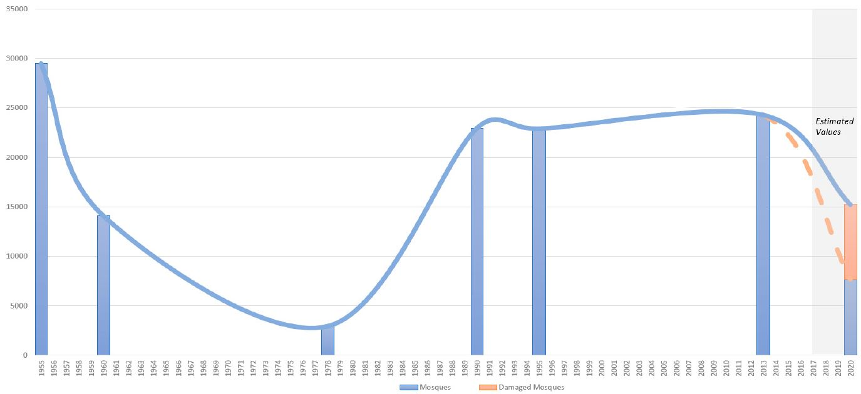
Figure 2: The Number of Mosques in the Xinjiang Uyghur Autonomous Region since its Founding [The Xinjiang Data Project]
MAJOR COUNTRIES AND ORGANISATIONS INVOLVED
Afghanistan
Afghanistan, a crossroad of ancient civilizations, has had its cultural properties ruined. Based on 1980 statistics, there were then more 2,800 historical sites and monuments in Afghanistan. [UNESCO] More recently, the Taliban’s destruction of the nation’s shrines highlight the need for proactive measures to prevent cultural erasure. One of the most important incidents, which took place in March 2001, was the demolition of the two Bamiyan Buddhas. The Buddha statues and the cave art in Bamiyan Valley are an outstanding representation of the Gandharan school of Buddhist art in the Central Asian region. [HIR]
Iran
In its provisions, Iran contains some of the richest historical heritage that have survived decades of armed conflicts before, but modern warfare differs. For the past year, Israeli and U.S. attacks have been targeted towards the land and the people of Iran. Strikes have damaged at least four cultural sites, raising alarm about the impact of this widening war. [DW] The speed of the damage has made Iran and Lebanon, send a request to the Director-General of UNESCO, requesting the addition of more of their sites to the World Cultural Heritage List. A recent attack happened in March, where UNESCO World Heritage site, the Golestan Palace in Tehran, was reportedly damaged by debris and the shock wave following an airstrike to the Arag Square. [PBS] UNESCO continues monitoring the situation, all across the region.
Iraq
Present day Iraq is the birthplace of numerous prehistoric and historic civilizations. The Islamic State in Iraq and Syria (ISIS), the extremist group that has declared itself the Islamic State, has gained control over parts of Iraq, which contain 6 properties inscribed on the World Heritage List. [UNESCO] Following the brutal destruction of many invaluable cultural items at the Mosul Museum and the bulldozing of the ancient Assyrian city of Nimrud, official sources reported the destruction of the World Heritage property of Hatra, the capital of the first Arab kingdom. [The Guardian] Even with the end of the war, the unstable political situation in Iraq is an impediment to stopping tomb raiders and looters.
Israel
Israel frequently employs the destruction of cultural sites in warfare. The Palestinian-Israeli conflict began decades ago. Following the October 2025 ceasefire, UNESCO has benefited from this opportunity, with rapid on-site assessments. "We are seeing more and more indications that Israel is carrying out a concerted campaign to obliterate Palestinian life in Gaza," said Chair of the UN Independent International Commission of Inquiry on the Occupied Palestinian Territory. The Commission also reported that the Israeli security forces have attacked and damaged more than 50% of Palestinian religious and cultural sites. [OHCR]
Kosovo
Despite Kosovo not being a UN Member State, during the 1998-1999 Kosovo war, deep scars were left on the country’s cultural properties. Cultural and religious monuments were specifically targeted as visual symbols belonging to the other group. In some sites, the damage that was once done is now barely visible, but in others the gap remains. Apart from the damage affecting the immovable cultural properties of Kosovo, more than 1,200 movable artifacts were looted, and only one of them has been returned. [SUP]
Sudan
In addition to the political and humanitarian crisis in Sudan that has been shaking the world for years, the looting of cultural heritage is now used as a weapon of war. More of the blame has been appointed to the parliamentary Rapid Support Forces (RSF), but the Sudanese government has founded an agency for the overseeing of its cultural sites, which according to its senior inspector, is now working to recover more than 100 years of history. [CFR] Faced with these destructions, UNESCO reacted early by condemning the looting. The organisation carried out the documentation of more than 1,700 objects, trained police and customs officers to recognise stolen antiquities, and appealed to international museums and collectors to refuse illegal acquisitions. [UNESCO]
Syria
Syria is home to some of the culturally richest cities and sites that have contributed to the development of conservation projects, but most sites are currently under significant devastation. Damage has been reported to almost all 6 sites located in Syria, and that could only be a mere glimpse of the problem. [AAAS] Both direct shelling and military occupation remain significant issues and cases of looting and iconoclasm have also been reported. [AC] It is ultimately the responsibility of the Syrian government to protect its heritage against any kind of destruction, but there is some apparent disregard of the government for the destruction. Due to the nation’s unstable governance following the Syrian Civil War, the legal framework and consequences are often not clear enough, causing their failure.
Ukraine
Following the ongoing war in Ukraine that started in 2022, 540 Cultural Heritage Sites have been verified by UNESCO as damaged, due to the allegedly deliberate Russian attacks. [UNHRC] UNESCO is conducting a preliminary damage assessment for cultural properties by cross-checking the reported incidents with credible sources, and by developing a mechanism for independent coordinated assessment of data in line with provisions of the 1954 Hague Convention. According to A. Cherednychenko, chair of Icom-Ukraine, ‘They want to prove that it’s Russian territory and that it’s never been Ukraine’. Russian forces are accused of deliberately bombing culturally significant sites, including immovable heritage sites and museums, as well as the mass looting of cultural property, actions which constitute war crimes under the Hague Convention of 1954. The multiple deliberate attacks on said properties, such as the bombing of the Mariupol Drama Theater (2022) and the Saint Sophia Cathedral in Kyiv (2026), prompt calls for stronger legal protections, since the Russian invasion has destroyed the country and shaken the global political order. [UNESCO]
Yemen
After the numerous attacks Yemen suffered through, all three World Heritage Sites in its premises have been added to the List of Cultural Heritage in Danger. 2015 was the year the nation went through its big crisis. In February, a huge conflict erupted, resulting in the loss of lives, and the destruction of multiple cultural properties, mostly through collateral damage. In June, the Old City of Sana’a was hit by a bombing raid, whilst several houses and historical buildings were destroyed. In July the intentional destruction of multiple ancient tombs was reported. [UNESCO] The ongoing conflict in Yemen has left its cultural heritage under threat, with events of looting and destruction taking place on a daily basis.
Blue Shield International
The Blue Shield International Network, is a non-governmental organisation, which was formed in response to the changes in international law, but is now working to protect cultural heritage in emergency situations. Blue Shield International is ‘committed to the protection of the world’s cultural property, and is concerned with the protection of cultural and natural heritage, tangible and intangible, in the event of armed conflict, natural- or human-made disaster. ‘ [Article 2.1, Blue Shield Statutes 2016]. In the event of armed conflict, Blue Shield has its eyes on Ukraine, with multiple missions taking place to protect the cultural sites of the country.
International Council on Monuments and Sites
The International Council on Monuments and Sites (ICOMOS) is an international non-governmental organisation that works for the conservation of monuments and sites all across the world. ICOMOS works in collaboration with UNESCO, as an advisory body, and is responsible for the review of Cultural Heritage Sites nominations. ICOMOS’ values revolve around diversity and solidarity, all dedicated to applying scientific techniques, theories and methodology. Currently, the two main projects of the council are the ones in Ukraine and Gaza/Israel.
International Institute for Conservation of Historic and Artistic Works (IIC)
The International Institute for Conservation of Historic and Artistic Works (IIC) is a global organisation based in London that promotes the preservation of cultural heritage through knowledge sharing, publications, conferences, and professional standards. IIC is the leading and oldest independent international professional membership society for conservators, conservation scientists and cultural heritage professionals. Established in 1950, the Organisation keeps bringing together the conservation community from around the world - educating, enabling and recognising excellence.
The Islamic State of Iran and Syria (ISIS)
From 2013 to 2019, the Islamic State of Iran and Syria (ISIS) waged a violent campaign, in a dangerous paradigm of ‘performative destruction’. The rise of Da’esh and its expansion were characterized by well-publicized attacks on both religious groups and cultural heritage. The destruction of these monuments and sites, is called by many an act of cultural genocide. One of the most important cases of deliberate destruction and looting made by ISIS, is the case of Manbij and its countryside. Starting January 2014, to August 2016, the city of Manbij was under the ISIS occupation, and during that time, the region suffered fierce battles for multiple sources of revenue. ISIS has also been accused with acts of ideological destruction and iconoclasm, making its case an even harder one to prosecute.
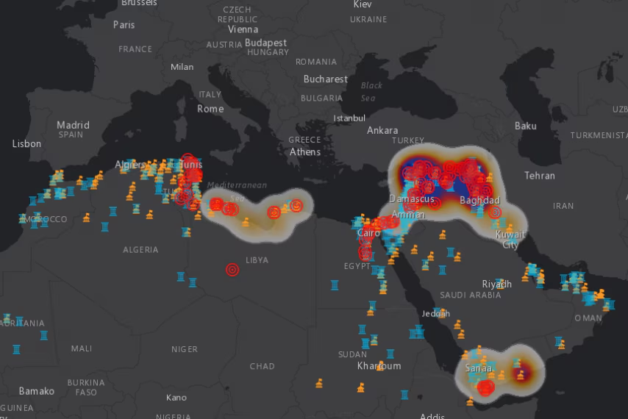
Figure 3: The Full Extent of ISIS’s cultural destruction [World Economic Forum]

United Nations Educational, Scientific and Cultural Organisation (UNESCO)
UNESCO is the official United Nations specialized agency, targeting the empowerment of the fields of education, information, science and culture. The Organisation has 194 official Member Parties that advocate in favour of its qualities. UNESCO encourages both the identification and protection of hundreds of cultural properties all across the globe. With the collaboration of its Member States, it has created the World Heritage List, a list containing all Cultural Heritage Sites that ensures each nation’s conservation of their natural and cultural heritage. The Organisation’s World Heritage Mission, also includes the encouragement of parties to protect and nominate their sites, and the emergency assistance UNESCO can provide for Member States. [UNESCO]
World Heritage Committee
The World Heritage Committee meets once a year and consists of representatives of its 21 State Parties, who are elected every two years by their peers. The Committee is responsible for both the implementation of the World Heritage Convention and the definition of the use of the World Heritage Fund. After ICOMOS and UNESCO, it has the final say whether a site can join the World Heritage List, and is also responsible for the inscription or deletion of a site to the List of World Heritage in Danger.

BLOCS EXPECTED
Bloc A
This bloc should consist of nations committed to assist as strong advocates for Cultural Protection, including affected nations. Among the nations that can join this alliance, are Afghanistan, Egypt, France, Iran, Iraq, Germany, Italy, Spain, Ukraine and the United Kingdom, mainly targeting how they can help affected states by taking both immediate action and ensuring long-term protection. The alliance can operate on the principles of collaboration, accountability and sustainability, ensuring that cultural protection remains a global priority. This bloc should lay the foundation of resilient and inclusive cultural preservation worldwide.
Bloc B
This bloc should consist of states that uphold the principles of sovereignty, territorial integrity and non-interference, maintaining that global governance respects the autonomy of nations. Member States such as China, Japan, Russia, the United States of America, the Republic of Korea, Canada, Australia and Member States with the same policies as the ones mentioned above, are welcome to join this alliance. They should be focusing on empowering existing legal frameworks, enhancing enforcement mechanisms and upholding sovereignty.

TIMELINE OF EVENTS
Date | Description of Event
10th December, 1948 | Establishment of the Universal Declaration of Human Rights  The Universal Declaration of Human Rights was established, containing Articles 17 and 27, which protect a person’s or a nation’s cultural property
14th May, 1954 | Creation of the 1954 Hague Convention  The Hague Convention was signed, the first and only international instrument aimed at the protection of Cultural Heritage, which continues being put into force to this day
14th November, 1970 | Establishment of the 1970 UNESCO Convention  The 1970 UNESCO Convention was signed, on the Means of Prohibiting the Illicit Import, Export and Transfer of Ownership of Cultural Property
8th June, 1977 | Addition of Protocols I and II to the Geneva Convention  Protocols I and II were added to the Geneva Convention, focusing on the protection of victims and their properties in armed conflict
24th June, 1995 | Adoption of the 1995 UNIDROIT Convention  The UNIDROIT Convention was adopted, a complementary instrument to supplement provisions of public law contained in UNESCO’s 1970 Convention, therefore straightening the already existing legal framework
17th July, 1998 | The Establishment of the Rome Statute, which guides the International Criminal Court  The International Criminal Court’s Rome Statute was established, which classifies international destruction of cultural property as a war crime
24th March, 2017 | Creation of UNSC Resolution S/RES/2347  The United Nations Security Council signed S/RES/2347, which further elaborates on the Hague Convention of 1954

RELEVANT RESOLUTIONS, TREATIES AND EVENTS
Resolutions
S/RES/2347
Signed in March of 2017, the Security Council’s Resolution S/RES/2347, is considered by many a ‘historical milestone’ in the international struggle to preserve cultural heritage. This resolution is the first UNSC resolution that focuses exclusively on the protection of cultural heritage as a matter of maintenance of international peace and security. Most significantly, this resolution declares attacks against movable or immovable cultural heritage sites as threats to international peace, and now have the same treatment as similar crimes, such as the proliferation of weapons of mass destruction or arms trafficking. It includes both protection from terrorist groups and attacks, but also. It condemns the ‘unlawful destruction of cultural heritage, including the destruction of religious sites and artefacts, and the looting and smuggling of cultural property from archaeological sites, museums, libraries, archives, and other sites, notably by terrorist groups.’ [UNSC]

Conventions
The 1954 Hague Convention for the Protection of Cultural Property in the Event of Armed Conflict
The 1954 Hague Convention for the Protection of Cultural Property in the Event of Armed Conflict, was signed by 138 State Parties in May 1954 and it was entered into force in August 1956, in accordance with Article 33. This was the first international treaty, made for safeguarding the safety of cultural protection in armed conflict zones. The Convention establishes legal protection for cultural properties, and was signed in response to the terrible destruction World War II spread. Two additional Protocols (1954 and 1999) were added to the convention that included rules against the seizure of cultural property. All 138 State Parties, committed to the Convention’s 8 obligations, which can be summarized in the words prevention; respect; registration; emblem; shelter; responsibility; sanctions and promotion. [UNGA]

‘...any damage to cultural property, irrespective of the people it belongs to, is a damage to the cultural heritage of all humanity, because every people contributes to the world's culture…’
– Preamble of the 1954 Hague Convention [UNESCO]

The 1972 Convention Concerning the Protection of World and Natural Heritage
Adopted in 1972 and ratified in 1975, the Convention Concerning the Protection of the World Cultural and Natural Heritage (also known as the World Heritage Convention), is an international agreement that seeks to preserve the world’s heritage of Outstanding Universal Value. Each State Party of the Convention, pledges to identify, protect, conserve and preserve the World Heritage properties located within its territory to ensure that this shared heritage can be passed on to future generations. With 196 Member State Parties, it is the most widely adopted framework for heritage protection. This document includes both natural and cultural properties, and focuses on the fundamental needs to ensure balance between the two. [UNESCO]
International Institute for the Unification of Private Law Convention on Stolen or Illegally Exported Cultural Objects (UNIDROIT)
UNIDROIT is an independent inter-governmental organisation that studies the needs for harmonizing private and commercial law between State Parties, The 1995 UNIDROIT Convention was adopted on June 1995, after UNESCO’s request for a view of developing a uniform minimum corpus of rules of private law relating to the international trade of art. The Convention is an additional clarification on UNESCO’s already existing framework, which can be found in UNESCO’s 1970 Convention. The UNIDROIT Convention covers all stolen cultural objects, and stipulates that all taken cultural properties shall be returned. As of February 2020, the Convention has 48 contracting States and 9 others have signed it, but not yet ratified it. [IIUPL]

Events
The International Criminal Court Prospectus for the Destruction of Cultural Property and the Act of Cultural Genocide
The Rome Statute was adopted in July 1998 by the United Nations Diplomatic Conference of Plenipotentiaries on the Establishment of an International Criminal Court, founding the International Criminal Court. It established the ICC to prosecute and treat genocide and crimes against humanity, including cultural genocide, war crimes and the crime of aggression, with complementary jurisdiction to national courts. The Court prosecuted offenders of the international legal framework that already exists on the topic, such as the cases of Al Hassan and Al Mahdi which worked in collaboration against the monuments of Timbukti. [OHCHR]

PREVIOUS ATTEMPTS TO SOLVE THE ISSUE
The System of Special Protection
‘A limited number of shelters intended to house movable or immovable cultural property and centers containing monuments are eligible to be placed under Special Protection and thereby gain immunity from acts of hostility or use of the property or its surroundings for military purposes.’ [UNESCO]
The Second Protocol to the 1954 Hague Convention, was created to offer higher levels of protection. Special Protection may only be granted to a limited number of monuments and movable or immovable cultural property. In order for sites to be qualified for Special Protection, the cultural property in question must be situated an adequate distance away from any large industrial center or important military objective and said site may not be used for military purposes. Protection may be granted after submission made by the State Party on whose territory the site is, to the UNESCO Director-General. In the rare occasion of a Member State requesting Special Protection in peacetime, but then becoming embroiled in armed conflict before the property receives protection, the UNESCO Director-General can temporarily register said site under Special Protection.
While first building the list offered by the system of Special Protection, Member States had to submit applications in order to create it, but parties were hesitant to do so. Officials argued that any public list could also function as a “hit-list” for both terrorist organisations and other Member States wishing to attack their territories. Eventually, Member States started listing Cultural Heritage Sites and prioritizing their protection, but the process was not quick, resulting in a very slow process of protecting them, so while that measure seemed appealing at first, it quickly escalated into a frustrating and ineffective cycle. The second Chapter of the Convention was never widely adopted. Only 18 Cultural Heritage Sites were registered, mainly because most sites could not fulfill all requirements made by UNESCO. While the Special Protection System could have been an efficient and effective solution to this problem, not all Member States trusted it.

International Criminal Court Al Mahdi Verdict on Cultural Destruction
The case of Al Mahdi, is one of the few instances of prosecution and international legal attention to a destructor of cultural heritage. Head of ‘Hisbah’ until September 2012, Mahdi was found guilty as a co-perpetrator of the war crime consisting in intentionally directing attacks against religious and historic buildings in Timbuktu, Mali, in June and July 2012, and was sentenced to nine years of imprisonment. Evidence shows that seven of the mausoleums attacked were situated in four Cultural Heritage Sites. Furthermore, the evidence is univocal in showing that the buildings/structures were specifically identified, chosen and targeted by the perpetrators as objects of their attack, precisely because of their religious and historical nature. The International Criminal Court Trial Chamber decided that the defendant is liable for 2.7 million euros in expenses for reparations to the Timbuktu community, for intentionally planning attacks towards the city’s cultural properties.

POSSIBLE SOLUTIONS
Preventive Measures and Immediate Emergency Protection that Can Take Place Efficiently and Effectively
Governments and institutions can take proactive steps to protect sites, by preparing inventories, planning emergency measures against fire or building collapse, and organising their transfer to safer locations. “Heritage Peacekeeping” missions with legal immunity could also be developed where specialized teams, similar to traditional UN peacekeepers, are deployed to monitor and protect sites such as museums and churches during active combat through a UN-managed fund. A team could consist of archaeologists, conservators and legal advisors with the sole mission of evacuating artifacts, negotiating with warring parties or stabilizing structures.

Supervision, Monitoring and Awareness of Cultural Property in Conflict Zones
Nations ought to establish specialized units within the armed forces, set sanctions for violations of the Convention, and promote its principles to the public, cultural heritage professionals, and security forces. They can also benefit from the use of technological innovations (e.g satellite monitoring, 3D digital preservation, digital databases etc.) in order to ensure surveillance 24/7. Additionally, states can be benefited by the use of Artificial Intelligence (A.I.) to predict high-risk areas and sites for destruction, allowing proactive legal interventions, such as preemptive sanctions or military no-strike orders.

Consider a Reassessed Legal Framework that Includes Real-Time Adaptability
Delegates can prompt Member States to integrate AI-driven legal tools into international law to automatically update protections based on real-time conflict data, such as new threats or shifting frontlines. A core agreement treaty could be structured, with add-on modules for specific scenarios. Adaptable treaties that can be quickly amended could also be developed, while conflict-specific protocols can also be created. Customizable legal protocols for different types of armed conflict (e.g. urban warfare, sieges, drone strikes) could also assist in ensuring relevance and effectiveness.

BIBLIOGRAPHY
General Bibliography
“Accueil - International Council on Monuments and Sites.” https://www.icomos.org/. Accessed 16 July 2026.
Almohamad, Adnan. “The Destruction and Looting of Cultural Heritage Sites by ISIS in Syria: The Case of Manbij and Its Countryside.” International Journal of Cultural Property, vol. 28, no. 2, May 2021, pp. 221–260, 10.1017/s0940739121000114. Accessed 16 July 2026.
Amiri, Farnoush. “War Damages Historical Sites in Iran.” AP News, 12 Mar. 2026, https://apnews.com/article/unesco-iran-war-heritage-sites-bff566d6bc1fb7167614b43690277414. Accessed 14 July 2026.
Brown, Jeffrey. “Sudan’s Cultural Heritage Becomes a Casualty in Its Civil War.” PBS News, 27 Oct. 2025, https://www.pbs.org/newshour/show/sudans-cultural-heritage-becomes-a-casualty-in-its-civil-war. Accessed 14 July 2026.
Centre, UNESCO World Heritage. “‘Destruction of Hatra Marks a Turning Point in the Cultural Cleansing Underway in Iraq’ Say Heads of Unesco and Isesco.” Unesco World Heritage Centre, https://whc.unesco.org/en/news/1245. Accessed 15 July 2026.
Centre, UNESCO World Heritage. “The World Heritage Committee.” 2021. https://whc.unesco.org/en/committee/. Accessed 15 July 2026.
UNESCO. “Unesco World Heritage Centre - List of World Heritage in Danger.” Unesco World Heritage Centre, https://whc.unesco.org/en/danger. Accessed 18 July 2026.
Fobbe, Seán. “How to Protect Outstanding Cultural Heritage from the Ravages of War? Utilize the System of Enhanced Protection Under the 1999 Second Protocol to the 1954 Hague Convention.” Antiquities Coalition Think Tank, 19 Sept. 2025, https://acthinktank.scholasticahq.com/article/143675-how-to-protect-outstanding-cultural-heritage-from-the-ravages-of-war-utilize-the-system-of-enhanced-protection-under-the-1999-second-protocol-to-the, Accessed 18 July 2026.
ICRC. “Military Necessity | How Does Law Protect in War? - Online Casebook.” Casebook.Icrc.Org, https://casebook.icrc.org/a_to_z/glossary/military-necessity. Accessed 15 July 2026.
International Committee of the Red Cross. “Cultural Property.” International Committee of the Red Cross, 28 July 2014, https://www.icrc.org/en/law-and-policy/cultural-property. Accessed 16 July 2026.
International Criminal Court. “Al Mahdi Case.” Www.Icc-Cpi.Int, 2015, https://www.icc-cpi.int/mali/al-mahdi. Accessed 17 July 2026.
Stein, Gil. “Performative Destruction: Da’esh (ISIS) Ideology and the War on Heritage in Iraq.” Cultural Heritage and Mass Atrocities, 20 Sept. 2022, https://www.getty.edu/publications/cultural-heritage-mass-atrocities/part-2/09-stein/. Accessed 17 July 2026.
UNESCO. “1954 Convention.” Unesco.Org, 2025, https://www.unesco.org/en/heritage-armed-conflicts/1954-convention. Accessed 13 July 2026.
UNESCO. “Convention for the Protection of Cultural Property in the Event of Armed Conflict with Regulations for the Execution of the Convention. | Unesco.” Www.Unesco.Org, 1954, https://www.unesco.org/en/legal-affairs/convention-protection-cultural-property-event-armed-conflict-regulations-execution-convention. Accessed 13 July 2026.
UNESCO. “Convention on the Means of Prohibiting and Preventing the Illicit Import, Export and Transfer of Ownership of Cultural Property. | Unesco.” Www.Unesco.Org, 14 Nov. 1970, https://www.unesco.org/en/legal-affairs/convention-means-prohibiting-and-preventing-illicit-import-export-and-transfer-ownership-cultural. Accessed 13 July 2026.
UNESCO. “Cultural Heritage & Armed Conflicts.” Unesco.Org, 2022, https://www.unesco.org/en/heritage-armed-conflicts. Accessed 13 July 2026.
UNESCO. “World Heritage.” Unesco.Org, 2019, https://whc.unesco.org/en/about/. Accessed 13 July 2026.
UNESCO World Heritage Centre. “Cultural Landscape and Archaeological Remains of the Bamiyan Valley.” Unesco.Org, 2011, https://whc.unesco.org/en/list/208/. Accessed 16 July 2026.
United Nations. “Rome Statute of the International Criminal Court.” Ohchr, United Nations, 17 July 1998, https://www.ohchr.org/en/instruments-mechanisms/instruments/rome-statute-international-criminal-court. Accessed 16 July 2026.
Zeqiri, Ardita. “Kosovo War Left Deep Scars on Cultural Heritage - Prishtina Insight.” Prishtina Insight, 2 Apr. 2026, https://prishtinainsight.com/war-in-kosovo-left-deep-scars-on-cultural-heritage-experts-say-mag/. Accessed 16 July 2026.
“Blue Shield International - Protecting Cultural Heritage.” Blue Shield International, https://theblueshield.org/. Accessed 18 July 2026.
Conflict, Heritage and Law | Heritage for Peace. https://www.heritageforpeace.org/heritage-for-peace/legal-framework/. Accessed 17 July 2026.
“Convention for the Protection of Cultural Property in the Event of Armed Conflict with Regulations for the Execution of the Convention.” Unesco.Org, 2024, https://www.unesco.org/en/legal-affairs/convention-protection-cultural-property-event-armed-conflict-regulations-execution-convention#item-3. Accessed 17 July 2026.
“Damaged Cultural Sites in Ukraine Verified by Unesco.” Unesco.Org, 2026, https://www.unesco.org/en/ukraine-war/damaged-cultural-sites. Accessed 18 July 2026.
“Enhanced Protection: Cultural Property of Highest Importance To.” Unesco.Org, 2025, https://www.unesco.org/en/heritage-armed-conflicts/enhanced-protection. Accessed 17 July 2026.
“International Institute for Conservation of Historic and Artistic Works.” Www.Iiconservation.Org, https://www.iiconservation.org/. Accessed 18 July 2026.
“Israeli Attacks on Educational, Religious and Cultural Sites in the Occupied Palestinian Territory Amount to War Crimes and the Crime Against Humanity of Extermination, UN Commission Says.” Ohchr, 2025, https://www.ohchr.org/en/press-releases/2025/06/israeli-attacks-educational-religious-and-cultural-sites-occupied. Accessed 18 July 2026.
“Museums and Cultural Heritage Protection: A Case Study of Repatriations to Yemen | Smithsonian Institution.” Si.Edu, 2024, https://www.si.edu/exhibitions/museums-and-cultural-heritage-protection-case-study-repatriations-yemen%3a171076003. Accessed 18 July 2026.
“Syria: Unesco Strengthens Its Efforts to Preserve Heritage With.” Unesco.Org, 2025, https://www.unesco.org/en/articles/syria-unesco-strengthens-its-efforts-preserve-heritage-support-germany. Accessed 18 July 2026.
“Unesco Expresses Concern over the Protection of Cultural Heritage.” Unesco.Org, 2026, https://www.unesco.org/en/articles/unesco-expresses-concern-over-protection-cultural-heritage-sites-amidst-escalating-violence-middle. Accessed 18 July 2026.
“World Heritage - Icomos.” Icomos.Org, 2019, https://www.icomos.org/world-heritage/. Accessed 16 July 2026.
Media Bibliography
Ruser, Nathan, et al. “Cultural Erasure | the Xinjiang Data Project.” 2017. https://xjdp.aspi.org.au/explainers/cultural-erasure/. Accessed 18 July 2026.
Thomson, Stéphanie. “This Map Reveals the Full Extent of ISIS’s Cultural Destruction.” World Economic Forum, 19 Feb. 2016, https://www.weforum.org/stories/resilience-peace-and-security/this-map-reveals-the-full-extent-of-isis-s-cultural-destruction/. Accessed 18 July 2026.
UNESCO. “UNESCO World Heritage Centre - World Heritage List.” UNESCO, 2023. https://whc.unesco.org/en/list/ Accessed 18 July 2026.

“Second Protocol to the Hague Convention of 1954 for the Protection of Cultural Property in the Event of Armed Conflict.” Unesco.Org, 2023, https://www.unesco.org/en/legal-affairs/second-protocol-hague-convention-1954-protection-cultural-property-event-armed-conflict.
United Nations. “Universal Declaration of Human Rights.” United Nations, 10 Dec. 1948, https://www.un.org/en/about-us/universal-declaration-of-human-rights.
UNESCO World Heritage Centre. “What Is World Heritage? - Frequently Asked Questions (FAQ).” UNESCO World Heritage Centre, 2022, whc.unesco.org/en/faq/19.
UNESCO World Heritage Centre. “Cultural Landscape and Archaeological Remains of the Bamiyan Valley.” Unesco.Org, 2011, https://whc.unesco.org/en/list/208/.
International Committee of the Red Cross. “Article 56 of the 1907 Hague Convention.” Icrc.Org, 2024, https://ihl-databases.icrc.org/en/ihl-treaties/hague-conv-iv-1907/regulations-art-56.
“Recommendation Concerning the Preservation of Cultural Property Endangered by Public or Private Works | UNESCO.” Www.unesco.org, www.unesco.org/en/legal-affairs/recommendation-concerning-preservation-cultural-property-endangered-public-or-private-works.
United Nations Human Rights Council. “Russian Authorities Committed Crimes Against Humanity Targeting Civilian Population.” Ohchr.org. 2025. https://www.ohchr.org/en/press-releases/2025/10/russian-authorities-committed-crimes-against-humanity-targeting-civilian.
United Nations. “Universal Declaration of Human Rights.” United Nations, 10 Dec. 1948, www.un.org/en/about-us/universal-declaration-of-human-rights.
United Nations. “Universal Declaration of Human Rights.” United Nations, 10 Dec. 1948, www.un.org/en/about-us/universal-declaration-of-human-rights.
“Cultural Heritage.” Unesco.org, 2025, www.unesco.org/en/query-list/c/cultural-heritage.
“Iconoclasm, N. Meanings, Etymology and More | Oxford English Dictionary.” Oed.Com, 2026, https://www.oed.com/dictionary/iconoclasm_n
“Cultural Genocide | Ebsco.” Ebsco Information Services, Inc. | Www.Ebsco.Com, 2023, https://www.ebsco.com/research-starters/law/cultural-genocide.
“Cultural Heritage.” Unesco.org, 2025, www.unesco.org/en/query-list/c/cultural-heritage.
International Committee of the Red Cross. “The Law Of Armed Conflict.” Icrc.Org, June 2002, https://www.icrc.org/sites/default/files/external/doc/en/assets/files/other/law1_final.pdf
“Ethnocentrism | EBSCO.” 2024, https://www.ebsco.com/research-starters/ethnic-and-cultural-studies/ethnocentrism.
UNESCO. “UNESCO World Heritage Centre - World Heritage List.” UNESCO, 2023. https://whc.unesco.org/en/list/
Ruser, Nathan, et al. “Cultural Erasure | the Xinjiang Data Project.” 2017. https://xjdp.aspi.org.au/explainers/cultural-erasure/.
Thomson, Stéphanie. “This Map Reveals the Full Extent of ISIS’s Cultural Destruction.” World Economic Forum, 19 Feb. 2016, https://www.weforum.org/stories/resilience-peace-and-security/this-map-reveals-the-full-extent-of-isis-s-cultural-destruction/.
UNESCO. “Unesco World Heritage Centre - World Heritage List.” Unesco.Org, UNESCO, 2023, https://whc.unesco.org/en/list/.
UNESCO. “Convention for the Protection of Cultural Property in the Event of Armed Conflict With Regulations for the Execution of the Convention. | UNESCO.” 1954. https://www.unesco.org/en/legal-affairs/convention-protection-cultural-property-event-armed-conflict-regulations-execution-convention.
Harvard University. “Palmyra | Whose Culture?” 2015. https://whoseculture.hsites.harvard.edu/palmyra.
Physicians for Human Rights. “Death, Destruction and Denial in Syria.” Phr.org. https://phr.org/our-work/resources/syria-conflict-death-destruction-denial/.
Secretary-General, UN. “Convention for the Protection of Cultural Property in the Event of Armed Conflict, the Hague, 1954 : Note / by the Secretary-General.” United Nations Digital Library System, UN, 13 Mar. 1956, https://digitallibrary.un.org/record/566393?v=pdf
Mao, William. “Conserving Afghanistan’s Cultural Heritage Under Taliban Rule.” Harvard International Review, 29 Jan. 2024, https://hir.harvard.edu/conserving-afghanistans-cultural-heritage-under-taliban-rule/.
“Bamiyan Valley (Afghanistan) No 208 Rev..” Unesco.Org, 2016, https://whc.unesco.org/document/152982.
News, PBS. “U.S and Israeli Strikes Are Damaging Iranian Historical Sites.” PBS News, 12 Mar. 2026, https://www.pbs.org/newshour/world/u-s-and-israeli-strikes-are-damaging-iranian-historical-sites.
Grenier, Elizabeth. “US-Israeli Strikes Damage Iran’s Cultural Heritage Sites.” Dw.Com, Deutsche Welle, 13 Mar. 2026, https://www.dw.com/en/us-israeli-strikes-damage-irans-cultural-heritage-sites/a-76350565.
Guardian staff reporter. “Isis Extremists Bulldoze Ancient Assyrian Site Near Mosul.” The Guardian, The Guardian, 6 Mar. 2015, https://www.theguardian.com/world/2015/mar/05/islamic-state-isis-extremists-bulldoze-ancient-nimrud-site-mosul-iraq.
World, UNESCO. “Iraq - UNESCO World Heritage Centre.” Unesco.Org, 2014, https://whc.unesco.org/en/statesparties/iq.
Herscher, Andrew. Violence Taking Place : The Architecture of the Kosovo Conflict. Stanford, Calif., Stanford University Press, 2010.
UNESCO. “Gaza Strip: Damage Assessment.” Unesco.Org, 2024, https://www.unesco.org/en/gaza/assessment.
Center for Preventive Action. “Civil War in Sudan.” Global Conflict Tracker, Council on Foreign Relations, 15 Apr. 2025, https://www.cfr.org/global-conflict-tracker/conflict/power-struggle-sudan.
“Ancient History, Modern Destruction: Assessing the Current Status of Syria’s World Heritage Sites Using High-Resolution Satellite Imagery.” American Association for the Advancement of Science, 2011, https://www.aaas.org/resources/ancient-history-modern-destruction-assessing-current-status-syria-s-world-heritage-sites.
Radwan, Tarek. “Iconoclasm and the Islamic State: Razing Shrines to Draw New Borders.” Atlantic Council, 26 Sept. 2014, https://www.atlanticcouncil.org/blogs/menasource/iconoclasm-and-the-islamic-state-razing-shrines-to-draw-new-borders/.
UNESCO. “UNESCO an Idea in Action.” Unesco.Org, 2025, https://www.unesco.org/en/about-us.
“UNESCO Statement on Ukraine.” Unesco.Org, UNESCO, 15 June 2026, https://www.unesco.org/en/articles/unesco-statement-ukraine.
Centre, UNESCO World Heritage. “The Director General of UNESCO Condemns the Destruction of Historic Buildings in the Old City of Sana’a, Yemen.” UNESCO World Heritage Centre, https://whc.unesco.org/en/news/1295.
Moses, A. Dirk. “Raphael Lemkin, Culture, and the Concept of Genocide.” Oxford Handbooks Online, 18 Sept. 2012, https://academic.oup.com/edited-volume/40215/chapter-abstract/344567191.
Ruser, Nathan, et al. “Cultural Erasure | the Xinjiang Data Project.” 2017. https://xjdp.aspi.org.au/explainers/cultural-erasure/.
OHCR. “Israeli attacks on educational, religious and cultural sites in the Occupied Palestinian Territory amount to war crimes and the crime against humanity of extermination, UN Commission says.” Ohchr, 2025, https://www.ohchr.org/en/press-releases/2025/06/israeli-attacks-educational-religious-and-cultural-sites-occupied.
United Nations Security Council. Resolution 2347 (2017): Adopted by the Security Council at Its 7907th Meeting, on 24 March 2017. United Nations, 24 Mar. 2017, United Nations Digital Library
United Nations General Assembly. Convention A/3119 (1956): Adopted by the United Nations General Assembly on 13 March 1956 , United Nations Digital Library
United Nations Educational, Scientific and Cultural Organization. Convention (1972): Adopted by UNESCO at its 17th Session on 16 November 1972 , UNESCO World Heritage Convention
International Institute for the Unification of Private Law. Convention (1995): Adopted by the International Institute for the Unification of Private Law on 24 June 1995 , UNIDROIT Convention on Stolen or Illegally Exported Cultural Objects
United Nations Diplomatic Conference of Plenipotentiaries on the Establishment of an International Criminal Court. Rome Statute (1998): Adopted by the UN on 17 July 1998 , United Nations Human Rights Office of the High Commissioner

