**Committee:** Economic and financial committee (GA2)

**Issue:** Regulating Digital Crypto-Currencies to Prevent Financial Crimes and Ensure Economic Stability

**Student Officer:** Emmanouela Papapavlou

**Position:**  Co - Chair 

**PERSONAL INTRODUCTION**

Dear Delegates,

My name is Emmanouela Papapavlou, and I am an 11th grader in Mandoulides Schools, in Thessaloniki. It is truly an honor to be your Co-Chair in the Economic and Financial Committee at 8th DSTMUN.

First and foremost, I would like to congratulate each and every one of you for choosing to participate in this year’s conference. It is indeed a genuine pleasure to see you and welcome you to what will be a dynamic, challenging, and productive journey. The subject we’re diving into is perhaps as relevant as ever in today’s rapidly evolving global economy. From the anonymity of transactions to the extreme unpredictability, digital currencies have presented regulators and financial institutions with plenty of unsolved problems. Now, as these challenges come to light, it’s your turn to take the floor.

As delegates, you will have to consider the balance between innovation and regulation, between financial freedoms and global safety. This study guide is a place to begin building on that understanding. But only through your own research and reflection will these concepts come to life. I challenge each of you to dig a little deeper, go a step further in your research, to examine the policies and approaches to digital currency as shaped by the political, economic, and cultural context of your assigned country. Your participation can make a real difference.

I realize that some of you may feel stressed, especially if it is your first MUN conference, but I assure you that we have all been in your position. Do not hesitate to participate and express your innovative ideas. Finally, if you have any questions, please don’t hesitate to reach out to me at [emmanpapapavlou@gmail.com](mailto:emmanpapapavlou@gmail.com). I’m here to support you and I truly look forward to meeting all of you in committee. Let’s make this conference unforgettable.

Warm regards,

Emmanouela Papapavlou

**TOPIC INTRODUCTION**

“Cryptocurrency is such a powerful concept that it can almost overturn governments.” — *Charles Lee*, creator of Litecoin[1]

One of the most fascinating inventions of recent decades, cryptocurrencies, still astound us today. In fact, the concept of digital currency began more than 40 years ago when David Chaum, an American cryptographer, developed a particular algorithm known as "blind signature."[2]

This technology created the foundation for modern digital currencies and made it possible for private and secure information transfers. This revolutionary breakthrough has led to the global rise in popularity of cryptocurrencies[3], particularly in recent years, and has had a significant impact on the digital economy. However, significant risks remain due to the lack of regulation in the market. The lenient and inconsistent legal framework surrounding cryptocurrencies creates opportunities for users to exploit regulatory loopholes. This has enabled a broad spectrum of illicit activities, including money laundering, tax evasion, terrorist financing, drug trafficking, and ransomware operations.[4] To address these threats effectively, robust consumer protection laws and classifications, typically established at the national level, are essential. Privacy and anonymity are among the main characteristics of cryptocurrencies. Furthermore, the cryptocurrency market is notorious for its fluctuating prices. These sharp swings have the potential to cause unrest and apprehension among investors. This wild ride highlights how crucial it is to investigate topics like financial misconduct and general market dependability in the cryptocurrency space.

The goal of this guide is to provide delegates with a thorough understanding of how cryptocurrencies run. It's also important to understand why proper regulation is necessary, which means getting a good grasp of what cryptocurrencies are and how they operate. It should be noted that since technology in this space evolves so quickly, staying updated on the latest trends and changes is essential, even beyond what’s covered here.

**DEFINITION OF KEY TERMS**

**Blockchain Technology**

Blockchain technology is an autonomous, decentralized, digital ledger of all cryptocurrency transactions. All data stored on blockchain is unable to be modified, majorly transforming industries, such as payments, cybersecurity and healthcare, by enhancing transparency, security, and efficiency.

**Consensus Mechanism**

A consensus mechanism is the method or process used in blockchain systems to make sure everyone agrees on the same version of the ledger or data. These mechanisms are really helpful because they can replace the slower, and sometimes less reliable, human checks or audits. In cryptocurrencies and distributed ledgers, consensus mechanisms help keep the system secure and trustworthy by allowing everyone to agree without needing a central authority.

**Cryptocurrency**

“A cryptocurrency is a virtual currency designed to work via a digital network that is not reliant on any central authority, such as a government or bank, to uphold or maintain it.”[5]

**Financial crime**

“Financial crime is generally defined as any activity involving fraudulent or dishonest behavior for personal financial gain. Financial crime refers to all crimes committed by an individual or a group of individuals that involve taking money or other property that belongs to someone else to obtain financial or professional gain. The two most significant types of financial crime are money laundering and the financing of terrorism.”

**Money Laundering**

“Money laundering involves disguising financial assets so they can be used without detection of the illegal activity that produced them. Through money laundering, the criminal transforms the monetary proceeds derived from criminal activity into funds with an apparently legal source”[6] . In simpler terms, money laundering is when someone tries to hide the fact that money came from criminal activity by moving it around in 3 steps: placing, layering and integrating the funds through a financial system with complicated schemes so that money can return to the economy as if legal.

**Peer to Peer Transactions (P2P)**

A peer to peer platform is a cryptocurrency marketplace that connects buyers and sellers directly. On a P2P exchange, a cryptocurrency transaction is paid between the two parties.

**Privacy Coins**

“Some cryptocurrencies, called privacy coins, shield potentially identifying information using an array of cryptographic techniques. Privacy coins can be popular for ransomware and other illicit uses, and have come under increased scrutiny from regulators and government agencies.”[7]

**Stablecoin**

“Stablecoins are cryptocurrencies whose value is pegged, or tied, to that of another currency, commodity, or financial instrument. Stablecoins aim to provide an alternative to the high volatility of the most popular cryptocurrencies, including Bitcoin (BTC), which has made crypto investments less suitable for everyday transactions.”[8](Tether (USDT) and TrueUSD (TUSD) are popular stablecoins backed by U.S. government)

**BACKGROUND INFORMATION**

**Major Financial crimes involving cryptocurrencies**

**Terrorist Financing and Human Trafficking**

Groups such as ISIS, Hamas, and Hezbollah have utilized crypto wallets and decentralized exchanges to collect donations and transfer funds across borders, bypassing traditional financial controls.[9] Human trafficking networks have also used crypto payments on darknet platforms to carry out illegal trade in humans. Crypto payments have enabled some investigations and seizures thanks to the transparency provided by the blockchain. During 2021, for example, officials tracked crypto transactions recorded on the blockchain to dismantle a human-trafficking network active at darknet markets and confiscated $5 million in cryptocurrency. [10]It clearly illustrates that while cryptocurrency can be used as a veil to hide behind by criminals, blockchain provides radical transparency which fights back against illegal activities.

**Fraud and Scams**

The crypto ecosystem has loads of different frauds and scams that have ranged from schemes and fraudulent investment platforms, to phishing and impersonations. The most well-known frauds that left the crypto marketplace reeling were **BitConnect** and **PlusToken,[11]** which conned investors out of billions, selling consumers returns that were too good to be true. Some that have surfaced more recently to take advantage of naive participants include celebrity endorsements and romance frauds that get people to send crypto to complete strangers.

**FTX (company, stands for Futures Exchange) collapse**

What is potentially the biggest collapse in all of crypto, at least since FTX crashed more than back in November 2022 has vanished after rumors circulated this week that another firm, Alameda Research had lost some customer funds and was allegedly using FTT as its client's collateral.[12] Binance's attempt to acquire FTX only worsened the situation as liquidity dried up and hundreds of thousands dollars worth in customer withdrawals began slacking. Founder of FTX Sam Bankman-Fried was found guilty on all seven counts of fraud and given a 25-year-sentence in prison, according to U.S. court records.[13] The incident revealed the inadequacies of the current crypto governance system as well as a push towards more stringent, targeted but transparent and mandated commoditization regulations worldwide.

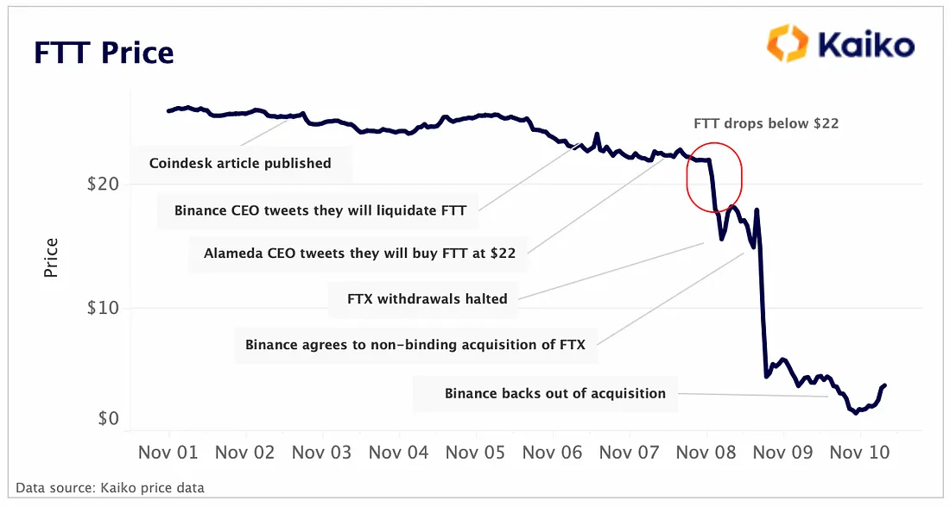

#1 A market analysis of the FTX collapse[14]

**Most common cryptocurrencies (as of July 2025)**

**Bitcoin (BTC)**

“Created in 2009 by the pseudonymous Satoshi Nakamoto, Bitcoin is the original and most recognized cryptocurrency. Bitcoin’s supply is limited to 21 million bitcoins and is often used as a legitimate means of exchange. Also, Bitcoin is regarded as the most influential currency for the past decade and as of December of 2017 when its price literally "skyrocketed" and 1 bitcoin's worth reached more than $20.000 USD. As of July 2025 the worth of 1 bitcoin has fallen to approximately $6.300 USD.” [15] The fluctuation in prices crypto tends to experience can also be linked to the lack of control and central pricing strategies. The absence of a central authority that controls the market means that prices can be far more easily controlled, or influenced, by panic, speculation, and concessions.

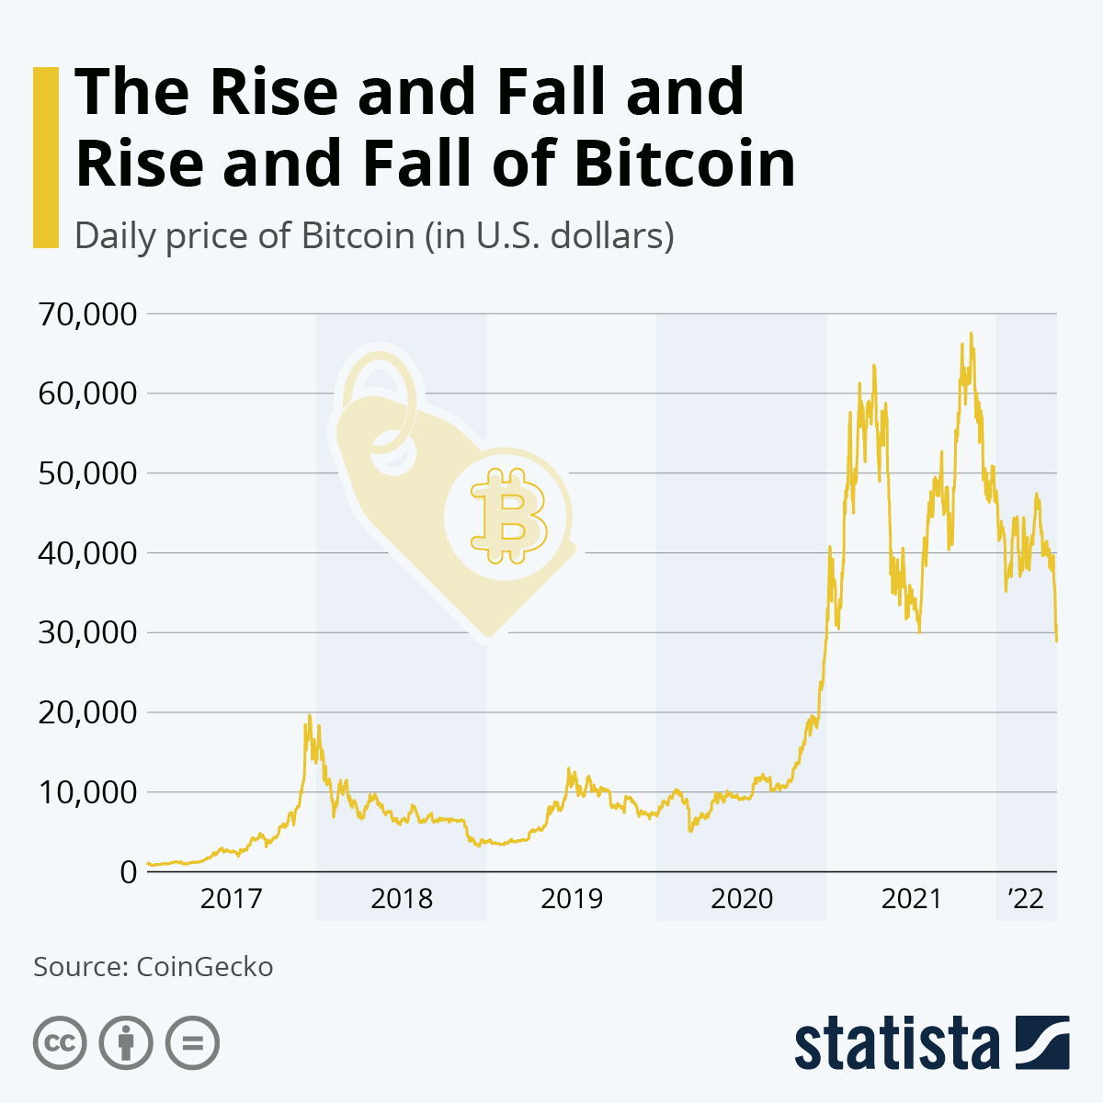

#2 Chart showcasing the fluctuation of the price of Bitcoin[16]

**Litecoin**

“Litecoin, released in 2011, works the same as bitcoin regarding its basic structure. The differences are that Litecoin has a supply limit of 84 million units, a slightly different algorithm than bitcoin and the time needed to create its blockchain is shorter. Regarding market capitalization Litecoin is ranked second or third most popular” [17]

**Ethereum (ETH)**

“Launched in 2015, Ethereum has made some major improvements on Bitcoin’s basic design. To be exact, with a cryptocurrency wallet, you can send and receive ether or pay for goods and services, if the digital currency is accepted as payment. Some platforms, such as Coinbase, allow you to take custody of your coins in a digital wallet, so you can make them less exposed to hackers, in theory.”[18]

**Cardano**

“Cardano (ADA) is a decentralized Proof-of-Stake (PoS) blockchain designed for global use by developers. Similar to Ethereum, Cardano's PoS consensus mechanism uses and rewards cryptocurrency for work done to review and expand the historical blockchain record.”[19]

**Ripple**

“Ripple is one of the largest cryptocurrency platforms by market capitalization. However, Ripple Labs, the company behind Ripple and its native cryptocurrency token XRP, had been around since 2012 and was one of the earliest pioneers in the blockchain only behind Bitcoin and even before the Ethereum network.”[20]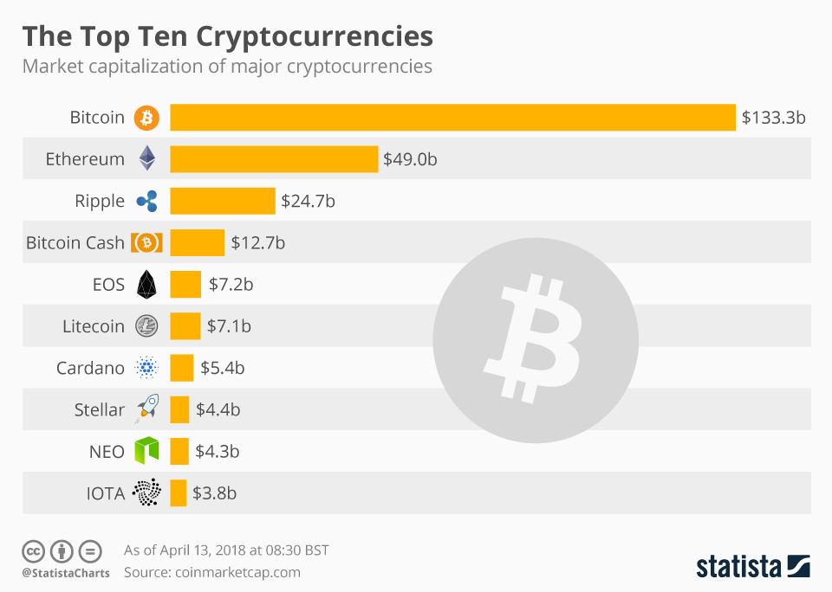

#3 The market cap of various cryptocurrencies[21]

**MAJOR COUNTRIES AND ORGANISATIONS INVOLVED**

**China**China has taken an alternative approach to regulation by imposing a complete ban on trading and mining activities. In September 2021, the People's Bank of China (PBoC) [22]enacted a prohibition on all transactions related to cryptocurrency, declaring it illegal, citing concerns over financial crime, capital flight from China, and the need to maintain financial control. Lack of regulation has been a sign of money laundering or fraud. It has been a deterrent of decentralized cryptocurrency for its potential threat to China's capability to strictly regulate and monitor the capital entering and leaving China.

**India**Currently, India is facing a dilemma regarding cryptocurrencies. They haven't been legalized yet, nor have they been prohibited. The Reserve Bank of India (RBI) is very apprehensive and has continually warned of the risks to financial stability, capital flight, and illegal activity, while advising the government to come up with very stringent regulations.[23] The Supreme Court has also encouraged the government to come up with a sensible regulatory framework.

**Japan**Japan is considered a standard for regulating cryptocurrency, with a robust legal framework that gives the ability to balance consumer protection while preventing financial crime. The Financial Services Agency (FSA) regulates cryptocurrency exchanges partially based on the Payment Services Act and the Financial Instruments and Exchange Act.[24] Japan also works internationally (including with the Financial Action Task Force (FATF)) to address crypto-related crime and protect financial stability.

**Singapore**To combat financial crimes relating to cryptocurrency, Singapore collaborates with international bodies including the United Nations and the Financial Action Task Force (FATF). As a member of the FATF, Singapore complies with international standards for due diligence to prevent money laundering or for terrorist funding related to crypto. The Monetary Authority of Singapore (MAS), the financial regulatory authority in Singapore regulates crypto companies requiring them to identify users involved in transactions.[25] These regulations assist in preventing crime and vice versa. The support from an international partnership adds to the strength of Singapore's domestic regulation and helps create a safer, more transparent worldwide cryptocurrency market.

**United Kingdom (UK)**The UK employs a phased approach to regulation of cryptocurrency emphasizing anti-money laundering (AML), consumer protection, crime prevention, and maintaining financial stability. As of 2020, cryptoasset exchanges and custodians need to register with the Financial Conduct Authority (FCA) in updated Money Laundering Regulations.[26] The FCA is working to prevent fraud and other illegal activity which signifies the UK is serious about crime prevention and market integrity.

**United States of America (USA)**In the US, regulation of cryptocurrency falls under several separate agencies, each having a unique role to play. The Financial Crimes Enforcement Network (FinCEN) implements Anti-Money Laundering (AML) and Know-Your-Customer (KYC) enforcement under the Bank Secrecy Act (BSA) which requires some crypto wallets and exchanges to register as Money Services Businesses (MSB) and file Suspicious Activity Reporting (SAR) to mitigate risk of Laundering and Terrorist financing. The Internal Revenue Service (IRS) takes care of the taxation of the digital asset and treats cryptocurrency as a property, meaning taxpayers must declare crypto gains, losses and income. The IRS has even launched initiatives such as “Operation Hidden Treasure” to tackle perceived crypto tax evasion. On the other hand, the Office of Foreign Assets Control (OFAC) also implements US economic sanctions. They crypto block transactions involving sanctioned individuals, entities, or countries and also maintain a Specially Designated Nationals (SDN) list which may involve adding specific crypto wallet addresses associated with illegal activities. These agencies, in combination, represent the fragmented crypto regulatory system in the US.

**Financial Action Task Force (FATF)**The Financial Action Task Force (FATF) devotes its work to combatting money laundering and terrorist financing. It has also broadened its coverage with respect to virtual assets (cryptocurrencies) and now includes Virtual Asset Service Providers (VASPs).[27] FATF implemented its rules on money laundering and terrorist financing in the crypto space last June when it updated its Recommendation 15. It also brought in the "Travel Rule," which tells VASPs to share details about the sender and recipient of money in a transaction. What's more, FATF pushed for countries to adopt and enforce these new standards to stop cross-border financial crime. FATF shapes domestic crypto rules and encourages teamwork through its growing oversight frameworks and international peer reviews. This helps to boost economic stability and cut down on illegal finance at home and around the world.

**International Monetary Fund (IMF)**The International Monetary Fund (IMF) has acquired a leading position in shaping worldwide policy on cryptocurrencies, especially regarding financial stability, monetary sovereignty, and crime prevention. In 2023, the IMF[28] published a framework containing nine key principles for regulating cryptocurrency. Three of the principles highlight the need to maintain control, not to recognize crypto as legal currency, and to regulate financial crime prevention laws. The IMF collaborates with nations via the Financial Sector Assessment Program (FSAP). The FSAP is an umbrella program designed to provide comprehensive and continuous support to governments to establish, harmonize regulation, increase supervision, and mitigate the risks associated with crypto-assets. The IMF will be persistent in calling for multilateral approaches and continues to push countries to ensure their crypto rules harmonize with the FATF and FSB global standards.

**World Economic Forum (WEF)**In January 2020 the WEF announced the first global consortium for digital currency governance.[29] The focus of it was to design a framework for the governance of cryptocurrencies. It brought together over 200 global institutions to address risks like financial crime and practical regulatory frameworks. These resources are now used by policymakers worldwide to support safe, inclusive, and stable digital currency systems.

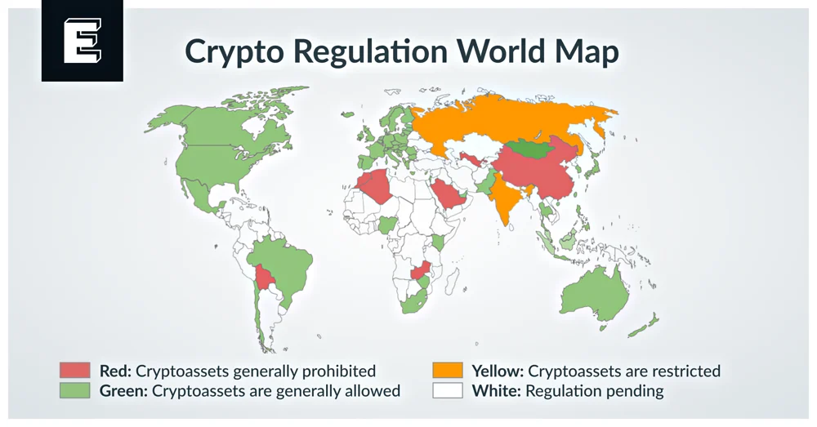

#4 Map showcasing crypto regulation around the world[30]

**BLOCS EXPECTED**

**Bloc 1: The Anti-Cryptocurrency Group:**

This group wants stricter regulations to protect the economy and stop money laundering. They worry about how digital currencies might harm financial stability, national security, and public safety if not properly controlled. These countries prefer centralized, government-led rules for cryptocurrencies and work together globally to fight money laundering, terrorism financing, and to protect consumers. Countries like India, China, France, Russia, and Indonesia belong to this group. They are concerned about illegal activities or have already put strict laws in place to control crypto use in their financial systems.

**Bloc 2: The Minimal Regulation and Innovation Group:**

This group favors minimal rules and focuses on encouraging crypto innovation. They see cryptocurrencies as a way to improve their economy, boost financial access, or gain political advantages. Their goal is to attract investment and support innovation by creating crypto-friendly laws. Countries like Switzerland, El Salvador, the UAE, Singapore, and Estonia are in this group. They often adopt blockchain early and support financial independence, with some even including crypto in their national financial plans.

**TIMELINE OF EVENTS**

| **Date** | **Description of event** |
| --- | --- |
| 2000 | Formation of the Global Forum on Transparency and Exchange of Information for Tax Purposes, a Forum working under the auspices of the OECD and the G20 aiming at the implementation of tax transparency and information exchange by all Member States. |
| 2011 | Bitcoin Classified as a Virtual Currency |
| 2013 | China prohibits financial institutions from participating in cryptocurrency related transactions. |
| 2013 | FinCEN’s First Guidance on Virtual Currencies (USA). This was the first significant step towards regulatory clarity in the US. The guidelines stated that both virtual currency exchangers and administrators are obligated to follow AML requirements. |
| January 2020 | World Economic Forum (WEF) Announces First Global Consortium to Govern Digital Currencies. This new consortium unites more than 200 global institutions to develop frameworks to mitigate risks like financial crime and make digital currency systems safer and more stable worldwide. |
| September 2021 | China Bans Cryptocurrency Transactions and Mining in Full. China’s cryptocurrency transaction and mining ban had geopolitical implications on the regulation and affected markets around the world, including crypto trading and mining centers. |
| 2023 | IMF Releases Nine Foundational Principles for Crypto Regulation. |
| 22 October 2024 | The FSB released a status report on the G20 Crypto-Asset Policy Implementation Roadmap, detailing significant progress. |
| 9 July 2025 | The FSB published new recommendations addressing financial stability risks |

**RELEVANT RESOLUTIONS, TREATIES AND EVENTS**

**United Nations Economic and Social Council Resolution E/RES/2017/3**

On the 20th of April 2017, the United Nations Economic and Social Council adopted a Resolution on "United Nations code of conduct on cooperation in combating international tax evasion" that called on the endorsement of the work done regarding automatic exchange of financial account information, including the CRS and on Member States that are following the code of conduct to adhere to high levels of transparency and information exchange in tax matters.

**G20 Riyadh Summit Declaration (2017)**

G20 leaders have collectively agreed on an extensive plan of action for regulating cryptocurrencies, indicating a new chapter for the market.[31] More thoroughly, at the 2017 G20 Summit hosted virtually by Saudi Arabia, leaders confirmed the validity of the Financial Action Task Force (FATF) standards, including the “Travel Rule” for crypto transactions to reduce money laundering and the support of economic terrorism. Moreover, they supported the continuous examination of Central Bank Digital Currencies (CBDCs) by the International Monetary Fund (IMF), Bank for International Settlements (BIS), and others, recognizing their potential impacts on cross-border payments. Finally, they emphasized the need for global cooperation in regulating crypto-assets to secure financial stability, protect consumers, and prevent unlawful activities.

**Financial Action Task Force (FATF) Recommendation 15 Update**

In June 2019[32], the Financial Action Task Force (FATF) made some important updates to its standards by explicitly incorporating virtual assets and Virtual Asset Service Providers (VASPs). One significant addition was the introduction of the "Travel Rule." This rule mandates that VASPs share information about both the sender and the receiver.

**PREVIOUS ATTEMPTS TO SOLVE THE ISSUE**

In recent years, there have been multiple courses of actions and drastic measures on the part of regulators to address the issues presented by cryptocurrencies more generally and for financial crime and economic stability more specifically. The Financial Action Task Force (FATF)[33] has become the leading best practice organization and has expanded its anti-money laundering (AML)/counter-terrorist financing (CTF) regime to include virtual assets and their respective Virtual Asset Services Providers (VASPs). The FATF adopted the "Travel Rule", meaning that all crypto service providers will exchange the identifying information of the parties engaging in a transaction, thus ensuring there is transparency and sharing across countries. Similarly, the International Monetary Fund (IMF) has also created significant guidance on the integration of regulation, the stability of financial systems[34] and the prevention of criminality. Moreover, The Basel Committee on Banking Supervision (BCBS)f[35] has also established prudential standards for banks exposed to risks from cryptocurrencies; with a similar goal of reducing systemic risk via increased capital ratios and mandatory risk management.

It is also important to recognize that there have been similarly, nationally and globally, countries that have filed their own regulatory strategies and legal frameworks to respond to cryptocurrencies focused on consumer protection, preventing crime, and market integrity. To provide examples, Japan's Financial Services Agency (FSA), requires exchanges to be registered and regulated by strict AML/KYC guidelines[36] and the UK FCA[37] has taken the position that cryptocurrencies are included within its money laundering regulations; Similarly, the USA relies on multiple regulators, including FinCEN, IRS, and OFAC respectively for AML, taxation and sanctioning; lastly, the Monetary Authority of Singapore (MAS)[38] establishes its domestic requirements against international standards working towards financial transparency and preventing financial misconduct.

**POSSIBLE SOLUTIONS**

The issue of the use of the minimal regulation of cryptocurrencies has been troubling the global community for ages and has still not been tackled completely, despite the significant progress that has been made. In order to resolve the matter, deeper cooperation between all countries and intergovernmental organizations is deemed necessary. Furthermore, a possible solution to the problem would be the enhancement of global frameworks similar to the Financial Action Task Force (FATF) recommendations, promoting automatic information exchange and transparency to combat money laundering and illicit activities in the crypto space. Another effective action would be the promotion of existing agreements that are focused on monitoring economic and transactional data on an international level. These agreements would help ensure that all nations act according to uniform standards for securing the sharing of information about crypto transactions, which would make it simpler to identify and prevent illegal activities worldwide.

**BIBLIOGRAPHY**

Jacobs, Rachel. “38 of the Wisest Bitcoin Quotes | BitcoinChaser.” *BitcoinChaser*, 3 Nov. 2018, [bitcoinchaser.com/fun/best-bitcoin-quotes](http://bitcoinchaser.com/fun/best-bitcoin-quotes).

Tambe, Nikita. “Cryptocurrency Has Its Own Advantages. Here’s a List.” *Forbes*, 10 Jan. 2024, [www.forbes.com/advisor/in/investing/cryptocurrency/advantages-of-cryptocurrency/](http://www.forbes.com/advisor/in/investing/cryptocurrency/advantages-of-cryptocurrency/).

Klawans, Justin. “2023: The Year of Crypto Instability.” *The Week*, 11 Dec. 2023, [theweek.com/tech/2023-crypto-instability](http://theweek.com/tech/2023-crypto-instability)

Mulligan, Cathy. “Blockchain and Sustainable Growth.” *United Nations*, Dec. 2018, [www.un.org/en/un-chronicle/blockchain-and-sustainable-growth](http://www.un.org/en/un-chronicle/blockchain-and-sustainable-growth)

Becher, Brooke. “What Is Blockchain Technology? How Does Blockchain Work? | Built In.” *Builtin.com*, 29 Mar. 2024, [builtin.com/blockchain](http://builtin.com/blockchain)

FinCEN. “What Is Money Laundering?” *Financial Crimes Enforcement Network*, 2019, [www.fincen.gov/what-money-laundering](http://www.fincen.gov/what-money-laundering)

Frankenfield, Jake. “Consensus Mechanism (Cryptocurrency).” *Investopedia*, 17 Feb. 2023, [www.investopedia.com/terms/c/consensus-mechanism-cryptocurrency.asp](http://www.investopedia.com/terms/c/consensus-mechanism-cryptocurrency.asp)

“The Role of Cryptocurrency in Financing Terrorist Organizations.” *PBS NewsHour*, 4 Nov. 2023, [www.pbs.org/newshour/show/the-role-of-cryptocurrency-in-financing-terrorist-organizations](http://www.pbs.org/newshour/show/the-role-of-cryptocurrency-in-financing-terrorist-organizations)

Butts, Dylan. “Over 60% of Illegal Crypto Activity Is Tied to Sanctioned Groups or Terrorist Organizations, Report Finds.” *CNBC*, 29 Feb. 2024, [www.cnbc.com/2024/02/29/sanctioned-and-terrorist-entities-receive-most-global-illicit-crypto.html](http://www.cnbc.com/2024/02/29/sanctioned-and-terrorist-entities-receive-most-global-illicit-crypto.html)

“8 Types of Crypto Scams to Watch out for in 2025.” *Cryptonews*, 27 Aug. 2024, [cryptonews.com/cryptocurrency/types-of-crypto-scams/](http://cryptonews.com/cryptocurrency/types-of-crypto-scams/)

Zahn, Max. “A Timeline of Cryptocurrency Exchange FTX’s Historic Collapse.” *ABC News*, 28 Mar. 2024, [abcnews.go.com/Business/timeline-cryptocurrency-exchange-ftxs-historic-collapse/story?id=93337035](http://abcnews.go.com/Business/timeline-cryptocurrency-exchange-ftxs-historic-collapse/story?id=93337035)

Armstrong, Martin. “Infographic: The Rise and Fall and Rise and Fall of Bitcoin.” *Statista Infographics*, 13 May 2022, [www.statista.com/chart/24966/bitcoin-ups-and-downs/](http://www.statista.com/chart/24966/bitcoin-ups-and-downs/)

WIRES, NEWS. “China’s Central Bank Declares All Cryptocurrency Transactions Illegal.” *France 24*, FRANCE 24, 24 Sept. 2021, [www.france24.com/en/asia-pacific/20210924-china-s-central-bank-declares-all-cryptocurrency-transactions-illegal?utm_source=chatgpt.com](http://www.france24.com/en/asia-pacific/20210924-china-s-central-bank-declares-all-cryptocurrency-transactions-illegal?utm_source=chatgpt.com).

George, Kevin. “Cryptocurrency Regulations around the World.” *Investopedia*, 2021, [www.investopedia.com/cryptocurrency-regulations-around-the-world-5202122#citation-52](http://www.investopedia.com/cryptocurrency-regulations-around-the-world-5202122#citation-52)<https://doi.org/10/3688172/4157443/4353814>

Sinha, Shishir. “India to Take a Call on Crypto Regulations after Wider Consultation, Indicated No Ban.” *BusinessLine*, 10 Sept. 2023, [www.thehindubusinessline.com/economy/india-to-take-a-call-on-crypto-regulations-after-wider-consultation-indicated-no-ban/article67291777.ece?utm_source=chatgpt.com](http://www.thehindubusinessline.com/economy/india-to-take-a-call-on-crypto-regulations-after-wider-consultation-indicated-no-ban/article67291777.ece?utm_source=chatgpt.com)

“Navigating the UK’s Evolving Crypto Regulations: Key Insights.” *Merklescience.com*, 2025,[www.merklescience.com/blog/navigating-the-uks-evolving-crypto-regulations-key-insights?utm_source=chatgpt.com](http://www.merklescience.com/blog/navigating-the-uks-evolving-crypto-regulations-key-insights?utm_source=chatgpt.com)

“Regulation of Digital Assets in the UK.” *FCA*, 25 Apr. 2023, [www.fca.org.uk/news/speeches/regulation-digital-assets-uk?utm_source=chatgpt.com](http://www.fca.org.uk/news/speeches/regulation-digital-assets-uk?utm_source=chatgpt.com)

“A Primer: Crypto Regulation in Singapore on June 10 Here’s EYNTK about Crypto in the Lion City | TRM Blog.” *Trmlabs.com*, 2025, [www.trmlabs.com/resources/blog/crypto-regulation-in-the-lion-city?utm_source=chatgpt.com](http://www.trmlabs.com/resources/blog/crypto-regulation-in-the-lion-city?utm_source=chatgpt.com)

“Governing the Coin: World Economic Forum Announces Global Consortium for Digital Currency Governance.” *World Economic Forum*, 2025, [www.weforum.org/press/2020/01/governing-the-coin-world-economic-forum-announces-global-consortium-for-digital-currency-governance/?utm_source=chatgpt.com](http://www.weforum.org/press/2020/01/governing-the-coin-world-economic-forum-announces-global-consortium-for-digital-currency-governance/?utm_source=chatgpt.com)

“Elements of Effective Policies for Crypto Assets.” *IMF*, [www.imf.org/en/Publications/Policy-Papers/Issues/2023/02/23/Elements-of-Effective-Policies-for-Crypto-Assets-530092](http://www.imf.org/en/Publications/Policy-Papers/Issues/2023/02/23/Elements-of-Effective-Policies-for-Crypto-Assets-530092)

21 Analytics. “2024 FATF Targeted Update Summarised with Recommendations.” *21 Analytics*, 6 Aug. 2024, [www.21analytics.ch/blog/2024-fatf-targeted-update/?utm_source=chatgpt.com](http://www.21analytics.ch/blog/2024-fatf-targeted-update/?utm_source=chatgpt.com)

Chan, Viviana. “Racing & Gaming Conference – Saratoga 2025.” *Asia Gaming News | AGB - Asia Gaming Brief*, 2 July 2025, [agbrief.com/news/world/03/07/2025/fatf-warns-of-rising-crypto-misuse-urges-stricter-global-oversight/?utm_source=chatgpt.com](http://agbrief.com/news/world/03/07/2025/fatf-warns-of-rising-crypto-misuse-urges-stricter-global-oversight/?utm_source=chatgpt.com).

UK, Simon Lovegrove. “FATF Updates Travel Rule.” *Global Regulation Tomorrow*, 19 June 2025, [www.regulationtomorrow.com/global/fatf-updates-travel-rule/](http://www.regulationtomorrow.com/global/fatf-updates-travel-rule/)

Willson, Candice. “Travel Rule Crypto: Balancing Privacy and Regulation in the Digital Age.” *Blockport*, 6 Aug. 2025, [blockport.io/crypto-regulations/travel-rule-crypto/](http://blockport.io/crypto-regulations/travel-rule-crypto/)

Jones, Huw. “EU Sticks to January 2025 Start for Final Batch of Basel Bank Capital Rules.” *Reuters*, 30 May 2024, [www.reuters.com/business/finance/eu-sticks-january-2025-start-final-batch-basel-bank-capital-rules-2024-05-30/](http://www.reuters.com/business/finance/eu-sticks-january-2025-start-final-batch-basel-bank-capital-rules-2024-05-30/)

1. “The Best Motivational and Positive Cryptocurrency Quotes by Famous People.” *StormGain*, [stormgain.com/blog/best-cryptocurrency-quotes-famous-people](http://stormgain.com/blog/best-cryptocurrency-quotes-famous-people)
2. https://www.facebook.com/Investopedia. “DigiCash: Meaning, History, Implications.” *Investopedia*, 2018, [www.investopedia.com/terms/d/digicash.asp?utm_source=chatgpt.com](http://www.investopedia.com/terms/d/digicash.asp?utm_source=chatgpt.com).
3. Dale, Brady. “The White House Is Pushing to Embed Crypto Everywhere, from Taxes to Retirement.” *Axios*, 30 July 2025, [www.axios.com/2025/07/30/trump-stablecoin-taxes-crypto](http://www.axios.com/2025/07/30/trump-stablecoin-taxes-crypto)
4. “Global AML/CFT Context.” *EU AML/CFT Global Facility*, 11 Aug. 2025, [www.global-amlcft.eu/global-anti-money-laundering-and-countering-terrorism-financing-context/](http://www.global-amlcft.eu/global-anti-money-laundering-and-countering-terrorism-financing-context/)
5. “Britannica Money.” *Britannica.com*, 21 July 2025, [www.britannica.com/money/cryptocurrency?utm_source=chatgpt.com](http://www.britannica.com/money/cryptocurrency?utm_source=chatgpt.com)
6. Chen, James. “Money Laundering.” *Investopedia*, 2022, [www.investopedia.com/terms/m/moneylaundering.asp](http://www.investopedia.com/terms/m/moneylaundering.asp)
7. “Privacy Coins Explained: How They Differ from Other Cryptos.” *CryptoManiaks*, 6 May 2025, [cryptomaniaks.com/guides/privacy-coins-explained](http://cryptomaniaks.com/guides/privacy-coins-explained)
8. Hayes, Adam. “Stablecoins: Definition, How They Work, and Types.” *Investopedia*, 2018, [www.investopedia.com/terms/s/stablecoin.asp?utm_source=chatgpt.com](http://www.investopedia.com/terms/s/stablecoin.asp?utm_source=chatgpt.com)
9. “Terrorist Financing: Six Crypto-Related Trends to Watch in 2023 | TRM Blog.” *Trmlabs.com*, 2023, [www.trmlabs.com/resources/blog/terrorist-financing-six-crypto-related-trends-to-watch-in-2023?utm_source=chatgpt.com](http://www.trmlabs.com/resources/blog/terrorist-financing-six-crypto-related-trends-to-watch-in-2023?utm_source=chatgpt.com).
10. Grigg, Gurvais. “Combating Trafficking with Blockchain Analysis.” *Chainalysis*, 12 Apr. 2022, [www.chainalysis.com/blog/combatting-trafficking-with-blockchain-analysis/](http://www.chainalysis.com/blog/combatting-trafficking-with-blockchain-analysis/)
11. “5 of the Biggest Crypto Ponzi Schemes | CoinMarketCap.” *CoinMarketCap Academy*, [coinmarketcap.com/academy/article/5-of-the-biggest-crypto-ponzi-schemes](http://coinmarketcap.com/academy/article/5-of-the-biggest-crypto-ponzi-schemes)
12. Bekiempis, Victoria. “The Rise and Fall of Sam Bankman-Fried: An Unrepentant Ex-Mogul Faces down Decades in Prison.” *The Guardian*, 23 Mar. 2024, [www.theguardian.com/business/2024/mar/23/sam-bankman-fried-rise-and-fall-details](http://www.theguardian.com/business/2024/mar/23/sam-bankman-fried-rise-and-fall-details)
13. “Samuel Bankman-Fried Sentenced to 25 Years for His Orchestration of Multiple Fraudulent Schemes.” *Justice.gov*, 28 Mar. 2024, [www.justice.gov/archives/opa/pr/samuel-bankman-fried-sentenced-25-years-his-orchestration-multiple-fraudulent-schemes](http://www.justice.gov/archives/opa/pr/samuel-bankman-fried-sentenced-25-years-his-orchestration-multiple-fraudulent-schemes)
14. Kaiko. “The FTX Collapse: A Market Analysis - Kaiko.” *Medium*, Kaiko, 10 Nov. 2022, [blog.kaiko.com/the-ftx-collapse-a-market-analysis-7c033ea5fab6](http://blog.kaiko.com/the-ftx-collapse-a-market-analysis-7c033ea5fab6)
15. Martucci, Brian. “What Is Cryptocurrency - How It Works, History & Bitcoin Alternatives.” *Money Crashers*, 18 May 2021, [www.moneycrashers.com/cryptocurrency-history-bitcoin-alternatives/](http://www.moneycrashers.com/cryptocurrency-history-bitcoin-alternatives/).
16. Armstrong, Martin. “Infographic: The Rise and Fall and Rise and Fall of Bitcoin.” *Statista Infographics*, 13 May 2022, [www.statista.com/chart/24966/bitcoin-ups-and-downs/](http://www.statista.com/chart/24966/bitcoin-ups-and-downs/)
17. “Litecoin - Open Source P2P Digital Currency.” *Litecoin.org*, 2011, [litecoin.org/](http://litecoin.org/).
18. Royal, James. “What Is Ethereum and How Does It Work?” *Bankrate*, Bankrate.com, 10 Aug. 2021, [www.bankrate.com/investing/what-is-ethereum/?mf_ct_campaign=yahoo-synd-feed&utm_content=syndication&uuid=1YtrBVRObyzAxnSd5374](http://www.bankrate.com/investing/what-is-ethereum/?mf_ct_campaign=yahoo-synd-feed&utm_content=syndication&uuid=1YtrBVRObyzAxnSd5374).
19. following, Full Bio Luke Conway has been, et al. “Cardano Definition.” *Investopedia*, [www.investopedia.com/cardano-definition-4683961](http://www.investopedia.com/cardano-definition-4683961)
20. CFI Team. “Ripple.” *Corporate Finance Institute*, [corporatefinanceinstitute.com/resources/cryptocurrency/ripple/.](http://corporatefinanceinstitute.com/resources/cryptocurrency/ripple/)
21. “Infographic: The Top Ten Cryptocurrencies.” *Statista Infographics*, [www.statista.com/chart/13520/the-top-ten-cryptocurrencies/](http://www.statista.com/chart/13520/the-top-ten-cryptocurrencies/)
22. “China: Central Bank Issues New Regulatory Document on Cryptocurrency Trading.” *The Library of Congress*, 2015, [www.loc.gov/item/global-legal-monitor/2021-10-13/china-central-bank-issues-new-regulatory-document-on-cryptocurrency-trading/](http://www.loc.gov/item/global-legal-monitor/2021-10-13/china-central-bank-issues-new-regulatory-document-on-cryptocurrency-trading/)
23. “Reserve Bank of India.” *Rbi.org.in*, 2025, [www.rbi.org.in/commonman/english/Scripts/PressReleases.aspx?Id=2522&utm_source=chatgpt.com](http://www.rbi.org.in/commonman/english/Scripts/PressReleases.aspx?Id=2522&utm_source=chatgpt.com)
24. Reuters Staff. “Japan to Give Crypto Assets Legal Status as Financial Products, Nikkei Says.” *Reuters*, 30 Mar. 2025, [www.reuters.com/technology/japan-give-crypto-assets-legal-status-financial-products-nikkei-says-2025-03-30/](http://www.reuters.com/technology/japan-give-crypto-assets-legal-status-financial-products-nikkei-says-2025-03-30/)
25. “Finreg.sg - Financial Regulations Made Accessible.” *Finreg.sg*, 2019, [finreg.sg/wiki/a08fddad-c2fb-4f21-ae1a-389b3dee7a73/53](http://finreg.sg/wiki/a08fddad-c2fb-4f21-ae1a-389b3dee7a73/53)
26. Asgari, Nikou. “Crypto Company Chaired by Ex-Chancellor Ditches Push for UK Registration.” *@FinancialTimes*, Financial Times, 20 Dec. 2024, [www.ft.com/content/3bfa0e6b-9a39-4198-840e-63611bf0cd5a](http://www.ft.com/content/3bfa0e6b-9a39-4198-840e-63611bf0cd5a)
27. “The FATF.” *Fatf-Gafi.org*, 2023, [www.fatf-gafi.org/en/the-fatf.html](http://www.fatf-gafi.org/en/the-fatf.html)
28. International Monetary Fund. “International Monetary Fund .” *IMF*, 2022, [www.imf.org/en/Home](http://www.imf.org/en/Home)
29. “Governing the Coin: World Economic Forum Announces Global Consortium for Digital Currency Governance.” *World Economic Forum*, 2025,[www.weforum.org/press/2020/01/governing-the-coin-world-economic-forum-announces-global-consortium-for-digital-currency-governance/](http://www.weforum.org/press/2020/01/governing-the-coin-world-economic-forum-announces-global-consortium-for-digital-currency-governance/)
30. Elliptic. “Tracing Bitcoins from a Hamas Terrorist Fundraising Campaign.” *Elliptic.co*, 2024, www.elliptic.co/blog/tracing-bitcoin-terrorism, <https://doi.org/108706526/module_123442832030_Author_Module>
31. Team, Trading Education. “Understanding the G20’S Recent Crypto Regulatory Decisions.” *Trading-Education.com*, Trading Education, 16 Oct. 2023, [trading-education.com/crypto/news/understanding-the-g20s-recent-crypto-regulatory-decisions](http://trading-education.com/crypto/news/understanding-the-g20s-recent-crypto-regulatory-decisions).
32. and. *Apml.gov.rs*, 2019, [www.apml.gov.rs/english/news/article/fatf-public-statement](http://www.apml.gov.rs/english/news/article/fatf-public-statement).
33. Financial Action Task Force. “FATF-GAFI.ORG - Financial Action Task Force (FATF).” *Fatf-Gafi.org*, 2019, [www.fatf-gafi.org/](http://www.fatf-gafi.org/)
34. International Monetary Fund. “Global Financial Stability Report.” *IMF*, 2024, [www.imf.org/en/publications/gfsr](http://www.imf.org/en/publications/gfsr)
35. “Core Principles for Effective Banking Supervision.” *Www.bis.org*, 25 Apr. 2024, [www.bis.org/bcbs/publ/d573.htm](http://www.bis.org/bcbs/publ/d573.htm)
36. “Section Home.” *Multilaw.com*, 2023, [multilaw.com/Multilaw/ZENTSO/BusinessGuides/Presentation/Section_Home.aspx?GuideId=2&GuideCountry=Japan&GuideSection=850](http://multilaw.com/Multilaw/ZENTSO/BusinessGuides/Presentation/Section_Home.aspx?GuideId=2&GuideCountry=Japan&GuideSection=850)
37. FCA. “Financial Conduct Authority.” *FCA*, 2025, [www.fca.org.uk/](http://www.fca.org.uk/)
38. “Financial Institutions Directory.” *Mas.gov.sg*, 2019, [eservices.mas.gov.sg/fid](http://eservices.mas.gov.sg/fid)