**Committee:** Security Council

**Issue:** Ensuring Civilian Security Amid Ongoing Violence in the Democratic Republic of the Congo and the Alleged Involvement of External Actors in the Conflict

**Student Officer:** Duru Ceylan

**Position:** Deputy President

**PERSONAL INTRODUCTION**

Dear Delegates,

My name is Duru Ceylan and I am an 11th grade student in the Pinewood-Anatolia IBDP Program here in Thessaloniki. This year I am honored to serve as one of your Deputy Presidents of the Security Council in the what is to be 8th DSTMUN Conference, the fourth that I will be attending!

I would like to extend my friendliest welcome to all of you; I only hope you are eagerly awaiting this simulation as much as I am. For any of those who are new, DSTMUN debates are always passionate, but what you will remember when they are over are the spontaneous friendships that you acquire over the course of the three days you will be attending. The different characters you will encounter will make your way into your memories more than the committee work.

Nevertheless, preparation determines how smoothly your part in the conference will go; considering the current significance of this topic regarding the security of innocent lives amidst brutal violence and terror across the globe, accurately understanding the conflict in the DRC should perhaps be a duty rather than a task. This study guide introduces the main events which have led to the instability in the DRC. However, for country-specific stances and details you must research individually, as to maximize the quality and frequency of your participation.

For the first-comers to the MUN world, or even just this particular MUN I want to emphasize that I have absolutely not forgotten what it is like to be newly immersed into the sometimes overwhelming processes of research and preparation; thus I encourage any and all of you to reach out if you need anything, you can ask for online sources or specific explanations or example committee texts, no introductions necessary whatsoever. If you have any questions regarding the topic or general procedures, please contact me via email at [dceylan@pinewood-school.gr](mailto:dceylan@pinewood-school.gr).

Sincerely,

Duru Ceylan.

**TOPIC INTRODUCTION**

The Democratic Republic of the Congo has been entangled in a highly fragmented conflict since the late 20th century. Ever since the conflict between ethnic groups in Rwanda made it into the DRC, countless notorious battles have been fought. With some ethnic groups remobilizing and scheming within its borders, and others completely ignoring its sovereignty to gather up those said ethnic groups, the Congolese people and any other individual under refugee status have all been endangered throughout two wars (1996-2003) with extremely high casualties up until the signing of a partial ceasefire monitored by a specially commissioned UN organization, accused of corruption and violence itself. While the fighting prevailed for the next 10 years, various agreements, elections, and divisions of power amongst armed groups managed to keep the conflict under the radar. However, It seems that 9 years later, even after the ICC prosecuted several criminal rebel leaders, the UN forces finally joined in the fight to contain the militias, elections were held, corruption investigations on Congolese officials were opened, foreign sanctions on Congolese officials and militia leaders were imposed for the responsibility of the deaths of protesters and other human rights violations, the same rebel groups have resurfaced. Now, Rwandan-backed armed rebel groups have begun to invade entire cities under the jurisdiction of the DRC government and the livelihoods of civilians are endangered.1

Thus, since 2022 the violence between local Congolese militias and Congolese national forces fighting against the Rwandan-aligned rebel groups have increased and intensified. Hundreds of thousands of people have been displaced once again, UN peacekeepers have been accused of inadequate help, the rebels have begun to raid hospitals and homes, and the DRC-Rwanda political tensions are now dangerously higher than ever. The ultimate straw, however, has been the capture of Goma, the capital of the North Kivu Province by the rebels in January 2025, causing the DRC to accuse Rwanda of legitimately declaring war. With critical trade and humanitarian routes being blocked off, UN forces unclear as to their role in the conflict itself, and a prospective third Congo War on the line, it is urgent to secure all civilians before violent activities reach them. While mass displacement, widespread sexual violence, and resource exploitation is concerning enough, this conflict escalating into total war would be too heavy on the current world agenda and a people that have been suffering since the colonial era.2

**DEFINITION OF KEY TERMS**

**Scramble for Africa**

Formally under the Berlin Conference of 1884-1885, the period of rapid colonization of the African continent for a few decades prior to WW1 with insufficient attention to ethnic, linguistic, and tribal borders and identities. The competition of territory between European forces became a rush when Belgium’s King Leopold II colonized DRC, a much more mainland conquest than usual. The lasting ramifications of exploitation and oppression implemented by the colonial forces proved detrimental post WW2 when the transition of many African nations into self-governance resulted in instability and insecurity.3-4

**Rebels & Militias**

Both are armed groups seeking some form of independence. However, while rebel groups oftentimes challenge the legitimacy of a government, with aims to overthrow it, militias can work within political structures. In the conflict of the DRC the rebels take on the more offensive stance against the Congolese government with significant external support, whereas the militias are predominantly local, branched out and take on the more defensive stance.

**Mineral Resources**

There are naturally occurring deposits of minerals, precious metals, and other geological materials in the Earth’s crust which are mined and utilized in manufacturing, electronics for instance, and luxury trade. Officially or unofficially, typically the richness of a geographic region in terms of these depository is a driving factor for those who claim rule over that territory. The DRC has abundant reserves of cobalt, copper, tantalum, manganese, gold and diamonds; however the extraction processes of many have been compromised for the government due to the presence of private foreign businesses and the violence of rebel groups and militias.5

**Disarmament, Demobilization, & Reintegration (DDR)**

A key framework of UN peacekeeping operations, disarmament, demobilization, and reintegration strives to redirect and rehabilitate ex-combatants and ex-members of armed groups in ways that do not jeopardize the civilian communities that they are reintroduced to. By removing gunfire and ammunition from the equation, this strategy allows peacekeepers to help everyone, regardless of their backgrounds.6

**Responsibility to Protect**

In response to the international community’s question of how to react to gross and systemic violations of human rights which emerged after the ill-managed conflicts in Rwanda and Kosovo, this principle was established as to protect targeted peoples from atrocities such as genocide, war crimes, ethnic cleansing, or crimes against humanity. This principle prioritizes human rights and safety over sovereignty, thereby defining strategic international intervention appropriate and just in the face of a nation who is deemed incompetent in securing the livelihoods of its inhabitants.7

**BACKGROUND INFORMATION**

**Rwandan Civil War Spills into the DRC: 1st & 2nd Congo Wars**

When the Hutu government, ex-genociders and former extremists who led the Rwandan genocide against people of Tutsi ethnicity, fled into eastern DRC territory after the Tutsis came into government office, international conflict penetrated the Congolese borders, spreading the country’s already thin security forces even thinner. Consequently, as the Hutus remobilized into an uprising in the refugee camps they were placed in, preparing to reassume power back home, the Rwandan government organized attacks to neutralize and kill the Hutus, whilst overthrowing the regime that protected them. Lasting for a whole year from 1996-1997, with the largest alliance of African Nations seen in the continent, this rebellion was formally known as the First Congo War, but informally as the African First World War.8-9

**Ulterior Motives of Gaining Mineral Reserves**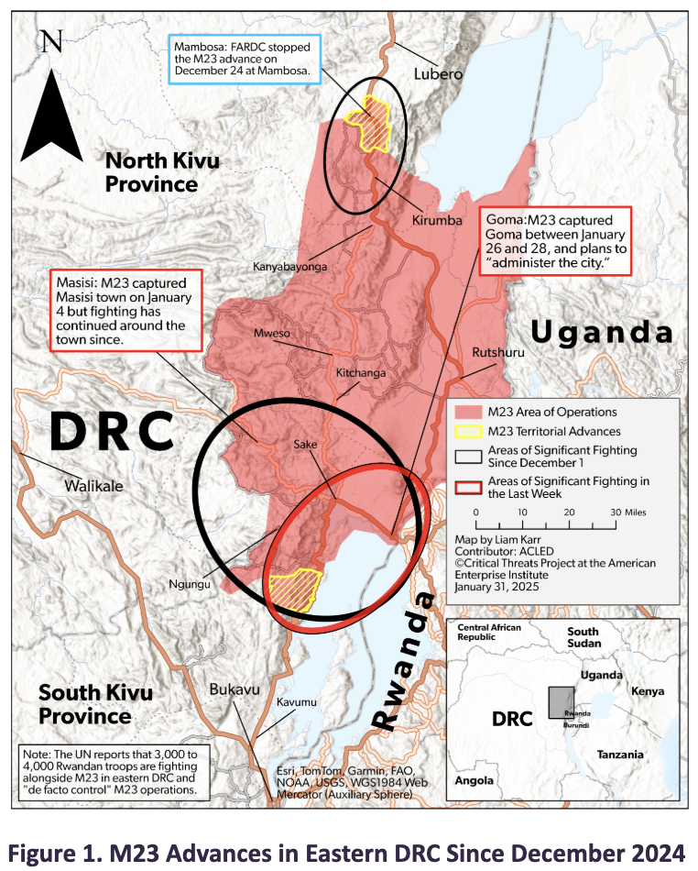

While the the majority of the conflict in eastern DRC can be traced back to the ethnic tensions between the Hutu and Tutsi peoples, it is highly likely that underneath it all, external actors are fueling the fighting to create circumstances in which they can exploit the region's extraordinarily rich, untapped mineral reserves with over half of the world’s cobalt. There is a pattern that can be observed of nations that were active in the mining industry before the current state of the conflict pushing for peace brokering, and nations who were not in the mining industry facing allegations of providing troops and arms, in which case all of the rebels and militias are simply proxies. For example, since the capture of cities such as Goma, located in the mineral rich region, it has been a pressing question, whether or not Rwanda has begun mining and manufacturing gold and colton from territory that is under Congolese jurisdiction.10 This process of illegally extracting minerals and precious metals has become common among armed groups of all sizes in the conflict, some of which the damage they produce extends to civilians as well. Furthermore, in February this year, president Felix Tshesekedi offered the USA access to these natural resources in exchange for protection services against the M23 insurgency. With the lingering opportunity of mineral exploitation, this conflict becoming a war is almost imminent.

**Western Aid & Corruption**

The effectiveness of financial aid is oftentimes quite controversial. Funds aimed at promoting economic growth or instating national security without proper follow-through oversight of their use and implementation can cause foreign aid to fall into the wrong hands and be perversely invested into unrelated government affairs. While the receiving governments must be held accountable in said situations, the lack of donor due diligence from Western countries when aiding countries that have established reputations or open cases of systemic government or military corruption is plausibly ignorant and negligent. In the DRC, providing military training and weapons is not increasing the FARDC’s success in defending civilians against warring groups, it is supplying abuse on civilians and extrajudiciary killings; financial aid intended for institutional reform is redirected into monopolized structures.

**Human Rights Violations & Abuses**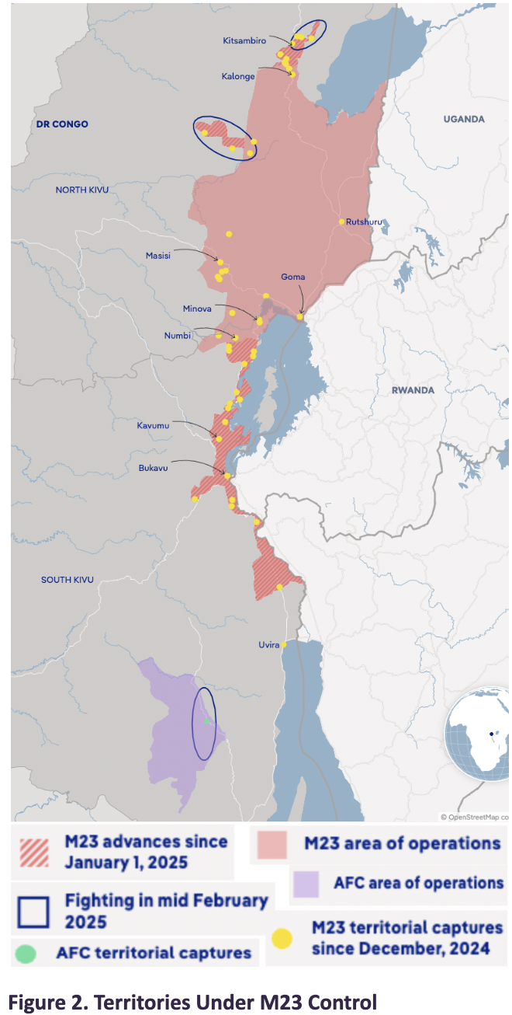

The humanitarian crisis of the DRC armed conflict has become a humanitarian emergency, under the definition and expertise of various humanitarian institutions. One of the most alarming characteristics of the conflict in the DRC is that there is not a single party that has not been in breach of international humanitarian law. It is concerning that even the people who are stationed in the region for ensuring security are being accused of violating locals. In the DRC sexual violence against both men and women, extrajudicial and summary executions, forced mass displacement of approximately a million people, inhumane detention conditions, and other restrictions on civil liberties have been on rapid rise since M23 reemerged in late 2021. Journalism is receiving violent censorship and threats, with journalists being accused of affiliation with military operations just for issuing regular reports. Explosive weapons are being indiscriminately detonated in civilian areas and civilians are deliberately being targeted in such operations. The occupiers have completely suspended any form of relocation activity or incoming aid from Lake Kivu, confining the civilians both physically and ideologically. This humanitarian crisis is extremely perilous as the number of victims produced are already so high, and the conflict is predicted to only get worse from this standpoint.11

**MAJOR COUNTRIES AND ORGANISATIONS INVOLVED**

**Armed Forces of the Republic of the Congo (FARDC)**

This is the state military organization, comprised of naval, air, and land forces, responsible for defending the DRC. The army’s primary focus right now is to resist the occupying M23 forces and prevent them from advancing further into the Congolese territory. Even though the FARDC is over 30 times the size of the M23 forces and their spendings have doubled to nearly $800 million, internal factors such as systemic corruption which prevents the proper allocation of these spendings, lacking troop morale and wellbeing, and outdated military logistics, technology, communication, and tactics are creating a gap between the army and the militias’ capabilities.

**Rwanda**

The Rwandan government identifies the FDLR as a “genocidal militia” who poses a great threat to their national security, even beyond the country’s borders, claiming that the armed group is scheming to exterminate the rest of the Tutsi people. The DRC, USA, UK, and France all claim that Rwanda is providing significant support to the M23, indirectly linking them to the escalation of the conflict and various human rights violations’ allegations in the DRC. According to MONUSCO’s intel and the obvious disproportion between M23’s size and damage, there is undeniable evidence that Rwanda is backing up the M23 fighters, with over 4000 soldiers. While the Rwandan government denies such involvement, it is said amongst UN experts that Rwanda holds a great deal of influence in the M23’s coordination. This form of support would be in breach of the peace deal that Rwanda and the DRC signed on 27 June this year.

**USA**

The USA has been a key body in brokering peace deals between the belligerents of the conflict and sanctioning the armed groups illicitly trading resources. Nevertheless, the most important development is the Congolese president Tshisekedi’s directly offering access to the DRC’s mineral reserves in exchange for military intervention. Accepting this offer would immerse the USA into another field of manufacturing, giving them a new advance in the USA-China trade wars. Additionally, it would give them a chance to neutralize the growing influence of the Russians and a share of the resources that Russia is predicted to break into the market of, in the near future.12-13

**Russia**

Since 2017, the Wagner Group, a Russian mercenary organization pursuing Russian military, political, and economic interests, has been in the African continent, in Sudan, CAR, Libya, and AES members. While the Russian Federation is calling for dialogue and the surrender of arms, with Russian diplomats stressing that the legacy of colonialism and the struggle to obtain natural riches being the core cause of the conflict, if the DRC does end up turning to the Russians for military aid, the heavy presence of the Wagner Group in surrounding countries guarantees that the response would be immediate.14

**France**

In February of this year, the permanent French representative in the UN stated that the French government condemns the offenses of the M23, urging the Rwandan forces to immediately stop their support of the militia. The French stance is highlighting the grave humanitarian situation, focusing on the incoming information regarding sexual violence, summary executions of children, and mass displacement. The French representative is voicing on behalf of their government the likelihood of this conflict becoming a full blown war, demanding a ceasefire and continuing their support for MONUSCO. The end of this conflict would be highly in their favor, as it would allow the French government to continue their affairs of developing their diplomatic and bilateral economic institutions and relations with the DRC.15

**China**

Since the beginning of the 21st century, China has been making major mineral investments under the radar throughout the African continent by means of state-owned enterprises (SOEs) and private corporations. The minerals and rare earth metals that the Chinese are bringing in, such as gold, lithium, cobalt, and copper are said to be directed into the Belt and Road Initiative by the government, particularly supplying the manufacturing of technological devices and batteries. While there does not seem to be enough of a political campaign to reinstate a colonial presence, the methods of extraction and financing of these minds raise valid suspicion. The local labourers who are employed are exploited, working under dangerous conditions with disproportionate compensation, alongside the environmental ramifications produced. China, adopting a mainly neutral position, is currently promoting disarmament and peace negotiations between the belligerent parties, emphasizing the necessity to align military actions with UN guidelines. However, China has an adamant stance regarding territorial integrity and sovereignty, and seeing as foreign invasions would stir up even more turmoil regarding the jurisdiction of said mines, the Chinese government is in support of the DRC.16

**March 23 Movement, 2009 (M23)**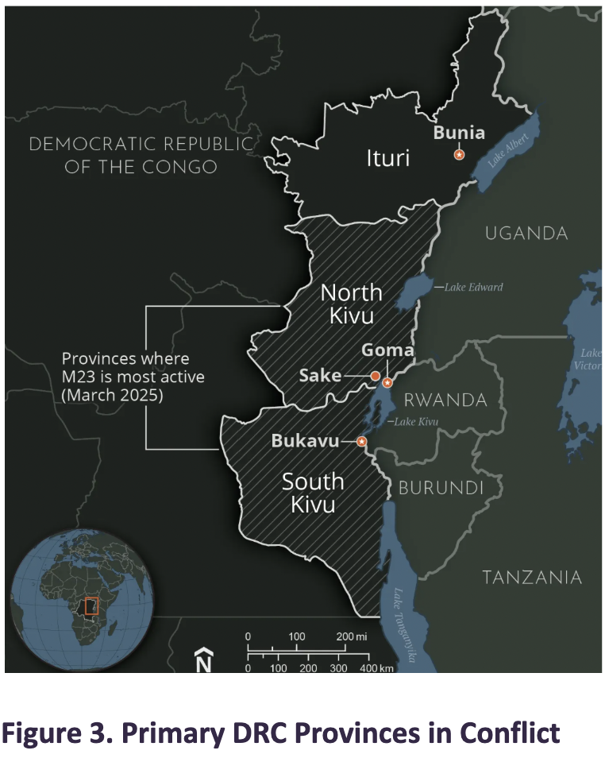

From 2006-2009 a rebel group of mainly Congolese Tutsis called the National Congress for the Defense of the People (CNDP) emerged to step up and protect the Tutsis from the FDLR in place of the supposedly unwilling FARDC. When the CNDP claimed that the DRC failed to honor and uphold the peace agreement they signed on March 23, 2009, the rebels rebranded into the M23. The M23 briefly invaded Goma in 2012, but their leaders were forced to flee to Rwanda and Uganda. In late 2021, though, Goma and other territories in the North Kivu province violently fell under the control of the rebels. They are currently clashing with the FARDC and being accused of extensive human rights violations. The M23 has a collage of demands, including establishing Tutsi representation in Congolese governance, neutralizing the FDLR and its allies, maintaining control over mineral reserves in North Kivu, and performing independent cross-border commerce.17

**Democratic Forces for the Liberation of Rwanda (FDLR)**

When the Tutsi regime in Rwanda flushed out the majority of ex-genociders, mainly those left from the Interahamwe militia who led the systemic violence and massacres of the Tutsi people, and Hutu people into the neighboring DRC, the Hutu refugees were accommodated in refugee camps, in which the fighters reassembled. After the partially revenge-driven and poorly regulated Rwandan forces intentionally attacked these refugee camps labeling them as security threats during the First Congo War, the Hutu fighters dispersed throughout the jungles of the DRC. While they were independently active, in 2000 they united to strengthen, forming the FDLR. Their purpose is to overthrow the current government of Rwanda and regain Hutu representation. They are currently clashing with the M23 just like the FARDC, but their military relationship is unclear. However, in September 2015 the organization’s president and vice-president were convicted for committing violations of international law, specifically for allegations of burning down several villages, attacking civilians, recruiting child soldiers, and committing sexual violence.18-19

**Mai-Mai**

In the eastern provinces of the DRC there are more than 130 factions of armed groups. The majority of them consist of 20-200 fighters and have clearly established goals they describe as self defence against foreigners. These local, community-based groups can migrate, do not have large capacities in terms of governing land, and have gained much support from Congolese patriots. However, in the post-war context, Mai-Mai groups received inadequate representation in the armies compared to other militias, causing them to remobilize and split in who they support. Their own conflict and ulterior motives of looting, banditry, and illicit mineral trading further complicate the question of stability in the DRC. Some examples are the ADF, CODECO, and FRPI who operate attacks mainly in the Ituri province, APCLS and Wazalendo who oppose the M23 - Tutsi influences, and Raïa Mutomboki who oppose Hutu factions in the Kivu provinces.20-21

**United Nations Organization Stabilization Mission in the DR Congo (MONUSCO)**

Created under the UNSC resolution 1279 on 30 November, 1999, the earlier version, MONUC, had a narrow observational mandate of overseeing the disengagement and withdrawal of the countries who signed the Lusaka Accord. The current MONUSCO, though, under UNSC resolution 2098 in 2013, has a very controversial operating offensive military unit called the Force Intervention Brigade (FIB), which allows for bigger contributions in the, what is now, fight to neutralize and disarm armed groups. The organization held the responsibility of protecting civilians from safety threats posed by all armed groups, helping the implementation of local DDR programs, supporting the strengthening of justice and human rights institutions, and aiding the Congolese government in reinstating their authority throughout the country. Unfortunately, not only did MONUC fail to carry out most of the terms of its mandate, MONUSCO receive extensive displeasure from Congolese authorities regarding their incompetent interventions in the conflict, but now some of its peacekeepers have been accused and detained for misconduct, specifically sexual violence against the locals, on more than one instances.22-23

**European Mercenaries > Asociatia RALF**

Mercenary fighters are soldiers from private military companies that are hired to serve alongside foreign militaries. Apart from the wide range of military services that contracted mercenaries can perform, they can also be financially more preferable in the face of understaffed, underfunded, and relatively unorganized national militaries, like in the case of the DRC. In the past, the employment of mercenaries proved complicated when the presence of white soldiers immediately following independence from Belgium tarnished the image of political leaders in the eyes of the public. More recently, multiple mercenary groups have been aiding the FARDC against the M23 movement in late 2022, one of them being Asociatia RALF, a predominantly Romanian company led by Horatiu Potra that was contracted with an initial duty of training the FARDC, later developed into direct engagement in combat and positions in defensive frontlines. Composed of Romanian veterans, this group has an active size of approximately 300 in the DRC. However, it is evident after the retreat of the Romanian mercenaries and the FARDC during the fall of Goma in January that the European mercenaries have ultimately just stirred up more chaos in the eastern DRC. Their ineffectiveness was stressed as M23 commanders accused captured Romanians of unjustly claiming drastic riches and getting mixed up in the ethnic conflict. Most of these Romanians, paid almost 50 times more than local soldiers, chose to come to the DRC for well-paying jobs, not to lay their lives down for a patriotic purpose. These differences in compensation and in objectives in combat between local and private militaries is still a risky fundamental issue of principles that influences the outcome of mercenary groups.

**BLOCS EXPECTED**

**Bloc A - aligned with the Rwandan Tutsi government & M23 movement : USA**

This block is adamant in linking all Hutu armed groups with the atrocities they committed in the Rwandan civil war. The goal here is to disarm them all, to eliminate the potential of terror and human abuses. Certain armed groups are being supplied.

**Bloc B - against foreign intervention & M23 movement : Russia, China, France, UK**25

This block is fighting against groups who are supported by non-Congolese parties. The goal here is to give the Congolese government the opportunity to defend themselves, threats to their sovereignty may jeopardize national security even further.

**TIMELINE OF EVENTS**

| **Date** | **Description of event** |
| --- | --- |
| June 30, 1960 | Congo Gains Independence from 80 Years of Belgian Colonial Rule |
| Apr-July 1994 | Rwandan Genocide |
| July 1994– | Hutu Militias Flee to Eastern DRC to Escape New Tutsi-led Gov. |
| 1996-2003 | First & Second Congo War |
| May 2012 | DRC Blames Rwanda for Rebel Support, UN Investigation Opened |
| Nov 2012 | Rebel Group CNDP Soldiers Become the M23 and Capture Goma |
| Nov 2021 | M23 Resurfaces |
| Jan 2025 | M23 Captures Goma, Blocks Travel & Aid |

**RELEVANT RESOLUTIONS, TREATIES AND EVENTS**

**Responsibility to Protect (R2P) - 2005 World Summit (**[**A/RES/60/1**](https://documents-dds-ny.un.org/doc/UNDOC/GEN/N05/487/60/pdf/N0548760.pdf?OpenElement)**)**

This principle of humanitarian law which redefines the protection of human rights as a core responsibility of governments was drafted mainly upon the Rwandan Genocide, during which no party was able to protect the Tutsis. It clearly draws a line that if a government is deemed unfit to protect a particular population from crimes against humanity, their sovereignty will be disregarded by international peacekeeping organizations and their allies to step in to protect said population. While in the past external actors have justified their interventions in the DRC in other ways, if the escalating tensions of the conflict lead countries such as the US to launch full-scale military interventions, then this term of the R2P may potentially be invoked as the legal basis of their presence in the DRC, in which case the already strained DRC sovereignty that Russia and China are striving to uphold will presumably crumble.

**Lusaka Ceasefire Agreement**

Marking the gradual end of the second Congo War, the Lusaka Peace Accord was the means by which the numerous African countries of Angola, Namibia, Rwanda, Uganda, and Zimbabwe were forced to withdraw their military participation on Congolese territory. It was a significant diplomatic achievement as it formally stopped the fighting, initiated the process of disarming armed groups, and ordered the creation and deployment of MONUC. However, its peacekeeping impacts did not prevail on a national scale, as the disarmament process was made even more difficult for the already weak government by external parties who allegedly supplied these groups.26-27

**PREVIOUS ATTEMPTS TO SOLVE THE ISSUE**

**February 24, 2000 UN Attempt 1: MONUC - OBSERVATIONAL MANDATE**

Following the Lusaka Agreement, MONUC’s mandate, distinguishing it from its succeeding mission, was that it was mainly observational, limiting their abilities to descalate the conflict and adequately support the local government from the beginning. Considering that the end of the Second Congo War was extremely complicated in terms of armed groups reorganizing, the main belligerents of the conflict recurrently refused the UN access to critical conflict zones, the mission was originally understaffed and underfunded, it was almost impossible for the mission to successfully ensure the withdrawal of foreign nations’ troops and the equal disarmament all rebels and militias.

**March 28, 2013 UN Attempt 2: MONUSCO - UN Force Intervention Brigade (FIB)**

MONUSCO’s goals were to protect civilians, become a means to peace talks, and help the local government in disarming all armed groups. With over 13000 personnel and a budget of over $1.1M, MONUSCO has failed to prevent the approximately 7000 casualties of the conflict that occurred since January alone. Ultimately, the inefficiency and ineffectiveness of this mission has caused the Congolese people to lose faith in the peacekeepers, leading former president Kabila and certain UN officials to demand the withdrawal of troops from the region.28-29

**POSSIBLE SOLUTIONS**

**UN Monitored DDR Peacekeeping Initiatives**

If peace talks prove as ineffective as previous UN missions, then the most urgent action will be to eliminate the physical threats that the rebels and militias hold: weapons and firepower. Whether or not MONUSCO could be authorized to carry such an operation is not guaranteed, but theoretically they definitely could be of assistance to the local governments in providing job training, mental health services, or housing assistance for the reintegration process. Yet, this alone does not ensure the safety of all civilians, as certain forms of vilence, like arson and rape, do not require fire power, meaning that the detention and reintegration sections of the solution must be reliable and structured. However, with the state of DRC authority, the competence of the government in carrying out these operations is questionable.

**Resource Allocation to Promote Inclusive Governance and Representation for All Ethnic Peoples**

As all of the armed groups have well distinguished motives of gaining representation or ensuring safety for the people of their own ethnicities, inclusive, responsible, and equitable governance can possibly allow peaceful coexistence in the future. Some forms of this initiative that foreign countries can contribute economically to show support are developing infrastructure with services and systems that do not segregate based on ethnic background and redistributing extracted mineral wealth proportionally among all regions, calculating the damage that certain communities have received. However, even if the ethnic tensions and discriminatory practices within Rwanda were subdued enough for this solution to be implemented, it would not account for the violence the ongoing in the DRC grounds. Additionally, in the alliance of the status quo, it does not seem likely enough that governmental politics could be isolated from the belligerents of the conflict for this governmental reform to take place.

**Preserve Displacement Routes and Hubs for Refugees**

In the quite possible case where the conflict only intensifies further, a focused strategy of evacuating the civilians from the fighting zones is crucial. Mobilizing MONUSCO to guide and guard clear corridors for humanitarian relief and civilian relocation is necessary as to not allow any food security, shelter, or healthcare scandals among the refugees, in which case local NGOs and refugee camps must also be alerted and conditioned to support peacekeepers.

**BIBLIOGRAPHY**

**Works Cited :**

ADONGO HOLDA, Sabrina. *Democratic Forces for the Liberation of Rwanda (FDLR): A Profile of This Rebel Group*. 2023, p. 88, [is.muni.cz/th/f1nza/DEMOCRATIC_FORCES_FOR_THE_LIBERATION_OF_RWANDA_FINAL.pdf](http://is.muni.cz/th/f1nza/DEMOCRATIC_FORCES_FOR_THE_LIBERATION_OF_RWANDA_FINAL.pdf).

Amnesty International. “Democratic Republic of the Congo 2020 Archives.” *Amnesty International*, 2022, [www.amnesty.org/en/location/africa/east-africa-the-horn-and-great-lakes/democratic-republic-of-the-congo/report-democratic-republic-of-the-congo/](http://www.amnesty.org/en/location/africa/east-africa-the-horn-and-great-lakes/democratic-republic-of-the-congo/report-democratic-republic-of-the-congo/).

Bartos, Haleigh, and John Chin. “The Congo’s Fork in the Road: If the West Won’t Intervene, Russia Will.” *Modern War Institute -*, Modern War Institute, 26 Feb. 2025, [mwi.westpoint.edu/the-congos-fork-in-the-road-if-the-west-wont-intervene-russia-will/](http://mwi.westpoint.edu/the-congos-fork-in-the-road-if-the-west-wont-intervene-russia-will/).

Braeckman, Colette. “Belgium’s Role in Rwandan Genocide.” *Le Monde Diplomatique*, 1 June 2021, [mondediplo.com/2021/06/11rwanda](http://mondediplo.com/2021/06/11rwanda).

“Ceasefire Agreement (Lusaka Agreement) | UN Peacemaker.” *Un.org*, 11 July 1999, [peacemaker.un.org/en/node/9615](http://peacemaker.un.org/en/node/9615).

Council on Foreign Relations. “Eastern Congo: A Legacy of Intervention.” *Council on Foreign Relations*, 2025, [www.cfr.org/timeline/eastern-congo-legacy-intervention](http://www.cfr.org/timeline/eastern-congo-legacy-intervention).

“Democratic Republic of the Congo’s Mineral Resources | EBSCO.” *EBSCO Information Services, Inc. | Www.ebsco.com*, 2024, [www.ebsco.com/research-starters/mining-and-mineral-resources/democratic-republic-congos-mineral-resources](http://www.ebsco.com/research-starters/mining-and-mineral-resources/democratic-republic-congos-mineral-resources).

“DR Congo: M23 Rebels Committing War Crimes.” *Human Rights Watch*, 11 Sept. 2012, [www.hrw.org/news/2012/09/11/dr-congo-m23-rebels-committing-war-crimes](http://www.hrw.org/news/2012/09/11/dr-congo-m23-rebels-committing-war-crimes).

“DRC: Who Are the Raïa Mutomboki? – Rift Valley Institute.” *Riftvalley.net*, 22 June 2018, [riftvalley.net/news/great-lakes/drc-who-are-raia-mutomboki/](http://riftvalley.net/news/great-lakes/drc-who-are-raia-mutomboki/).

“First Congo War 1996-1997 | EBSCO.” *EBSCO Information Services, Inc. | Www.ebsco.com*, 2021, [www.ebsco.com/research-starters/history/first-congo-war-1996-1997](http://www.ebsco.com/research-starters/history/first-congo-war-1996-1997).

“France Deplores M23 Attacks and Reaffirms Its Support for MONUSCO.” *France ONU*, 2025, [onu.delegfrance.org/france-deplores-m23-attacks-and-reaffirms-its-support-for-monusco](http://onu.delegfrance.org/france-deplores-m23-attacks-and-reaffirms-its-support-for-monusco).

“In the Great Lakes Region, Lasting Peace Remains Elusive between Armed Groups with International Ties.” *ACLED*, 27 Sept. 2024, [acleddata.com/report/great-lakes-region-lasting-peace-remains-elusive-between-armed-groups-international-ties](http://acleddata.com/report/great-lakes-region-lasting-peace-remains-elusive-between-armed-groups-international-ties).

Karr, Liam, and Yale Ford. “Institute for the Study of War.” *Institute for the Study of War*, 2025, [www.understandingwar.org/backgrounder/africa-file-special-edition-m23-march-threatens-expanded-conflict-dr-congo-and-regional](http://www.understandingwar.org/backgrounder/africa-file-special-edition-m23-march-threatens-expanded-conflict-dr-congo-and-regional).

Kinshasa, U. S. Embassy. “U.S. Engagement in the DRC.” *U.S. Embassy in the Democratic Republic of the Congo*, 4 Mar. 2024, [cd.usembassy.gov/us-engagement-in-the-drc/](http://cd.usembassy.gov/us-engagement-in-the-drc/).

Maron, Jeremy. “What Led to the Genocide against the Tutsi in Rwanda?” *Canadian Museum for Human Rights*, 26 June 2019, [humanrights.ca/story/what-led-genocide-against-tutsi-rwanda](http://humanrights.ca/story/what-led-genocide-against-tutsi-rwanda).

Morgan, Azaria. “Rethinking Rebel Rule: How Mai-Mai Groups in Eastern Congo Govern.” *Conflict Research Programme Blog*, 3 Oct. 2018, [blogs.lse.ac.uk/crp/2018/10/03/mai-mai-groups-in-eastern-congo/](http://blogs.lse.ac.uk/crp/2018/10/03/mai-mai-groups-in-eastern-congo/).

Office, Development. “UK Statement on Response to the Situation in Eastern DRC.” *GOV.UK*, 25 Feb. 2025, [www.gov.uk/government/news/uk-statement-on-response-to-the-situation-in-eastern-drc](http://www.gov.uk/government/news/uk-statement-on-response-to-the-situation-in-eastern-drc).

“Protection of Civilians and Protection Tools.” *MONUSCO*, 22 Feb. 2016, [monusco.unmissions.org/en/protection-civilians-and-protection-tools](http://monusco.unmissions.org/en/protection-civilians-and-protection-tools).

Rolley, Sonia, and Fiston Mahamba. “Eight UN Peacekeepers Detained in Congo over Sexual Abuse Claims, Sources Say.” *Reuters*, 13 Oct. 2023, [www.reuters.com/world/africa/un-suspends-some-peacekeepers-congo-denounces-sexual-abuse-2023-10-12/](http://www.reuters.com/world/africa/un-suspends-some-peacekeepers-congo-denounces-sexual-abuse-2023-10-12/).

Schoonover, Nathan. “China in Africa: March 2025.” *Council on Foreign Relations*, 28 May 2025, [www.cfr.org/article/china-africa-march-2025](http://www.cfr.org/article/china-africa-march-2025).

Sheposh, Richard. “Scramble for Africa | EBSCO.” *EBSCO Information Services, Inc. | Www.ebsco.com*, 2023, [www.ebsco.com/research-starters/history/scramble-africa](http://www.ebsco.com/research-starters/history/scramble-africa).

Staff, SWJ. “MONUSCO’s Force Intervention Brigade: A Blueprint for Success or a Recipe for Failure? | Small Wars Journal by Arizona State University.” *Small Wars Journal by Arizona State University*, 20 Oct. 2023, [smallwarsjournal.com/2023/10/20/monuscos-force-intervention-brigade-blueprint-success-or-recipe-failure/](http://smallwarsjournal.com/2023/10/20/monuscos-force-intervention-brigade-blueprint-success-or-recipe-failure/).

“THE WAR within the WAR.” [*Www.hrw.org*](http://www.hrw.org), [www.hrw.org/reports/2002/drc/Congo0602-03.htm](http://www.hrw.org/reports/2002/drc/Congo0602-03.htm).

United Nations. “About the Responsibility to Protect | United Nations.” *United Nations*, United Nations, 2005, [www.un.org/en/genocide-prevention/responsibility-protect/about](http://www.un.org/en/genocide-prevention/responsibility-protect/about).

---. “Disarmament, Demobilization and Reintegration.” *United Nations Peacekeeping*, United Nations, 2017, [peacekeeping.un.org/en/disarmament-demobilization-and-reintegration](http://peacekeeping.un.org/en/disarmament-demobilization-and-reintegration).

“US Sanctions DR Congo Armed Group over Illicit Mining, Ceasefire Tested.” *Al Jazeera*, 12 Aug. 2025, [www.aljazeera.com/news/2025/8/12/us-sanctions-dr-congo-armed-group-over-illicit-mining-ceasefire-tested](http://www.aljazeera.com/news/2025/8/12/us-sanctions-dr-congo-armed-group-over-illicit-mining-ceasefire-tested).

Wafula, Ian. “DR Congo Fighting: The Evidence That Shows Rwanda Is Backing M23 Rebels.” *BBC*, 29 Jan. 2025, [www.bbc.com/news/articles/ckgyzl1mlkvo](http://www.bbc.com/news/articles/ckgyzl1mlkvo).

---. “DR Congo’s Failed Gamble on Romanian Mercenaries.” *BBC*, 31 Jan. 2025, [www.bbc.com/news/articles/c9d591ldq46o](http://www.bbc.com/news/articles/c9d591ldq46o).

*Icrc.org*, 2025, [ihl-databases.icrc.org/en/national-practice/fdlr-leaders-case](http://ihl-databases.icrc.org/en/national-practice/fdlr-leaders-case).

**List of Figures :**

Fischer, Nikolas. “Why DR Congo’s Army Struggles against the Smaller M23.” *Dw.com*, Deutsche Welle, 13 Mar. 2025, [www.dw.com/en/why-dr-congos-army-struggles-against-the-smaller-m23/a-71898011](http://www.dw.com/en/why-dr-congos-army-struggles-against-the-smaller-m23/a-71898011).

Karr, Liam, and Yale Ford. “Institute for the Study of War.” *Institute for the Study of War*, 2025, [www.understandingwar.org/backgrounder/africa-file-special-edition-m23-march-threatens-expanded-conflict-dr-congo-and-regional](http://www.understandingwar.org/backgrounder/africa-file-special-edition-m23-march-threatens-expanded-conflict-dr-congo-and-regional).

McKenna, Amy. “March 23 Movement | Leader, Funding, Rebels, AFC, & Congo.” *Encyclopedia Britannica*, 6 Feb. 2025, [www.britannica.com/topic/March-23-Movement](http://www.britannica.com/topic/March-23-Movement).