**Committee:** Disarmament and International Security (GA1)

**Issue:** Preventing the Recruitment of Ethnic Minorities in Armed Conflicts and Insurgent Groups

**Student Officer:** Nikolaos-Argyrios Tsikopoulos

**Position:** Co-Chair

**PERSONAL INTRODUCTION**

Dear delegates, International Security Committee (GA1) during the 8th DSTMUN.

At the conference you will debate, collaborate and come up with solutions to real world problems, alongside your fellow delegates. During the conference, you need to be informed about the topic and prepared to handle the discussions/disputes/debates which may occur. For your preparation, you should work closely with the study guides. However, you are also encouraged to conduct your own, independent research.

The first topic of this committee refers to the Prevention of the Recruitment of Ethnic Minorities in Armed Conflicts and Insurgent Groups. In this study guide you will find all required information to participate successfully in the conference. Yet, as mentioned earlier, it is strongly recommended to conduct your independent research, for it will prove to be advantageous. You might start from overlooking autonomously the given sources given in the bibliography, located at the end of this document.

If any complications regarding your preparation, or the conference itself, arise,

My name is Nikolaos-Argyrios Tsikopoulos, I am a student in the German School of Thessaloniki. At the time of the conference I will be attending the 12th grade. It is an honour for me to serve as one of the Co-Chairs of the Disarmament and do not hesitate to reach out to me through my personal email : [n.tsikopoulos@gmx.de](mailto:n.tsikopoulos@gmx.de).   
  
I am eager to meet and work with all of you. Have fun preparing!

Sincerely,

Nikolaos-Argyrios Tsikopoulos

**TOPIC INTRODUCTION** [1]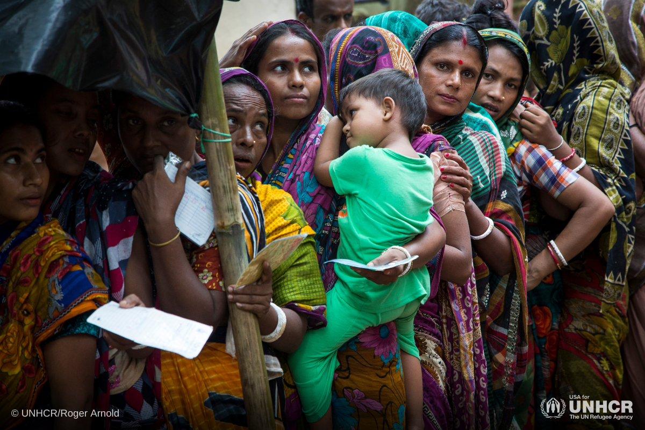

Across the globe ethnic minorities are dragged into armed conflicts against their will. Predatory regimes or armed resistance groups achieve this through means such as legal threats, physical threats, arrests, abductions, propaganda and coercion. The extent of this troubling phenomenon is cross-continental. According to the Minorities At Risk project (MAR)[2] over 60% out of approximately 300 politically active minority groups have faced targeted and strategic recruitment or other forms of marginalisation. Documented cases range from the favelas of Colombia where indigenous youth find themselves forced to enlist in guerillas or other gangs[3], to the civil war in Congo where militias, often backed by large governments, attack small ethnic minority communities and forcibly recruit vulnerable members of these communities[4], such as children, to the Ukrainian war where Russia conscripts rural, Siberian, Mongolian and Caucasian ethnic minorities into active war zones[5].

As a result these communities are left drained, vulnerable and destabilised both economically and politically. Most importantly they are exposed to repeated cycles of abuse and marginalization.

Countries and armed resistance groups engage in minority recruitment for a plethora of reasons. Their motives include nationalist beliefs which shield the majority population from the dangers of warfare, or even in pursuit of ethnic cleansing, avoiding domestic unrest (avoiding the recruitment from densely populated urban areas, where the losses would be more apparent, fearing the uprisings and resistance from the people and instead preferring rural communities with limited means of resistance) and the need for soldiers (attempting to substitute casualties by conscripting populations).

The dynamics of recruitment differ by context. It is noteworthy that in Western armies, the quota of minority enlistments has been increasing. This is not because of any of the aforementioned reasons, but rather because their traditional recruitment populations (i.e., white, rural, male) have diminished.[6] Furthermore ethnic minority populations often join insurgencies because of fear towards a predatory government, in an attempt to find local governance or to gain status, e.g. Democratic Republic of Congo, young men joining Mai-Mai groups for status and protection.[7] Assuredly there are also cases of ethnic minorities joining willingly, because of ethnic and ideological bonds to an insurgency group.[8]

The issue may not be examined solely through the lens of conflict involvement. Instead, it needs to be understood as a component of a broader context of political exclusion, socio-economic vulnerability, and historical exploitation. Tackling this problem, therefore, requires a multi-dimensional response incorporating prevention, protection, and accountability, thus ensuring that ethnic minorities are no longer disproportionately used as tools of war.

**DEFINITION OF KEY TERMS**

**Conscription**

The term “conscription” can be defined as the compulsory enrollment for service in a country’s armed forces.**[9]**

**Recruitment**

“the [process](https://dictionary.cambridge.org/de/worterbuch/englisch/process) of [employing](https://dictionary.cambridge.org/de/worterbuch/englisch/employ) new [people](https://dictionary.cambridge.org/de/worterbuch/englisch/people) to [work](https://dictionary.cambridge.org/de/worterbuch/englisch/work) for a [company](https://dictionary.cambridge.org/de/worterbuch/englisch/company) or [organization](https://dictionary.cambridge.org/de/worterbuch/englisch/organization)”[10]

**Insurgency**

“A term historically restricted to rebellious acts that did not reach the proportions of an organized revolution. It has subsequently been applied to any such armed uprising, typically guerrilla in character, against the recognized government of a state or country”. **[11]**

**Insurgent Groups**

Armed organizations that challenge established governments through the use of force, often using guerrilla tactics and aiming to gain control over territory or political power.

**Independent Militias**

“a private group of armed individuals that operates as a paramilitary force and is typically motivated by a political or religious ideology”[12]

**Ethnic Armed Organisations (EAOs)**

An insurgent group composed by and carrying the character of a specific ethnic group**[13]**

**Guerilla warfare**

“type of warfare fought by irregulars in fast-moving, small-scale actions against orthodox military and police forces”**[14]**

**Urban warfare**

Urban warfare refers to combat occurring in a built environment of some significant size. It is sometimes referred to as Military Operations on Urbanized Terrain (MOUT) or as Fighting in Built Up Areas (FIBUA).**[15]**

**Nationalism**

Nationalism refers to an [ideology](https://www.britannica.com/topic/ideology-society) largely based on the [premise that](https://www.merriam-webster.com/dictionary/premise) the individual’s loyalty and devotion to the [nation-state](https://www.britannica.com/topic/nation-state) surpass other individual or group interests.[16]

**Grave offense**

In 1999, the first resolution on children and armed conflict adopted by the United Nations Security Council placed the issue of children affected by war on the Council’s agenda. The resolution also identified and condemned six grave violations affecting children the most in times of war and asked the Secretary-General to report on the issue. The six grave violations being: recruit, kill or maim children, commit sexual violence, abduct children and attack schools and hospitals**[17]**

**Displacement**

**“**when [people](https://dictionary.cambridge.org/de/worterbuch/englisch/people) are [forced](https://dictionary.cambridge.org/de/worterbuch/englisch/forced) to [leave](https://dictionary.cambridge.org/de/worterbuch/englisch/leave) the [place](https://dictionary.cambridge.org/de/worterbuch/englisch/place) where they [normally](https://dictionary.cambridge.org/de/worterbuch/englisch/normally) [live](https://dictionary.cambridge.org/de/worterbuch/englisch/live)”[18]

**Internally Displaced People(IDPs)**

“Internally displaced people (IDPs) have been forced to flee their homes by conflict, violence, persecution or disasters. However, unlike refugees, they remain within their own country.”**[19]**

**Marginalisation**

“Marginalisation refers to the process by which certain people or groups are excluded from meaningful participation in social, economic, political, and cultural life. These groups are often denied access to power and decision-making, leading to systemic disadvantage and inequality.”[20]

**Ethnic minorities**

“a [particular](https://dictionary.cambridge.org/dictionary/english/particular) [ethnic](https://dictionary.cambridge.org/dictionary/english/ethnic) [group](https://dictionary.cambridge.org/dictionary/english/group) (= a [group](https://dictionary.cambridge.org/dictionary/english/group) of [people](https://dictionary.cambridge.org/dictionary/english/people) with a [shared](https://dictionary.cambridge.org/dictionary/english/shared) [culture](https://dictionary.cambridge.org/dictionary/english/culture), [tradition](https://dictionary.cambridge.org/dictionary/english/tradition), [language](https://dictionary.cambridge.org/dictionary/english/language), [history](https://dictionary.cambridge.org/dictionary/english/history), etc.) [living](https://dictionary.cambridge.org/dictionary/english/living) in a [country](https://dictionary.cambridge.org/dictionary/english/country) where most [people](https://dictionary.cambridge.org/dictionary/english/people) are from a different [ethnic](https://dictionary.cambridge.org/dictionary/english/ethnic) [group](https://dictionary.cambridge.org/dictionary/english/group)”[21]

**BACKGROUND INFORMATION**

**Ancient and medieval foundations[22]**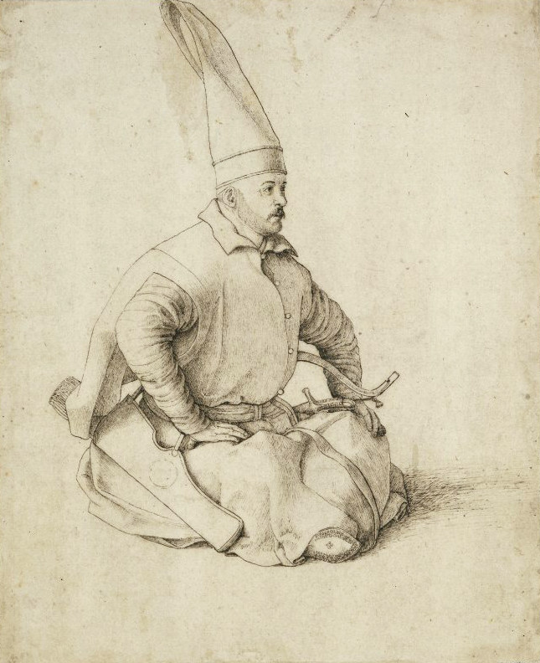

Even before colonial empires were established, rulers relied on minority or foreign groups in their military to maintain loyalty and suppress rivals. The Roman Empire is famously noted for using subjugated populations as auxiliaries, while Medieval Islamic Caliphates utilised systems of enslaved soldiers such as the Mamluks and the Janissaries. These systems often rested on the logic that soldiers drawn from foreign or marginalised groups could be more dependable than majority populations with competing political stakes and enough power to pose a threat in the event of an uprising. For instance the Janissaries, which were Christian youths taken through an Ottoman system of forced recruitment known as Devshirme Levy[23], were rigorously trained as elite and incorporated in the Ottoman armed forces as elite infantry. The janissaries served as a disciplined and politically insulated force whose sole loyalty was to the sultan.

**[24]Colonial/early post-colonial expansion**

Throughout modern history, ethnic minorities have frequently been disproportionately involved in armed conflicts whether as targets of recruitment or as strategic participants. During colonial and post-colonial periods, state and non-state actors often exploited ethnic divisions to consolidate power. Colonial powers such as Britain and France, for instance, selectively recruited minority groups into their military forces, including the Gurkhas in South Asia and the Tutsis in Central Africa. The British also developed the so-called “martial races” theory in India, privileging communities like the Sikhs and Pathans for army service, which not only entrenched ethnic hierarchies but also tied military identity to broader structures of colonial governance .

**The imprint on post-colonial states**

These practices persisted after independence, with many post-colonial states inheriting or perpetuating militarized ethnic divisions. In countries like Sudan and Myanmar,**[25]** minority groups were often drawn into conflicts, either in self-defense against systemic marginalization or as instruments in broader civil or ethnic struggles. These historical patterns continue to shape conflicts today.

**Voluntary, forced and coerced recruitment**

On the topic of recruitment in armed conflicts, these are the three most relevant and prevalent categories of recruitment.

**Voluntary**

It is often the case that members of an ethnic minority join armed conflicts or insurgencies willingly because of personal motivations. Examples often include perceived injustice, social exclusion or ethnic solidarity. An example are the Kurdish minorities in Turkey and Iraq**[26]**, where civilians join armed groups such as the Kurdistan Workers Party (PKK) to assert cultural rights and autonomy. Similarly, in Iraq, civilians belonging to ethnic minorities align with militias for political leverage hoping to gain influence or control over important decisions regarding their communities.

**Forced**

When talking about forced recruitment, examples stretch from governmental executive orders to abductions, threats and violence. In Myanmar for instance,**[27]** the Myanmar National Democratic Alliance Army (MNDAA) and other groups have forcibly conscripted ethnic minorities like the Shan and the Rohingya, particularly from internally displaced camps. In some cases, parents are coerced to surrender their own children to militias out of fear.

**Coerced**

Coerced recruitment occupies a middle ground between voluntary and forced enlistment. Ethnic minority youth may join armed groups out of necessity whether for protection, survival, or a sense of retribution. In the Democratic Republic of Congo (DRC), for example, Mai-Mai militias recruit young men by framing their cause as a defense against state forces or rival communities.**[28]**

**Socioeconomic and political drivers**

The sunken socioeconomic position in which ethnic minorities find themselves results in feelings of weakness, anger and a desire for retaliation. Combined with a number of disadvantageous political drivers, armed actors are enabled to easily exploit grievances. Leading causes for grievances include lack of security, discrimination, political exclusion and economic deprivation. Thus militaries turn vulnerability for recruitment.

**Economic deprivation**

High unemployment rates, restricted access to land, public services, education, and a lack of viable livelihood opportunities create fragility among minority groups. Insurgent groups are easily able to exploit this vulnerability by offering economic incentives, provisions and economic security.

**Security vacuums**

Security vacuums fuel the issue, adding increased pressure to recruit. Due to the weak or predatory character of the state, ethnic populations are exposed to a variety of threats and dangers. Therefore, communities resort to local armed actors in search of safety and protection. With the passing of time communities build up reliance on the actors, which is then abused to prolong and scale the recruiting processes.

**Political exclusion and discrimination**

More often than not ethnic minorities are underrepresented in political institutions, face systemic discrimination in law and practice and have low trust in governments. This can lead to grievances that armed groups exploit and use as a justification for recruitment, positioning themselves as defenders and political representatives of the communities.

**Social factors**

Stigmatisation and displacement may make recruitment into armed groups socially acceptable or even customary as a means of empowerment and vengeance. The lack of institutional protective bodies and leadership, eliminates any obstacle which may have occurred, thus facilitating membership even more.

**Deliberate targeting**

Lastly, intentional recruitment is prevalent. Insurgencies deliberately target minorities, because of the mentioned limitations and troubles of the communities. Lacking visibility to authorities, having limited economic prospects and self protection capabilities, and their pursuit of status, protection and revenge. Armed groups strategically exploit every single one of their weak points. Attempting various coercion methods, systematically abducting the vulnerable, even using social media platforms to promote, glamourise themselves, and groom susceptible individuals.

**Child recruitment among minorities**

**Scale[29]**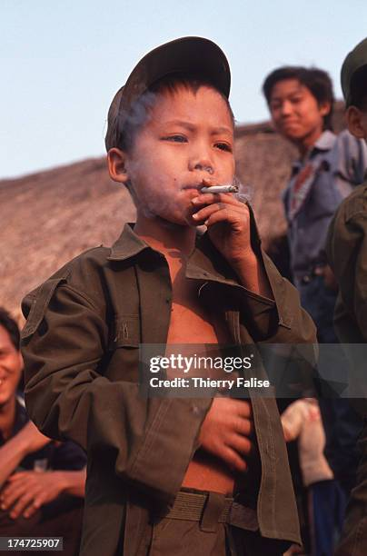

This problem continues to be substantial. According to UN reports, thousands of children are active in conflicts and are being recruited every year. To be precise, according to the Secretary-General Annual Report on Children and Armed Conflict „The United Nations verified 32,990 grave violations in 2023 […] following the recruitment and use of 8,655 children“.[30] Apart from the obvious combat positions, children are also utilised in support roles and even subjected to sexual exploitation.

**Traditional recruitment methods**

Traditionally, the recruitment of vulnerable populations into armed groups has taken multiple forms, ranging from outright abduction and forced conscription to more subtle forms of coercion. In many cases, children and adults alike were seized during raids, detained at checkpoints, or taken from their communities against their will, leaving them no opportunity to resist. Forced recruitment was often accompanied by violence, threats to families, or the destruction of homes and livelihoods, making refusal impossible.

In other instances, armed actors relied on inducements rather than brute force, offering food, basic shelter, or the promise of protection in conflict zones. Such incentives, though framed as “choices,” must be understood within the context of extreme deprivation. In environments where hunger, insecurity, and poverty dominate daily life, the line between voluntary and coerced enlistment becomes blurred. Individuals may appear to join willingly, but their decision is shaped by the absence of real alternatives for survival.

This dynamic is particularly stark for children from impoverished backgrounds. Lacking access to education, employment opportunities, or stable family support, many children become easy targets for recruitment strategies. They may be enticed by the prospect of belonging to a group, gaining status, or receiving minimal sustenance, yet in reality, their participation is a direct outcome of structural inequalities and systemic neglect. Thus, so-called “voluntary enlistment” often masks the underlying coercion of poverty, social exclusion, and insecurity.

**Gender**

Recruitments are not determined by gender. Female children are just as susceptible to falling victim as their male counterparts. They are also enlisted to combat, but mostly get sexually exploited. This is the case both for sex work/sexual slavery and forced marriages.

**Modernised recruitment methods**

As mentioned, recruiters utilize online platforms to increase their reach. Amongst children this method is exceptionally successful. They use grooming methods and advertise the pros of joining an armed group with incentives including monetary, food, protection, heroism.

**Resulting trauma**

With new recruitment methods emerging, their reach among children has drastically increased. The number of children, who fall victim, rises drastically. The consequences as expected are dire. Educational loss, social isolation and severe trauma are just the surface of the damage caused.

**MAJOR COUNTRIES AND ORGANISATIONS INVOLVED**

**Myanmar**

The recruitment of ethnic minorities in Myanmar is very prevalent. Just last year in February of 2024, the Junta government announced state conscription. According to the authorities the conscription laws would go into effect for all citizens of Myanmar around April 2024. Despite that, Rohingya people faced cruel conscription methods only weeks after the announcement without even being citizens of Myanmar. Not only were they not citizens but they have long been denied citizenship under the 1982 Citizenship Law.

The extent of minority exploitation in Myanmar goes so far that even EAOs, which typically consist of ethnic minorities themselves, also abuse ethnic minority populations (often of shared ethnicity). In regions such as the Rakhine state, Rohingya ethnics face recruitment pressure from both the Junta and the armed resistances. In some cases the recruitments even cross the borders, particularly from refugee camps in Bangladesh. [31]

**Russia**

Ever since the beginning of the Russo-Ukrainian war, the Russian state has disproportionately mobilized civilians of ethnic minority background for military service. Affected are primarily ethnic minorities like the Buryats, Tuvans, Kalmyks as well as indigenous peoples in regions such as Siberia and Caucasus. Other non-slavic populations are also endangered to a lesser extent. The disproportionate recruitment is paired with above average combat death rates. The elevated recruitment and death rates take their toll on the communities. The mentioned communities happen to be some of the poorest and most underprivileged in the country. Due to their circumstances, they face the most long-lasting and potentially devastating consequences.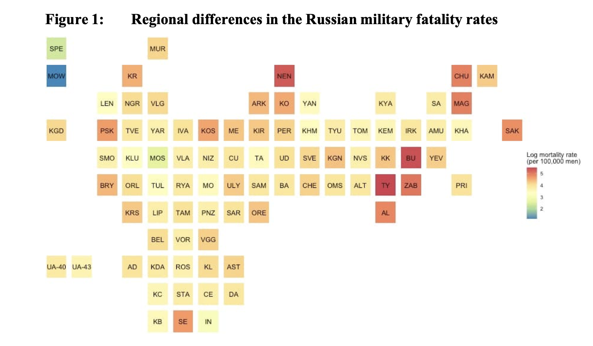**[32]**

**Sudan**

Since the beginning of the civil war in Sudan between the Sudanese Armed Forces (SAF) and the Rapid Support Forces (RSF) -The SAF being a governmentally aligned military organisation and the RSF being a rebellious insurgency- 30.4 million people have been left in need of assistance[33] including food, health, WASH and protection. Out of the 30.4 registered people left vulnerable, at least 16.6 million are minors. That means over 51% of the affected people are underage. From the beginning of the conflict (15 April 2023) to July 2025, 7.66 million people have been internally displaced. Adding to the 2.39 million people displaced internally prior to April 2023, leading to a total of approximately 10 million IDPs. [34] As the extent and impact of the conflict might suggest, minorities have faced a number of complications. Among them mass recruitment. The recruitment campaigns alone pose a threat to the existence of multiple underprivileged ethnic minorities.

**United Nations International Children's Emergency Fund (UNICEF)**

UNICEF counteracts ethnic minority recruitment into armed conflict and insurgencies by responding to disparities and vulnerabilities that put them at risk of exploitation. Through educational interventions, social inclusion, poverty reduction, and protection of rights, UNICEF allows marginalised ethnic groups to access opportunities that reduce the appeal or coercion of armed movements. It also supports governments in implementing anti-discrimination and exclusion policies to ensure minority groups are not disproportionately targeted or swept into cycles of violence, but instead empowered to participate in peaceful and sustainable development. International monitoring and reporting mechanisms, such as the UN-led Monitoring and Reporting Mechanism (MRM) on grave violations, that track and react to recruitment trends and abuses against vulnerable populations are also enabled by UNICEF.

**Human Rights Watch (HRW)**

Human Rights Watch works to prevent the recruitment of minority ethnic groups into insurgencies and armed fighting by investigating and exposing abuse against these marginalised groups. Working with extensive fieldwork, interviews, and documentation, HRW brings to light discriminatory patterns, forced recruitment, and coercion that encourage governments and military forces to end these. Its activism protects global awareness and accountability, promoting reforms to prevent minority groups from being recruited into war. HRW also has strong monitoring and reporting mechanisms, releasing regular findings that record abuses and track trends in recruitment, creating constant global scrutiny and pressure for change.

**International Committee of the Red Cross (ICRC)**

The International Committee of the Red Cross encourages the prevention of ethnic minorities' recruitment into insurgencies and armed conflicts through the blending of humanitarian intervention with protection. As a mediator, the ICRC provides required assistance, such as food, health, and water, to vulnerable conflict communities, lessening vulnerability that is likely to drive minorities into recruitment. At the same time, it promotes adherence to strict rules of international humanitarian law (IHL), which forbids forced or coercive conscription, and quietly negotiates with governments and non-state armed groups for adherence. Through its quiet monitoring and confidential reporting mechanisms, the ICRC documents violations and uses low-key pressure tactics to protect vulnerable populations without losing access to persons in need.

**BLOCS EXPECTED**

**Bloc 1 :** Germany, Canada, NGOs, etc.

Firmly condemning the targeted or even forced recruitment of ethnic minorities in armed conflicts, urging change, proposing monitoring.

**Bloc 2 :** Russia, Myanmar, Congo, etc.

Denying or downplaying the issue, prioritising sovereignty, denying monitoring.

**TIMELINE OF EVENTS**

| **Date** | **Description of event** |
| --- | --- |
| 1948 | Adoption of the Universal Declaration of Human Rights, affirming equality and protection against discrimination |
| 1966 | Adoption of the International Covenant on Civil and Political Rights (ICCPR), protecting minority rights |
| 1992 | UN Declaration on the Rights of Persons Belonging to National or Ethnic, Religious and Linguistic Minorities |
| 2003 | Darfur conflict (Sudan): ethnic minorities such as the Fur, Masalit, and Zaghawa face forced recruitment by Janjaweed militias and government-aligned forces[35] |
| 2007 | Myanmar begins recruiting child soldiers from ethnic minority groups, publicly reported |
| 2014 | Launch of the “Children Not Soldiers” campaign by UN |
| 2021 | Repeated rise in violence leads to mass forced recruitments in Myanmar |

**RELEVANT RESOLUTIONS, TREATIES AND EVENTS**

**UN General Assembly Resolution 217 A (Universal Declaration of Human Rights, 1948)**

This foundational resolution affirms the right to life, liberty, and security of a person, as well as protection against discrimination. Its principles are relevant because the systematic denial of rights and discrimination against ethnic minorities often create the grievances that armed groups exploit during recruitment.

**International Covenant on Civil and Political Rights (ICCPR, 1966)**

The ICCPR protects freedoms such as expression, assembly, and association while explicitly prohibiting discrimination based on race, ethnicity, or religion.

**Rome Statute of the International Criminal Court (1998)**

The Rome Statute criminalizes acts such as persecution based on ethnicity and the use of civilians in armed conflicts.

**UN Human Rights Council Resolutions on Myanmar**

These resolutions highlight how ethnic minorities, particularly the Rohingya and others, face institutionalised violence and discrimination that leaves them vulnerable to recruitment by armed forces. The Myanmar example highlights the need for international monitoring and pressure as a way of averting a pattern of marginalisation and insurgency.

**UN Special Rapporteur on Minority Issues (since 2005)**

The Special Rapporteur gives detailed reporting on instances where minorities are excluded, victimised, or discriminated against. These reports are usually descriptive of patterns likely to result in armed group recruitment, and thus the mandate is crucial for early warning and policy advice to forestall escalation.

**UN Forum on Minority Issues – Annual Sessions (since 2008)**

The Forum creates a platform for dialogue on the rights of minorities, including their protection from violence and conflict. By promoting inclusion, participation, and state accountability, the Forum directly addresses the structural inequalities that often drive ethnic minorities toward insurgent movements.

**PREVIOUS ATTEMPTS TO SOLVE THE ISSUE**

**Disarmament Demobilisation and Reintegration**

Αmong the strongest meαsures initiated by the international community to address the issue of recruitment of ethnic minorities and children into armed conflicts has been the adoption of Disarmament, Demobilisation, and Reintegration (DDR) programs under the umbrella of the United Nations. These programs attempt to remove active combatants, especially children and oppressed ethnic communities, from armed factions and enable their reintegration into civilian life through education, vocational training, and psychosocial assistance. Despite their ambitious goals, the work of DDRs has been seriously hampered by a persistent lack of funds, restricted coordination between national and international actors, and an inability to maintain long-term reintegration, especially in regions plagued by recurring cycles of violence. While successful cases exist, such as partial demobilisation in Liberia and Sierra Leone, relapse into conflict remains a pressing concern in other states.

**Non Governmental Organisations**

Alongside government-led campaigns, non-governmental organisations (NGOs) such as the Human Rights Watch, Amnesty International, and Save the Children have been essential in documenting violations, lobbying governments toward greater protection, and offering rehabilitation assistance to forced recruitment victims. Their efforts include education drives, policy advocacy at the legislative level, and actual humanitarian aid extended to affected minority groups. NGOs are dependent on foreign donations and government assistance, yet both are usually imperilled within unstable conflict environments.

**Unionised attempts**

Nationally and regionally, institutions such as the African Union (AU) and the Economic Community of West Africa States (ECOWAS) have developed action plans against the use of children as soldiers, as well as ethnic recruitment and the provision of reintegration assistance. Further, community-led projects attempt awareness creation, conflict resolution, and the reintegrations of affected communities. Although promising, these projects are constrained by available resources, restricted reach, and the intricacy of the political environments where they operate.

**POSSIBLE SOLUTIONS**

**Supporting and funding**

Upon examination of the issue it becomes clear that the directed abuse and exploitation is largely enabled by the unfortunate circumstances of the communities, both politically and socio-economically. Direct your attention to the forceful recruitment of populations in the Russian far east and in the Rohingya region in Myanmar, coercion in Sudan's deserted Darfufian villages with the illusion of free choice being carefully fabricated and the destruction of entire communities out of spite, as a means of revenge or simply to prove a point. The events mentioned above are just the highlights, all enabled by the lack of economic and political power.

Initiatives and programs, aiming to create economic opportunities, legitimate political representation, and the first steps towards autonomy already exist. The expansion and Improvement of these is one of the first crucial steps for they will be setting the ground for communities in enabling them to resist violations (ranging from targeted state recruitments, to insurgent attacks), withstand coercive campaigns (the allure of benefits and perks insurgencies offer) and not depend on incentives (when they are the only option to sustain and provide for themselves).

**Community-based rehabilitation programs**

**Employment**

Vocational training programs and employment opportunities must be created to equip youth from minority communities with marketable skills and pathways to sustainable livelihoods. Thus reducing the appeal of coercive incentives, such as monetary rewards.

**Peer support**

Mentorship networks should be established, utilising rehabilitated combatants. Providing positive role models for youth, steering them away from the dangers of militias. The ex-combatants would serve as community leaders and general points of contact for troubled youth.

**BIBLIOGRAPHY**

“Minorities At Risk Project” University of Maryland <http://www.mar.umd.edu/>

“Group of Rohingya ethnics” USA for UNHCR, UN refugee agency, <https://www.unrefugees.org/media/amkbi42y/rf2128249-rohingya-hindu-minority-swept-up-in-myanmar-violence.png>

# “Colombia peace deal failing as violent gangs recruit vulnerable children” BBC, Katy Watson, 5 August 2022 <https://www.bbc.com/news/world-latin-america-62413672>

“Army Recruitment of Ethnic Minorities” Springer Nature Link, <https://link.springer.com/rwe/10.1007/978-3-319-74319-6_2>

# “Forced, coerced and voluntary recruitment into rebel and militia groups in the Democratic Republic of Congo” Cambridge University Press, Joanne Richards, 30 April 2014, <https://www.cambridge.org/core/journals/journal-of-modern-african-studies/article/forced-coerced-and-voluntary-recruitment-into-rebel-and-militia-groups-in-the-democratic-republic-of-congo/6842D5D8E2A4725A2A994D168D66C167>

“Individuals approached for recruitment by armed groups” January 2021, European Union Agency for Asylum, <https://euaa.europa.eu/country-guidance-iraq-2022/26-individuals-approached-recruitment-armed-groups>

“Conscription” Encyclopædia Britannica, Encyclopædia Britannica, Inc <https://www.britannica.com/topic/conscription>

“Recruitment” Cambridge Dictionary<https://dictionary.cambridge.org/de/worterbuch/englisch/recruitment>

“Insurgency” Encyclopædia Britannica, Encyclopædia Britannica, Inc <https://www.britannica.com/topic/insurgency>

“Militia” Mariam-Webster Dictionaries<https://www.merriam-webster.com/dictionary/militia>

“Urban warfare” oxford bibliographies, <https://www.oxfordbibliographies.com/display/document/obo-9780190922481/obo-9780190922481-0046.xmlm>

“The Six Grave Violations” Office of the Special Representative of the Secretary-General for Children and Armed Conflicts, <https://childrenandarmedconflict.un.org/six-grave-violations/>

“[Identity Crisis: Ethnicity and Conflict in Myanmar”, IV The Militarisation of Ethnicity](https://www.jstor.org/stable/resrep31436), Aug. 28, 2020, pp. Page 13-Page 27, jstor, [www.jstor.org/stable/resrep31436.7](http://www.jstor.org/stable/resrep31436.7)

“Nationalism” Britannica, History & Society <https://www.britannica.com/topic/nationalism>

“A 15th-century Janissary, drawing by Gentile Bellini” wikipedia, Janissary, <https://de.wikipedia.org/wiki/Janitscharen#/media/Datei:Yenieri-aturkishjanissary-gentilebellini.jpg>

Displacement" Cambridge Dictionary, <https://dictionary.cambridge.org/de/worterbuch/englisch/displacement>

“Country Guidance: Iraq” European Union Agency for Asylum, 29 June 2022, <https://euaa.europa.eu/country-guidance-iraq-1>

“Marginalisation - Definition and explanation” Oxford Review<https://oxford-review.com/the-oxford-review-dei-diversity-equity-and-inclusion-dictionary/marginalisation-definition-and-explanation/>

“Ethnic Minority” Cambridge Dictionary<https://dictionary.cambridge.org/dictionary/english/ethnic-minority>

“Myanmar” International Crisis Group, <https://www.crisisgroup.org/asia-pacific/south-east-asia/myanmar>

“Anual Report 2023” Africa Group |constituency, Dr. Floribert Ngaruko, 2023 <https://thedocs.worldbank.org/en/doc/e0f016c369ef94f87dec9bcb22a80dc7-0330212023/original/Annual-Report-2023.pdf>

“UN OHCHR report 2022”, United Nations Human Rights Office of The High Commissioner, 1 June 2023, <https://www.ohchr.org/en/publications/annual-report/ohchr-report-2022>

“Myanmar: Military Forcibly Recruiting Rohingya” Human Rights Watch, 9 April 2024 9:00PM EDT <https://www.hrw.org/news/2024/04/10/myanmar-military-forcibly-recruiting-rohingya>

# “Myanmar: Armies Target Ethnic Rohingya, Rakhine” Human Rights Watch, 12 August , 2024 7:00PM EDT, <https://www.hrw.org/news/2024/08/12/myanmar-armies-target-ethnic-rohingya-rakhine>

Ethnic and regional inequalities in Russian military fatalities in Ukraine, Alexey Bessudnov, 2023 <https://www.demographic-research.org/volumes/vol48/31/48-31.pdf>

“Russia’s Indigenous Communities and the War in Ukraine” Wilson Centre, Kennan institute, The Russia File, Isabella Tabarovski, 27 March 2025, <https://www.wilsoncenter.org/blog-post/russias-indigenous-communities-and-war-ukraine>

# “The ‘Deathonomics’ Powering Russia’s War Machine” the wall street journal, georgi kantche; Matthew luxmoore, Nov. 13, 2024 12:02 am ET <https://www.wsj.com/world/russia/russia-ukraine-war-military-death-pay-6cfe936e>

“Russia’s Indigenous Communities and the War in Ukraine” Pavel Sulyandziga, 26 March 2025, <https://www.wilsoncenter.org/event/russias-indigenous-communities-and-war-ukraine>

“SUDAN Protection Risk Analysis 2025” ACAPS analysis hub, Thematik report,

31 july 2025, <https://www.acaps.org/fileadmin/Data_Product/Main_media/20250731_ACAPS_Sudan-_Protection_risks_analysis_2025.pdf>

“Individuals fearing forced recruitment by the RSF” European Union Agency for

Asylum, June 2025, <https://euaa.europa.eu/country-guidance-sudan/32-individuals-fearing-forced-recruitment-rsf>

“*Country Focus: Sudan* (Feb 2025)”, European Union Agency for Asylum, February 2025 , p. 41 (citing UN Fact-Finding Mission, para. 224) <https://euaa.europa.eu/publications/coi-report-sudan-country-focus-0>

1. Group of rohingya ethnics fleeing <https://www.unrefugees.org/media/amkbi42y/rf2128249-rohingya-hindu-minority-swept-up-in-myanmar-violence.png>
2. “Minorities At Risk project” university of MAryland, <http://www.mar.umd.edu/>
3. # “Colombia peace deal failing as violent gangs recruit vulnerable children” BBC, Katy Watson, 5 August 2022 <https://www.bbc.com/news/world-latin-america-62413672>

  
4. “Forced, coerced and voluntary recruitment into rebel and militia groups in the Democratic Republic of Congo” Cambridge University Press, Joanne Richards, 30 April 2014, <https://www.cambridge.org/core/journals/journal-of-modern-african-studies/article/forced-coerced-and-voluntary-recruitment-into-rebel-and-militia-groups-in-the-democratic-republic-of-congo/6842D5D8E2A4725A2A994D168D66C167>
5. “Russia’s Indigenous Communities and the War in Ukraine” Pavel Sulyandziga 26 March 2025, <https://www.wilsoncenter.org/blog-post/russias-indigenous-communities-and-war-ukraine>
6. “Army Recruitment of Ethnic Minorities” Springer Nature Link, <https://link.springer.com/rwe/10.1007/978-3-319-74319-6_2>
7. “Forced, coerced and voluntary recruitment into rebel and militia groups in the Democratic Republic of Congo” Cambridge University Press, Joanne Richards, 30 April 2014, <https://www.cambridge.org/core/journals/journal-of-modern-african-studies/article/forced-coerced-and-voluntary-recruitment-into-rebel-and-militia-groups-in-the-democratic-republic-of-congo/6842D5D8E2A4725A2A994D168D66C167>
8. “Individuals approached for recruitment by armed groups” January 2021, European Union Agency for Asylum, <https://euaa.europa.eu/country-guidance-iraq-2022/26-individuals-approached-recruitment-armed-groups>
9. “Conscription” Encyclopædia Britannica, Encyclopædia Britannica, Inc <https://www.britannica.com/topic/conscription>
10. “Recruitment” Cambridge Dictionary <https://dictionary.cambridge.org/de/worterbuch/englisch/recruitment>
11. “Insurgency” Encyclopædia Britannica, Encyclopædia Britannica, Inc <https://www.britannica.com/topic/insurgency>
12. “Militia” Mariam-Webster Dictionaries <https://www.merriam-webster.com/dictionary/militia>
13.
14. “Guerila Warfare" Encyclopædia Britannica, Encyclopædia Britannica, Inc <https://www.britannica.com/topic/guerrilla-warfare>
15. “Urban warfare” oxford bibliographies, <https://www.oxfordbibliographies.com/display/document/obo-9780190922481/obo-9780190922481-0046.xmlm>
16. “Nationalism” Britannica, History & Society <https://www.britannica.com/topic/nationalism>
17. “The Six Grave Violations” Office of the Special Representative of the Secretary-General for Children and Armed Conflicts, <https://childrenandarmedconflict.un.org/six-grave-violations/>
18. Displacement" Cambridge Dictionary, <https://dictionary.cambridge.org/de/worterbuch/englisch/displacement>
19. “Internally Displaced People” UNHCR The UN Refugee Agency, <https://www.unhcr.org/about-unhcr/who-we-protect/internally-displaced-people>
20. “Marginalisation - Definition and explanation” Oxford Review <https://oxford-review.com/the-oxford-review-dei-diversity-equity-and-inclusion-dictionary/marginalisation-definition-and-explanation/>
21. “Ethnic Minority” Cambridge Dictionary <https://dictionary.cambridge.org/dictionary/english/ethnic-minority>
22. “A 15th-century Janissary, drawing by Gentile Bellini” wikipedia, Janissary, <https://de.wikipedia.org/wiki/Janitscharen#/media/Datei:Yenieri-aturkishjanissary-gentilebellini.jpg>
23. “Devshirme System” world history commons, Heidi Morrison, 6 september 2025 <https://worldhistorycommons.org/devshirme-system>
24. “Devşirme” Encyclopedia Britannica, <https://www.britannica.com/topic/devsirme>
25. “[Identity Crisis: Ethnicity and Conflict in Myanmar”, IV The Militarisation of Ethnicity](https://www.jstor.org/stable/resrep31436), Aug. 28, 2020, pp. Page 13-Page 27, jstor, [www.jstor.org/stable/resrep31436.7](http://www.jstor.org/stable/resrep31436.7)
26. Country Guidance: Iraq” European Union Agency for Asylum, 29 June 2022, <https://euaa.europa.eu/country-guidance-iraq-1>
27. “Myanmar” International Crisis Group,<https://www.crisisgroup.org/asia-pacific/south-east-asia/myanmar>
28. “Forced, coerced and voluntary recruitment into rebel and militia groups in the Democratic Republic of Congo” Cambridge University Press, Joanne Richards, 30 April 2014, <https://www.cambridge.org/core/journals/journal-of-modern-african-studies/article/forced-coerced-and-voluntary-recruitment-into-rebel-and-militia-groups-in-the-democratic-republic-of-congo/6842D5D8E2A4725A2A994D168D66C167>
29. “Shan boy, fighting in state army” <https://www.gettyimages.fi/search/2/image?page=7&phrase=shan+state+army>
30. “Secretary-General Annual Report on Children and Armed Conflict” General Assembly, Security Council, Seventy-eighth session, Seventy-ninth year, Agenda item 67, <https://docs.un.org/en/S/2024/384>
31. # “Myanmar: Armies Target Ethnic Rohingya, Rakhine” Human Rights Watch, August 12, 2024 7:00PM EDT, <https://www.hrw.org/news/2024/08/12/myanmar-armies-target-ethnic-rohingya-rakhine>

   
32. Ethnic and regional inequalities in Russian military fatalities in Ukraine, Alexey Bessudnov, 2023

    <https://www.demographic-research.org/volumes/vol48/31/48-31.pdf>
33. “SUDAN Protection Risk Analysis 2025” ACAPS analysis hub, Thematik report, 31 july 2025,

    <https://www.acaps.org/fileadmin/Data_Product/Main_media/20250731_ACAPS_Sudan-_Protection_risks_analysis_2025.pdf>
34. “SUDAN Protection Risk Analysis 2025” ACAPS analysis hub, Thematik report, 31 july 2025,

    <https://www.acaps.org/fileadmin/Data_Product/Main_media/20250731_ACAPS_Sudan-_Protection_risks_analysis_2025.pdf>
35. Human Rights Watch, *Entrenching Impunity: Government Responsibility for International Crimes in Darfur,* Dec. 2005, [www.hrw.org/reports/2005/darfur1205/4.htm](http://www.hrw.org/reports/2005/darfur1205/4.htm)