**Committee:** SpecialPolitical and Decolonisation Committee (GA4)

**Issue:** Assessing Affirmative Action Policies for Indigenous Representation in Government and Legislative Bodies

**Student Officer:** Nicholas Vratsidas

**Position:** Co-chair

**PERSONAL INTRODUCTION**

Dear Delegates,

My name is Nicholas Vratsidas and I am 17 years old, currently attending grade 12 at Pinewood American International School of Thessaloniki. It is a huge honor for me to be serving as one of the two Co-Chairs of the GA4 committee in the 8th DSTMUN Conference.

It is with great pleasure that I welcome you all to this year’s DSTMUN session and I look forward to meeting all of you! During this conference, we will be debating upon two topics, with the first one being the one discussed in this study guide (assessing affirmative action policies for indigenous representation in government and legislative bodies). Throughout the conference, you will be debating upon both topics, collaborating with peers to create resolutions, and eventually voting on these resolutions.

As mentioned, the first topic of the GA4 committee this year is assessing affirmative action policies for indigenous representation in government and legislative bodies. This study guide is built to equip you with all of the necessary knowledge and information in order to understand the topic and be ready to debate on it. With that being said, I also highly recommend that you conduct some further research on the topic to have an even deeper understanding of the topic.

If you have any questions concerning this specific topic, committee, or the conference in general, please do not hesitate to reach out to me via email at [nvratsidas@pinewood-school.gr](mailto:nvratsidas@pinewood-school.gr).

I am looking forward to meeting you all and seeing you debate!

Sincerely,

Nicholas Vratsidas

**TOPIC INTRODUCTION**

The idea of affirmative action policies aimed at increasing indigenous representation have the goal of addressing the historic marginalization and underrepresentation of indigenous populations in various political systems, such as in government and other legislative bodies.[1] This marginalization and underrepresentation has been, and continues to be an issue for indigenous populations all over the world, and is deeply rooted in hundreds of years of colonization, systemic exclusion, and marginalization. The main causes of this exclusion of indigenous populations in politics lie in forced assimilation, the dispossession of land belonging to natives, and overall discriminatory governmental structures that have long denied indigenous peoples’ right to self determination and autonomy.[2] Most, if not all post-colonial and colonial states built the foundations of their governments and legislative systems around majority populations, focusing on their wants and needs. On the other hand, indigenous populations and their unique cultures and identities were disregarded. This has had a variety of detrimental effects to indigenous populations, such as limited access to education, poverty, loss of culture and overall identity, and above all the barrier of structural discrimination that makes it so difficult for these groups to participate in conventional and mainstream politics.2

Some of the policies that have been used in the past (and continue to be in use) include measures such as electoral quotas and reserved seats that guarantee that indigenous peoples are part of national decision making processes. Such action and measures are most prominent in Latin America, where nations like Venezuela, Colombia, and Bolivia reserve some of their legislative power for indigenous groups.[3] In addition, New Zealand has long maintained a system that dedicates electorates for the indigenous Māori peoples, as well as India that also reserves seats in local councils and parliament for some of its Tribes.[4]

Overall, these initiatives have had a mix of results. On the positive side, they have increased the number of indigenous legislators present in decision making processes and raised public awareness of the rights and unique identities of indigenous groups. On the negative side, however, such initiatives sometimes struggle with achieving more complicated and meaningful goals, in the sense that it is not uncommon for these representatives to have limited real influence over important policy. 3 In addition, they risk being sidelined by larger and more mainstream political parties.

While affirmative action has helped increase the number of indigenous peoples in government and legislative bodies, debate still continues whether existing solutions really do work, or if they are even implemented correctly. Unfortunately, it is still unclear over what the best way to move beyond just symbolic representation and numerical value toward genuine self-determination and empowerment for indigenous populations is, though there have been some steps in the right direction.

**DEFINITION OF KEY TERMS**

**Indigenous Populations[5]**

“Distinct social and cultural groups with historical ties to specific lands and resources, often predating the establishment of modern nation-states. They are characterized by unique cultural practices, languages, knowledge systems, and often a close relationship with their ancestral territories.”

**Electoral Quotas[6]**

“Mechanisms, often implemented in electoral systems, that reserve a specific number or proportion of seats for certain groups, such as women or ethnic minorities, in a legislature or other elected body.”

**Legislator**[7]

“A person who makes laws; a member of a legislative body”

**Plurinational**[8]

“Relating to or consisting of a state that is made up of multiple distinct nations or peoples, each recognized as having its own political and cultural identity within the same country.”

**Native American reservation**[9]

“A designated area of land managed by a federally recognized Native American tribe and held in trust by the US federal government. These lands are reserved for the tribe’s use and governance, often as a result of treaties, executive orders, or other agreements with the US government. Reservations are distinct from state and local jurisdictions, offering a degree of tribal sovereignty and swelf-governance”

**Māori Peoples**[10]

“A group of indigenous peoples of Aotearoa in New Zealand with a long lasting cultural and unique political history. They have one of the oldest systems of guaranteed parliamentary representation due to the Māori Representation Act that guaranteed four seats in the New Zealand parliament. This number was later increased to seven, and this act still stands today”

**Native Americans/American Indians[11]**

“All of the indigenous peoples in the US are collectively referred to as American Indians or Native Americans. Currently, there are around 574 different federally recognized groups spread all throughout the country, with some major groups being:

* Cherokee Nation- Based in Oklahoma, one of the largest tribes in the US
* Kanaka Maoli (Native Hawaiian)- The indigenous peoples of Hawaii
* Aleut, Iñupiat, Yupik- The Indigenous peoples of Alaska
* Diné/Navajo Nation- The largest tribe in the US, spreading over a variety of states including Utah, New Mexico, and Arizona

**BACKGROUND INFORMATION**

**How did the idea of indigenous representation in legislative and governmental bodies come about?**

The idea of indigenous representation largely stems from the historical exclusion of indigenous peoples from both legislative and governmental bodies. Indigenous people were more often than not denied any type of voice or representation in politics during the reign of colonial and post colonial systems, leaving them marginalized in governance and lawmaking systems.[12] They were denied any type of voice or representation because, as mentioned in the background information section, most, if not all post-colonial and colonial states built the foundations of their governments and legislative systems around majority populations, while indigenous populations and their unique cultures and identities were disregarded. As a result of ongoing marginalization and exclusion, indigenous activist movements slowly began to arise, with examples being the American Indian Movement (AIM) in 1968, the Zapatista movement in Mexico in 1994 and the Māori Renaissance in the 1970s-80s. Starting in the 19th and 20th centuries, Indigenous movements around the world all joined together the fight for land, self-determination, and cultural survival to the demand for direct governmental and political participation and representation. 12 This led to some of the first ‘concrete’ policies to be set into place, such as the creation of Māori electorates in New Zealand in 1867, and later the constitutional reforms across Latin America, in nations such as Bolivia, Mexico, Ecuador, Venezuela and Colombia.

Starting from the 1970’s, there was an increase of states around the world adopting a plurinational or multicultural focused political framework, with some even opting to create frameworks that were both plurinational and multicultural. An example of this is the Māori electorate that was originally established in 1867 (and later expanded and made more elaborate) that allows individuals of Māori descent to vote and elect their own representatives. 4 This action ensured that there was an indigenous leader that could represent the indigenous and voice their concerns in an organized parliament alongside other general electorates. Another such example are the constitutional reforms in Latin America. To give some context, throughout most of Latin America, Indigenous peoples had been constantly marginalized starting from the colonial times and by the 70s and 80s, strong indigenous movements began to take shape. These movements matched a more broad trend in Latin America at the time, a wave of democratization. Military dictatorships gave way for far more pluralistic and ‘just’ constitutions, presenting indigenous activists with an opportunity to demand political representation and recognition. Colombia led the way in 1991, with their constitution recognizing the nation as a multicultural and multiethnic country. It also guaranteed a small amount of reserved seats for indigenous peoples in the national legislature, as well as recognizing indigenous rights to territorial independence. Bolivia, Ecuador, Venezuela, and Mexico followed by introducing new constitutions and reforms that gave indigenous populations more freedoms and just treatment.[13] In later years, agreements and treaties such as the ILO Convention 169 in 1989 and the UN Declaration on the Rights of Indigenous Peoples in 2007 further strengthened indigenous rights to fair political participation, setting the stage for more drastic measures to be taken world wide. Soon after the UN Declaration in 2007, countries began to introduce reforms such as quotas for indigenous participation/representation in legislation, reserved seats and even special electorates. Such movements and reforms were especially prevalent in some parts of Asia, Latin America and Oceania, with the ultimate goal of fully guaranteeing indigenous representation in legislatures and the just treatment of indigenous populations.

**Why is indigenous representation in government and legislative bodies important?**

Indigenous representation in governmental and legislative processes is crucial for ensuring that the unique rights, opinions, voices, and identities of indigenous populations are not only recognized but also respected in policy making. This is most effectively achieved when an individual of indigenous descent who is both trusted within the indigenous community but also understands the unique needs of indigenous populations has a voice in such bodies. Furthermore, throughout history indigenous groups have been constantly left out from decision making processes, often leading to policies that are unfavorable towards them and are unable to sufficiently satisfy their needs. Overall this can facilitate inequality amongst different groups and can even lead to conflict and large scale disagreements and separation within a nation. 12 An example of such an occurrence is the Dakota Access Pipeline protests at Standing Rock in 2016 and 2017. The Dakota Access Pipeline protests at Standing Rock occurred in the United States, and it showed how indigenous voices were disregarded in environmental related decision making. Though the project posed a significant threat to sacred indigenous lands and water sources and despite heavy disagreement and opposition from the Sioux tribes, it was ultimately completed, highlighting how indigenous interests and voices are sidelined even with heavy resistance.[14]

On the other hand however, when indigenous peoples are given the opportunity to participate in government and decision making processes, they can voice their concerns and issues (rights to land, preservation of culture and identity, even improvement to social services), leading to more just, respectful and overall efficient governance. Having such governance also facilitates more peace and better understanding and cooperation between indigenous and non-indigenous groups within the same nation. The previously mentioned Māori Representation Act of 1867 in New Zealand was an act that dedicated seats of parliament for Māori representatives (now expanded to reserve 7 seats in parliament for Māori representatives) and is a perfect example of how indigenous representation in governmental processes can allow for an indigenous cultural and peoples to continue to thrive in the modern world, as well as assimilate into more modern day practices of non Māori peoples. Overall, empowering the participation of indigenous groups in decision making processes can make democratic institutions a lot more reflective of the different cultures and identities that exist in a nation. It also facilitates peace, seeing as though indigenous peoples are seen as equal partners in the shaping of national decisions and development of a nation’s future. 4

**Indigenous populations present around the world**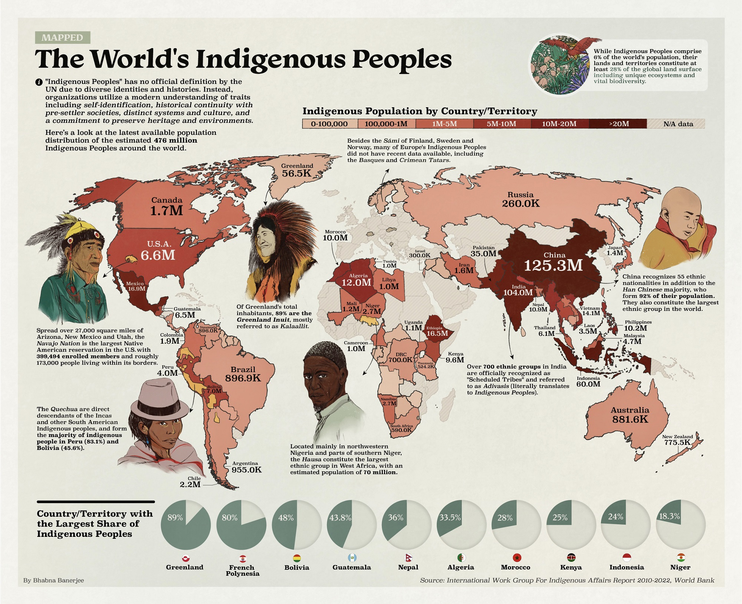

**Figure 1. Overall number of indigenous populations around the entire world**

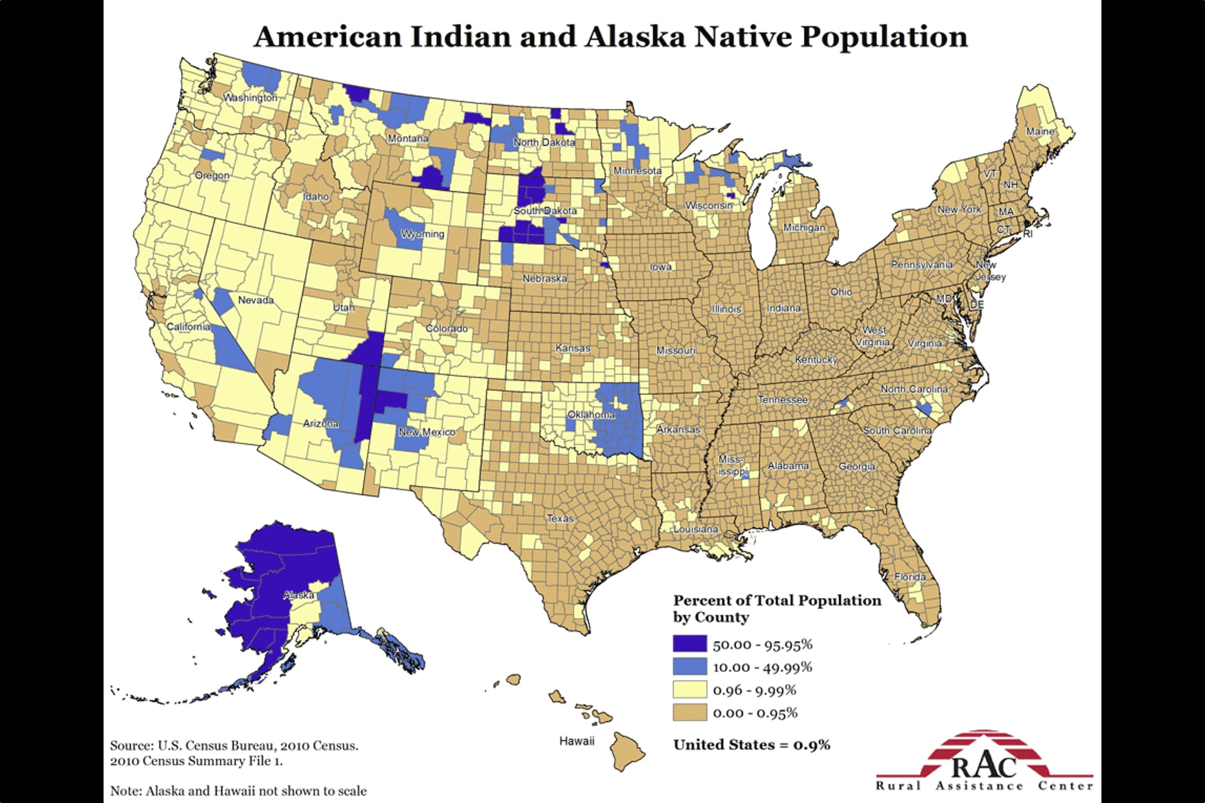

**Fig 2. Breakdown of Indigenous Populations in the United States of America**

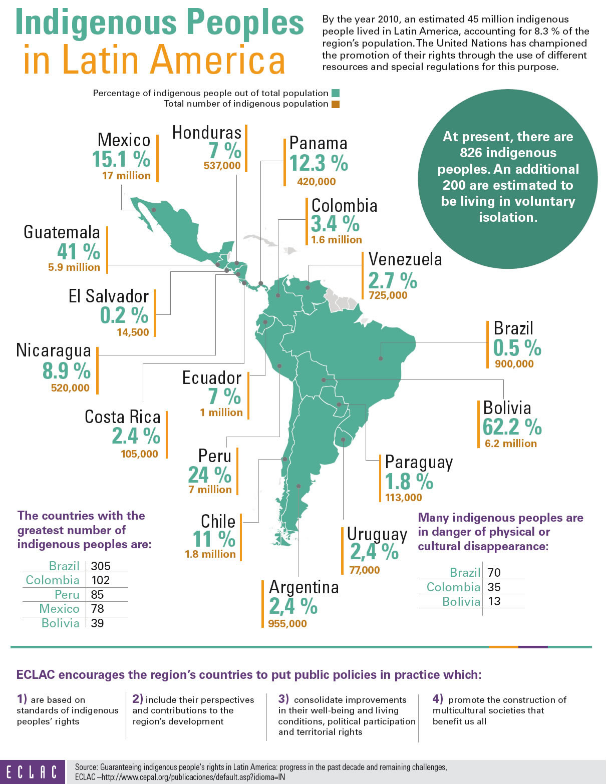

**Fig 3. Breakdown of Indigenous Populations in Latin America**

**Current statistics regarding the number of indigenous representation in legislative bodies around the world**

Though indigenous representation in legislative bodies largely varies all around the world, one thing is certain- indigenous groups are severely underrepresented everywhere. In Mexico, there are only around 14 indigenous representatives present to the national legislature, which is quite concerning considering the size of the indigenous population present in the nation.[15] In the United States, there are currently only 4 Native Americans present in Congress, and throughout history there have only ever been 27 total to serve in Congress. Around the nation, the number of elected indigenous representatives is in the hundreds at local, state, and federal levels which is also extremely low considering the size of the native population present in the US.[16] In the US’s North American counterpart Canada, indigenous participation is a lot more prominent when comparing it to the US, with a total of 12 representatives out of 343 in the House of Commons (national legislature). However, in the more provincial legislature there are around 26 indigenous representatives across a variety of provinces, showing a growing but still limited representation of Indigenous peoples in Canadian politics.[17] New Zealand is the only nation in the world that can say that their indigenous population is being adequately represented, currently having 7 out of 120 total seats in parliament belonging to members of the Māori peoples. Overall, this number of representatives can be seen as more than sufficient to represent indigenous voices considering the number of Maori peoples living in the nation.

**MAJOR COUNTRIES AND ORGANISATIONS INVOLVED**

**Canada** 17

Canada is known for having one of the largest indigenous populations in the world . As a result of this, the nation (despite not being one of the nations that implemented the ILO Convention 169) is a leader in indigenous representation policy and overall indigenous participation in legislative bodies. Canada has a large number of indigenous representatives in national government, which other nations with a somewhat large number of indigenous populations severely lack.

**United States** 16

The United States, much like Canada, is also known for its large indigenous population, having one of the largest indigenous populations in the world. The US has some form of indigenous representation in the provincial legislature, however the numbers are very few when considering the indigenous population present in the nation. Furthermore, the US has an even fewer number of indigenous representatives within the national government compared to numbers in provincial legislatures, and when looking at the nation’s number of representatives in national government compared to Canada’s number of representatives, it is clear that concrete action must be taken to bring in more indigenous voices. All in all, the US has very few indigenous representatives in the legislature on all levels, especially when considering the vast indigenous population living in the US.

**Mexico** 15

Much like Canada and the US, Mexico also boasts a large indigenous presence within the nation. With that being said, however, there are very few indigenous representatives in any form of legislature within the nation, and this is largely due to the fact that there has not been any effective action taken to increase the number of indigenous members of legislature despite there being such a huge indigenous population. Moreover, if some form of action is not taken to voice indigenous concerns, it is likely that indigenous identity and culture will continue to be lost and it could eventually cease to exist due to assimilation into more modern day practices.

**New Zealand[18]**

In today’s world, New Zealand is seen as a pioneer in indigenous representation due to the nation’s implementation of laws protecting indigenous identity since the 1800’s. When looking at the statistics and taking into consideration the size of the nation and its indigenous population, it is clear that indigenous representation is not so much of an issue due to there being seven total indigenous representatives out of 120 in the national legislature. This can be credited to the Māori Representation Act that dedicates seven parliamentary seats for Māori individuals. Overall, a consistently high amount of indigenous representation has led to the indigenous population present in New Zealand to continue to preserve their unique culture, as well as assimilate with other non-indigenous peoples. Overall indigenous representation has facilitated a peaceful and friendly environment for indigenous peoples in New Zealand, giving them the ability to thrive and express themselves and their traditions.

**IWGIA[19]**

The IWGIA is an independent and non governmental human rights focused organization that was founded in 1968. It focuses on defending, promoting, and strengthening the rights of all indigenous peoples and groups around the world. In addition, this UN organization also focuses on publishing and documenting accurate statistics on indigenous peoples and their representation. It publishes the ‘Indigenous World’ report every year, in which they include detailed updates on the status and statistics of indigenous peoples living in different regions and countries of the world. The IWGIA also supports more locally based activist groups with funding, international exposure and visibility, and capacity building. All in all, the IWGIA mainly focuses on indigenous land rights, self determination, human rights violations and representation in governmental and legislative processes, while also ensuring that the UNDRIP is being implemented/urging the implementation of the UNDRIP (UN declaration on the rights of indigenous peoples).

**BLOCS EXPECTED**

**Bloc A**

One of the two possible blocs would be the bloc supporting immediate action that aims to increase the number of indigenous representatives present in legislative bodies This bloc would likely include nations with large indigenous populations, and would be headlined by nations such as Canada and New Zealand that have successfully created policies that increase the number of indigenous representatives in legislature and government.

**Bloc B**

The second possible bloc would be one that is opposed to interfering with representation in all legislative bodies. This bloc would likely include nations with less of an indigenous population or nations that believe that there is no need to take action for indigenous representation as their indigenous populations are being treated fairly with the current legislature that is in place. Some examples of nations that could be found in this bloc are Türkiye, Russia, and China.

**TIMELINE OF EVENTS**

| **Date** | **Description of event** |
| --- | --- |
| 1492 | Christopher Columbus and his crew reach the Americas, marking the beginning of European dominance and colonization in the Western Hemisphere |
| 17th-18th centuries | British, Dutch and French colonies expand further into North America, the Caribbean, Africa and Asia, removing indigenous people from their lands and incorporating them as forced laborers into their workforces/empires |
| 1867 | New Zealand passes the Maori Representation Act. This act dedicated four parliamentary seats to Maori peoples with the goal of bringing the Maori peoples into the political system of the self governing colony. Later in 1876, the number of seats increased from 4 to 7. |
| 1967 | The Canadian Council and Office of Aboriginal Affairs are created. These two bodies were formed to both advise and implement indigenous policies in the nation. |
| 1989 | Sami parliament is created in Norway, providing the indigenous Sami peoples jurisdiction over linguistic and cultural affairs in Norway. |
| 1991 | Colombia creates a new constitution that recognizes the nation as a multiethnic state. It also reserved a small amount of legislative seats for the indigenous populations and gave them some form of territorial autonomy. |
| 1994 | Bolivia undergoes reforms regarding their indigenous population, granting them representation on the municipal level of government. |
| 1998 | Ecuador undergoes reforms regarding their indigenous population, announcing the recognition of indigenous communities and their rights. |
| 1999 | Venezuela signs a new constitution, in which indigenous groups are granted land, cultural, and political rights, and reserved seats in local councils. |
| 2001 | Mexico announces a new amendment to their laws, giving indigenous groups the right to self-determination and local governance rights |
| 2008 | Ecuador signs a new constitution that declares the nation a plurinational and multicultural state, while giving indigenous people the right to self-determination. |
| 2009 | Bolivia signs a new constitution that declares the nation as a plurinational state, while giving indigenous peoples the right to self-determination and reserved seats in low level governance systems |
| 1990’s-2000’s | A large variety of indigenous rights measures are taken in Canada throughout these years. Some examples include a focus on land claims and the expansion of indigenous representation in legislative bodies and governance. |
| 2022-2025 | Australia introduces a new Indigenous strategy that puts a focus on the participation and representation in leadership bodies and educational institutions of indigenous peoples. |
| 2023-2028 | Canada announces their UN Declaration Act Action Plan, that includes over 180 possible actions that are to be taken to align laws with the UNDRIP, address racism, increase and advance indigenous rights, and promote governance. |
| January 2025 | The United States announces a new executive order on affirmative action, that has the goal of “Ending illegal discrimination and restoring merit-based opportunity” |

**PREVIOUS ATTEMPTS TO SOLVE THE ISSUE**

As mentioned throughout the study guide, there have been quite a few attempts to deal with indigenous representation. The most notable of these attempts, and the approach most nations seem to be taking is reserved seats for indigenous representatives. One example of this approach is the Māori Representation Act of 1867 that guaranteed parliamentary representation through the form of reserved seats for the Māori indigenous peoples. Some other examples include nations in the region of Latin America, with Colombia’s 1991 Constitution, Venezuela’s 1999 Constitution, and Bolivia’s 2009 Constitution that all guaranteed a small amount of seats in some form of government (usually lower power bodies). These measures have been successful in ensuring that there is some form of indigenous representation and voice in governmental processes, however it seems as though they are not single handedly sufficient to represent the unique needs and identities of indigenous peoples and earn them just and fair rights and representation.

Another approach that is being taken is the establishment of solely indigenous councils and parliaments which provide government recognized platforms for indigenous opinions and voices. The most noteworthy of these attempts are the Sámi parliaments in Norway (1989), Sweden (1993), and Finland (1996).[20] These parliaments allowed the indigenous Sàmi people to influence governmental decisions solely related to land rights, language, and culture. Such frameworks serve as important bodies that focus solely on indigenous rights and representatives, however they often have limited power and can only influence decisions related to certain issues they have a say in.

Perhaps the most international approaches of them all are legal frameworks with the goal of earning and solidifying indigenous presence and participation in all governments. An example of such a framework would be the ILO Convention 169 that is a legally binding treaty that needs governments to reach out to indigenous populations and consult with them on any opinions they may have, or issues they may be facing and attempt to help solve them in any way they see fit. Another framework that usually goes hand in hand with the ILO Convention 169 is the UN Declaration on the Rights of Indigenous Peoples (UNDRIP) 2007. This framework, though unlike the ILO it is not legally binding, re-enforces indigenous peoples’ rights to just governance, self-determination, and Free, Prior, and Informed consent. These two frameworks are similar in nature, however they are not both legally binding and they only cover a certain aspect of indigenous rights and representation.

**POSSIBLE SOLUTIONS**

One possible solution that could arise to address the issue of indigenous representation in government and legislative bodies is a combination of structural reforms, as well as affirmative action policies. As seen through New Zealand’s Māori Representation Act, dedicated/reserved parliamentary seats for indigenous peoples can provide a guaranteed voice in politics, while constitutional recognition, like for example Bolivia’s 2009 plurinational framework can guarantee that the representation of indigenous peoples is embedded as a fundamental right rather than a simple temporary measure. Another possible solution would be the establishment of treaty based co-governance. The idea of treaty based co-governance is molded on the Treaty of Waitangi, and it would offer a variety of mechanisms for shared decision making rights and power. In addition, it would further strengthen indigenous sovereignty through the recognition of authority.

At the international level, a possible solution could be putting a focus on governments to align national policies with the standards presented in the UN Declaration on the Rights of Indigenous Peoples and the ILO Convention 169. This would reinforce compliance with the human norms presented around the globe and also strengthen legitimacy. Moreover, the implementation of reserved representation and electoral quotas, as seen in Venezuela and Colombia, guarantee that indigenous peoples are given a voice in decision making processes and that they have a seat across different levels of governance. One important thing to note, however, is that all of these measures would ideally be matched with capacity building initiatives that would ensure that indigenous leaders are equipped with all of the necessary knowledge and support they would need to have actual meaningful and impactful participation. This would also ensure that their leadership and representation would translate into real world influence rather than just a number used to fill quotas.

**Relevant Treaties**

**Treaty of Waitangi**[21]

A treaty signed in 1840 between the British Crown and Māori chiefs. It made British governance in New Zealand official, establishing the Brits as the official governors of the island, while also recognizing the rights of Māori peoples to their own resources and land. Though changes and differences between the English and the Māori version of the treaty led to disagreements and conflicts which saw the Māori people lose land, this treaty set the foundation for future Māori representation in the legislature and the Māori Representation Act.

**Māori Representation Act 4**

An act signed in 1867 that was and continues to be seen as a monumental act law in New Zealand that established four Māori electorates in Parliament. This gave Māori voters the right to directly vote for their own representatives that understood their unique culture, needs and identity. The number of seats was later increased to 7, and today this system still continues guaranteeing the Māori people a voice in government and the legislature.

**ILO convention 169**[22]

A crucial legally binding treaty adopted by the ILO (International Labour Organization) in 1989 for the recognition of indigenous peoples’ rights to their own land, culture, self-governance, and participation in politics. It shifted away from full assimilation into society and more toward respect and empowerment. It is the only international treaty that addresses the rights of tribes and indigenous peoples, with 24 countries having ratified it.

**1991 Political Constitution of Colombia**[23]

Colombia’s new constitution, signed in 1991, declared the state a multiethnic and multicultural nation. This constitution also granted a small amount of reserved legislative seats for indigenous peoples and recognized their indigenous territorial independence and self-determination.

**1999 Constitution of the Bolivarian Republic of Venezuela**[24]

Venezuela's new constitution signed in 1999 that guaranteed that indigenous peoples are to be given equal rights to the non-indigenous Venezuelan population, while also reserving 3 seats for indigenous representatives in the National Assembly.

**UN Declaration on the Rights of Indigenous Peoples**[25]

Adopted by the UN in 2007, it asserts that indigenous peoples have the right to participation, land, culture, and above all self determination in decision making processes. It also established the ideas of free, prior, and informed consent. Unlike the ILO Convention 169, it is not legally binding, however it is the most advanced global framework addressed towards indigenous rights today, with 144 countries voting in favor of the declaration in 2007.

**2009 Political Constitution of the Plurinational State of Bolivia**[26]

Bolivia signed its new constitution in 2009 that re-founded the nation as a plurinational state. This constitution also granted indigenous peoples with reserved representation in low level governmental bodies.

**BIBLIOGRAPHY**

Amnesty International. “Indigenous Peoples’ Rights.” *Amnesty International*, 2024, [www.amnesty.org/en/what-we-do/indigenous-peoples/](http://www.amnesty.org/en/what-we-do/indigenous-peoples/).

August 29, Nick Burns |. “Chile Could Become ‘Plurinational.’ What Does That Mean?” *Americas Quarterly*, 2022, [www.americasquarterly.org/article/chile-could-become-plurinational-what-does-that-mean/](http://www.americasquarterly.org/article/chile-could-become-plurinational-what-does-that-mean/).

Banerjee, Bhabna. “Mapped: The World’s Indigenous Peoples.” Visual Capitalist, 18 Mar2023, [www.visualcapitalist.com/cp/mapped-the-worlds-indigenous-peoples/](http://www.visualcapitalist.com/cp/mapped-the-worlds-indigenous-peoples/).

Bhavnani, Rikhil. “Do Electoral Quotas Work after They Are Withdrawn? Evidence from a Natural Experiment in India | Gender Action Portal.” *Gap.hks.harvard.edu*, 2009, [gap.hks.harvard.edu/do-electoral-quotas-work-after-they-are-withdrawn-evidence-natural-experiment-india](http://gap.hks.harvard.edu/do-electoral-quotas-work-after-they-are-withdrawn-evidence-natural-experiment-india).

Cambridge Dictionary. “Legislator.” *@CambridgeWords*, 18 Sept. 2024, [dictionary.cambridge.org/dictionary/english/legislator](http://dictionary.cambridge.org/dictionary/english/legislator).

Caribbean, Economic Commission for Latin America and the. “Indigenous Peoples in Latin America.” *Www.cepal.org*, 11 Nov. 2014, [www.cepal.org/en/infographics/indigenous-peoples-latin-america](http://www.cepal.org/en/infographics/indigenous-peoples-latin-america).

Gisselquist, Rachel, and Min J. Kim. “Affirmative Action Policies to Increase Diversity Are Successful, but Controversial, around the World.” *United Nations University*, 28 Feb. 2024, [unu.edu/article/affirmative-action-policies-increase-diversity-are-successful-controversial-around-world](http://unu.edu/article/affirmative-action-policies-increase-diversity-are-successful-controversial-around-world).

Hope, Native. “Native American History - Native Hope.” *Native Hope*, 26 Dec. 2024, [www.nativehope.org/native-american-history/](http://www.nativehope.org/native-american-history/).

ILO. “Convention 169 and International Day of the World’s Indigenous People | International Labour Organization.” [*Www.ilo.org*](http://www.ilo.org), 7 May 2012, [www.ilo.org/resource/convention-169-and-international-day-worlds-indigenous-people](http://www.ilo.org/resource/convention-169-and-international-day-worlds-indigenous-people).

IWGIA. “Mexico - IWGIA - International Work Group for Indigenous Affairs.” *Iwgia.org*, 15 Sept. 2024, [iwgia.org/en/mexico.html](http://iwgia.org/en/mexico.html).

IWGIA Assistant. “The Indigenous World 2024: United States of America - IWGIA - International Work Group for Indigenous Affairs.” *Iwgia.org*, 16 Apr. 2024, [iwgia.org/en/usa/5396-iw-2024-united-states.html](http://iwgia.org/en/usa/5396-iw-2024-united-states.html).

Jaouen, Morgane. “The Indigenous World 2023: Canada - IWGIA - International Work Group for Indigenous Affairs.” *Iwgia.org*, 17 Apr. 2023, [iwgia.org/en/canada/5187-iw-2023-canada.html](http://iwgia.org/en/canada/5187-iw-2023-canada.html).

Mamo, Dwayne. “IWGIA - IWGIA - International Work Group for Indigenous Affairs.” *Iwgia.org*, Apr. 2025, [iwgia.org/en/](http://iwgia.org/en/).

Marcus, Constanza. “The Indigenous World 2025: Aotearoa (New Zealand) - IWGIA - International Work Group for Indigenous Affairs.” *Iwgia.org*, 25 Apr. 2025, [iwgia.org/en/aotearoa-new-zealand/5766-iw-2025-aotearoa-new-zealand.html](http://iwgia.org/en/aotearoa-new-zealand/5766-iw-2025-aotearoa-new-zealand.html).

Max Planck Institute. “Bolivia (Plurinational State Of) 2009 Constitution - Constitute.” [*Www.constituteproject.org*](http://www.constituteproject.org), 2009, [www.constituteproject.org/constitution/Bolivia_2009](http://www.constituteproject.org/constitution/Bolivia_2009).

Max Planck Institute. “Colombia 1991 (Rev. 2015) Constitution - Constitute.” [*Www.constituteproject.org*](http://www.constituteproject.org), 1991, [www.constituteproject.org/constitution/Colombia_2015](http://www.constituteproject.org/constitution/Colombia_2015).

Morris, Shireen. *Mechanisms for Indigenous Representation, Participation and Consultation in Constitutional Systems International Examples to Inspire Chile.* 2021, [www.idea.int/sites/default/files/publications/mechanisms-for-indigenous-representation-participation-consultation.pdf](http://www.idea.int/sites/default/files/publications/mechanisms-for-indigenous-representation-participation-consultation.pdf).

National Constituent Assembly of Venezuela. “Constitution of the Bolivarian Republic of Venezuela | Rights Mapping and Analysis Platform.” *Unhcr.org*, 2025, [rimap.unhcr.org/node/65992](http://rimap.unhcr.org/node/65992).

New Zealand Ministry for Culture and Heritage Te Manatu Taonga. “Story: Māori.” *Govt.nz*, Feb. 2005,<https://teara.govt.nz/en/maori>.

Orange, Claudia. “Te Tiriti O Waitangi – the Treaty of Waitangi.” *Govt.nz*, 2012, [teara.govt.nz/en/te-tiriti-o-waitangi-the-treaty-of-waitangi/print](http://teara.govt.nz/en/te-tiriti-o-waitangi-the-treaty-of-waitangi/print).

Protsyk, Oleh. *The Representation of Minorities and Indigenous Peoples in Parliament a GLOBAL OVERVIEW Promoting Inclusive Parliaments: The Representation of Minorities and Indigenous Peoples in Parliament.* 2010, [www.agora-parl.org/sites/default/files/agora-documents/A%20global%20Overview_The%20representation%20of%20minorities%20and%20indigenous%20peoples%20in%20parliament-1.original.pdf](http://www.agora-parl.org/sites/default/files/agora-documents/A%20global%20Overview_The%20representation%20of%20minorities%20and%20indigenous%20peoples%20in%20parliament-1.original.pdf).

SÁMEDIGGI. “About the Sámi Parliament - Sametinget.” *Sametinget.no*, 2021, sametinget.no/about-the-sami-parliament/.

Smithsonian. “Standing Rock Sioux and Dakota Access Pipeline.” *National Museum of the American Indian*, 2018, [americanindian.si.edu/nk360/plains-treaties/dapl](http://americanindian.si.edu/nk360/plains-treaties/dapl).

The Amerind Foundation. “The Size of the Indigenous Population in the United States - Amerind for Educators.” *Amerind for Educators*, 9 Nov. 2022, [amerindforeducators.org/size-of-the-indigenous-population/](http://amerindforeducators.org/size-of-the-indigenous-population/).

United Nations. “Indigenous Peoples.” *United Nations*, 2025, [www.un.org/en/fight-racism/vulnerable-groups/indigenous-peoples](http://www.un.org/en/fight-racism/vulnerable-groups/indigenous-peoples).

United Nations. “United Nations Declaration on the Rights of Indigenous Peoples.” *United Nations*, 2007,<https://doi.org/10.1353/hrq.2011.0040>.

Uprimny, Rodrigo. “StackPath.” *Corteidh.or.cr*, 2011, corteidh.or.cr/tablas/r27168.pdf.

U.S. Department of the Interior Indian Affairs. “What Is a Federal Indian Reservation? | Indian Affairs.” [*Www.bia.gov*](http://www.bia.gov), 19 Aug. 2017, [www.bia.gov/faqs/what-federal-indian-reservation](http://www.bia.gov/faqs/what-federal-indian-reservation).

Wallenfeldt, Jeff. “Maori Representation Act | Maori Representation in Parliament | Britannica.” [*Www.britannica.com*](http://www.britannica.com), 2025, [www.britannica.com/event/Maori-Representation-Act](http://www.britannica.com/event/Maori-Representation-Act).

1. Gisselquist, Rachel, and Min J. Kim. “Affirmative Action Policies to Increase Diversity Are Successful, but Controversial, around the World.” *United Nations University*, 28 Feb. 2024, [unu.edu/article/affirmative-action-policies-increase-diversity-are-successful-controversial-around-world](http://unu.edu/article/affirmative-action-policies-increase-diversity-are-successful-controversial-around-world).
2. Amnesty International. “Indigenous Peoples’ Rights.” *Amnesty International*, 2024, [www.amnesty.org/en/what-we-do/indigenous-peoples/](http://www.amnesty.org/en/what-we-do/indigenous-peoples/).
3. Morris, Shireen. *Mechanisms for Indigenous Representation, Participation and Consultation in Constitutional Systems International Examples to Inspire Chile*. 2021, [www.idea.int/sites/default/files/publications/mechanisms-for-indigenous-representation-participation-consultation.pdf](http://www.idea.int/sites/default/files/publications/mechanisms-for-indigenous-representation-participation-consultation.pdf).
4. Wallenfeldt, Jeff. “Maori Representation Act | Maori Representation in Parliament | Britannica.” *Www.britannica.com*, 2025, [www.britannica.com/event/Maori-Representation-Act](http://www.britannica.com/event/Maori-Representation-Act).
5. United Nations. “Indigenous Peoples.” *United Nations*, 2025, [www.un.org/en/fight-racism/vulnerable-groups/indigenous-peoples](http://www.un.org/en/fight-racism/vulnerable-groups/indigenous-peoples).
6. Bhavnani, Rikhil. “Do Electoral Quotas Work after They Are Withdrawn? Evidence from a Natural Experiment in India | Gender Action Portal.” *Gap.hks.harvard.edu*, 2009, [gap.hks.harvard.edu/do-electoral-quotas-work-after-they-are-withdrawn-evidence-natural-experiment-india](http://gap.hks.harvard.edu/do-electoral-quotas-work-after-they-are-withdrawn-evidence-natural-experiment-india).
7. Cambridge Dictionary. “Legislator.” *@CambridgeWords*, 18 Sept. 2024, [dictionary.cambridge.org/dictionary/english/legislator](http://dictionary.cambridge.org/dictionary/english/legislator).
8. August 29, Nick Burns |, and 2022. “Chile Could Become ‘Plurinational.’ What Does That Mean?” *Americas Quarterly*, 2022, [www.americasquarterly.org/article/chile-could-become-plurinational-what-does-that-mean/](http://www.americasquarterly.org/article/chile-could-become-plurinational-what-does-that-mean/).
9. U.S. Department of the Interior Indian Affairs. “What Is a Federal Indian Reservation? | Indian Affairs.” *Www.bia.gov*, 19 Aug. 2017, [www.bia.gov/faqs/what-federal-indian-reservation](http://www.bia.gov/faqs/what-federal-indian-reservation).
10. New Zealand Ministry for Culture and Heritage Te Manatu Taonga. “Story: Māori.” *Govt.nz*, Feb. 2005, <https://teara.govt.nz/en/maori>.
11. Hope, Native. “Native American History - Native Hope.” *Native Hope*, 26 Dec. 2024, [www.nativehope.org/native-american-history/](http://www.nativehope.org/native-american-history/).
12. Protsyk, Oleh. *The Representation of Minorities and Indigenous Peoples in Parliament a GLOBAL OVERVIEW Promoting Inclusive Parliaments: The Representation of Minorities and Indigenous Peoples in Parliament*. 2010, [www.agora-parl.org/sites/default/files/agora-documents/A%20global%20Overview_The%20representation%20of%20minorities%20and%20indigenous%20peoples%20in%20parliament-1.original.pdf](http://www.agora-parl.org/sites/default/files/agora-documents/A%20global%20Overview_The%20representation%20of%20minorities%20and%20indigenous%20peoples%20in%20parliament-1.original.pdf).
13. Uprimny, Rodrigo. “StackPath.” *Corteidh.or.cr*, 2011, [corteidh.or.cr/tablas/r27168.pdf](http://corteidh.or.cr/tablas/r27168.pdf).
14. Smithsonian. “Standing Rock Sioux and Dakota Access Pipeline.” *National Museum of the American Indian*, 2018, [americanindian.si.edu/nk360/plains-treaties/dapl](http://americanindian.si.edu/nk360/plains-treaties/dapl).
15. IWGIA. “Mexico - IWGIA - International Work Group for Indigenous Affairs.” *Iwgia.org*, 15 Sept. 2024, [iwgia.org/en/mexico.html](http://iwgia.org/en/mexico.html).
16. IWGIA Assistant. “The Indigenous World 2024: United States of America - IWGIA - International Work Group for Indigenous Affairs.” *Iwgia.org*, 16 Apr. 2024, [iwgia.org/en/usa/5396-iw-2024-united-states.html](http://iwgia.org/en/usa/5396-iw-2024-united-states.html).
17. Morgane Jaouen. “The Indigenous World 2023: Canada - IWGIA - International Work Group for Indigenous Affairs.” *Iwgia.org*, 17 Apr. 2023, [iwgia.org/en/canada/5187-iw-2023-canada.html](http://iwgia.org/en/canada/5187-iw-2023-canada.html).
18. Marcus, Constanza. “The Indigenous World 2025: Aotearoa (New Zealand) - IWGIA - International Work Group for Indigenous Affairs.” *Iwgia.org*, 25 Apr. 2025, [iwgia.org/en/aotearoa-new-zealand/5766-iw-2025-aotearoa-new-zealand.html](http://iwgia.org/en/aotearoa-new-zealand/5766-iw-2025-aotearoa-new-zealand.html).
19. Mamo, Dwayne. “IWGIA - IWGIA - International Work Group for Indigenous Affairs.” *Iwgia.org*, Apr. 2025, [iwgia.org/en/](http://iwgia.org/en/).
20. SÁMEDIGGI. “About the Sámi Parliament - Sametinget.” *Sametinget.no*, 2021, [sametinget.no/about-the-sami-parliament/](http://sametinget.no/about-the-sami-parliament/).
21. Orange, Claudia. “Te Tiriti O Waitangi – the Treaty of Waitangi.” *Govt.nz*, 2012, [teara.govt.nz/en/te-tiriti-o-waitangi-the-treaty-of-waitangi/print](http://teara.govt.nz/en/te-tiriti-o-waitangi-the-treaty-of-waitangi/print).
22. ILO. “Convention 169 and International Day of the World’s Indigenous People | International Labour Organization.” *Www.ilo.org*, 7 May 2012, [www.ilo.org/resource/convention-169-and-international-day-worlds-indigenous-people](http://www.ilo.org/resource/convention-169-and-international-day-worlds-indigenous-people).
23. Max Planck Institute. “Colombia 1991 (Rev. 2015) Constitution - Constitute.” *Www.constituteproject.org*, 1991, [www.constituteproject.org/constitution/Colombia_2015](http://www.constituteproject.org/constitution/Colombia_2015).
24. National Constituent Assembly of Venezuela. “Constitution of the Bolivarian Republic of Venezuela | Rights Mapping and Analysis Platform.” *Unhcr.org*, 2025, [rimap.unhcr.org/node/65992](http://rimap.unhcr.org/node/65992).
25. United Nations. “United Nations Declaration on the Rights of Indigenous Peoples.” *United Nations*, United Nations, 2007, <https://doi.org/10.1353/hrq.2011.0040>.
26. Max Planck Institute. “Bolivia (Plurinational State Of) 2009 Constitution - Constitute.” *Www.constituteproject.org*, 2009, [www.constituteproject.org/constitution/Bolivia_2009](http://www.constituteproject.org/constitution/Bolivia_2009).