**Committee:** European Union (EU)

**Issue:** Re-evaluating EU-Africa Partnerships in Development, Trade and Security

**Student Officer:** Iasonas Fotios Kadis

**Position:** Deputy President

**PERSONAL INTRODUCTION**

Dear Delegates,

My name is Iasonas Fotios Kadis and I am currently attending the 11th grade of the German School of Thessaloniki. This year I have the honor of serving as a Deputy President in the Council of The European Union at the 8th DST MUN conference. I would like to welcome you all and extend my congratulations to you for selecting this inspiring committee.

For me, MUN has been an exciting journey. It has taught me how to express my opinion in a diplomatic manner, conduct thorough research, and collaborate with fellow delegates effectively to find feasible solutions to severe complications. But most importantly, it has integrated me into the amazing MUN family of my school, which has aided me in expanding my social circle. I wholeheartedly hope that this conference enriches you with the same values.

During the three days of the conference you will be expected to draft speeches and resolutions, cooperate and debate. While this study guide should offer you a broad overview on the topic “**Re-evaluating EU-Africa Partnerships in Development, Trade and Security**”, its mere aim is to familiarize you with it. As independent representatives of your countries, you are highly encouraged to assess the subject further and dig into your delegations point of view.

Should any of you have any inquiries regarding the conference, the topic of this study guide or anything further, please do not hesitate to contact me at iasonas.kadis@icloud.com.

I am looking forward to meeting and collaborating with you all.

Best regards,

Iasonas Fotios Kadis

**TOPIC INTRODUCTION**

There has been a succession of phases in the relationship between the European Union and the African continent from colonization and decolonization through development aid and strategic partnership. Both are at a turning point. The European Union is attempting to reorient its relationship with Africa away from paternalistic models of aid and towards cooperation based on shared values, interests, and goals.

This new appearance has been accelerated by global developments such as China's and other emerging powers' intervention in Africa, rising migration pressure, security threats emanating from terrorism and continental volatility, and urgent climate and health resilience demands. The EU has responded through mechanisms such as the Joint Africa-EU Strategy (JAES), the Global Gateway investment plan, and more intense security and trade arrangements. Most African stakeholders, however, still perceive the partnership as unbalanced.

The international community is tasked with the immediate challenge of redefining EU–Africa development, trade, and security relations. The challenge entails examining how cooperation between the two continents can be made more sustainable and balanced in an era of interdependence globally. How can the EU promote African industrialization more? How can trade be better balanced? How can security cooperation be more sovereignty-respecting and effective against threats facing them in common? 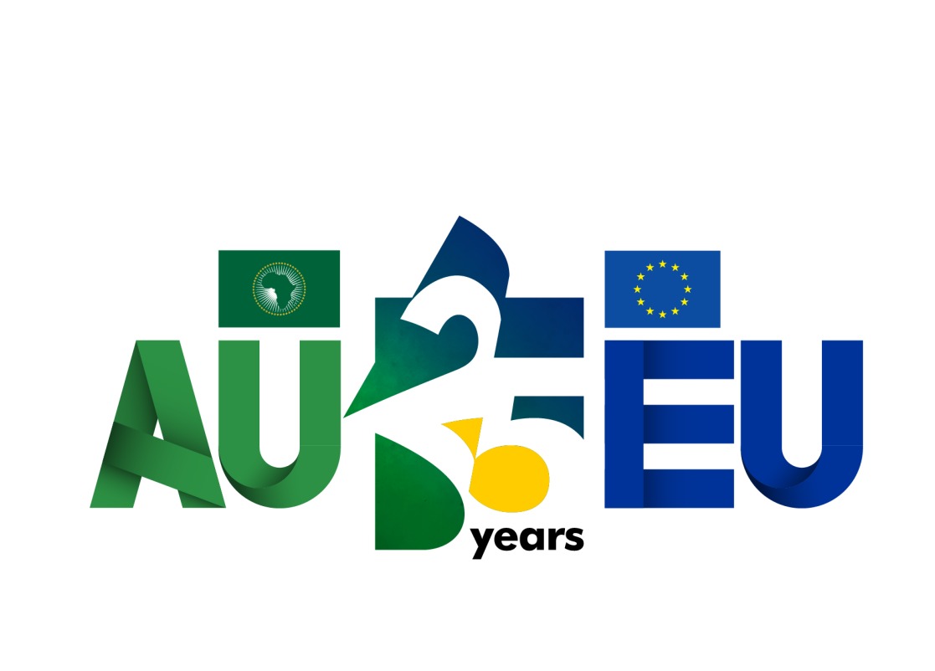

**[1]**

**DEFINITION OF KEY TERMS**

**African Continental Free Trade Area (AfCFTA[2])**

Historical trade agreement among 54 African nations to create a single market of services and goods to build intra-African trade and economic development

**Economic Partnership Agreements (EPAs[3])**

EU-regional African group trade and development agreements aimed at enhancing market access while promoting sustainable development

**Global Gateway[4]**

The EU's strategic project initiated in 2021 to raise up to €300 billion of investments globally, with priority given to Africa, as an alternative to China's Belt and Road Initiative

**Joint Africa-EU Strategy (JAES[5])**

Initiative launched in 2007 to secure the long-term strategic partnership between Africa and the EU on the shared values and interests

**Migration Management[6]**

The measures and policies governments undertake to handle the movement of citizens between nations, such as legal migration, asylum procedures, and border control

**Neocolonialism[7]**

Indirect control through which an old colonial state or industrialized country continues to exert control over an emerging nation through economic, political, or military means

**Security Partnership[8]**

Institutionalized collaboration between two or more parties (states or organizations) for the development of peace, stability, and capacity-building in areas including defense, policing, and counterterrorism

**Trade Liberalization[9]**

Removal or decrease in trade barriers, such as tariffs and quotas, to encourage free trade between nations

**Team Europe[10]**

An instrument that brings together the EU, its member states, and European financial institutions to apply joint action globally, but especially in development cooperation

**BACKGROUND INFORMATION**

**Historical Foundations of the EU–Africa Relationship**

The EU–Africa relationship can only be properly understood in terms of its historical foundations. Colonialism was the pioneering influence that conditioned initial relations, leaving behind political, social, and economic imbalances which continue to condition modern cooperation. After independence, African nations found themselves dependent on European powers for the purpose of development, creating a model of donor–recipient in which the EU was the donor and Africa was to adapt to extrinsic standards. With time, this restrictive strategy was converted to a more complex one, as both the regions realized that their stability and prosperity in the long run were interdependent. Though the relationship has increasingly turned strategic and multifaceted, it continues to be afflicted with structural power, representation, and agenda-setting inequalities that have a tendency to prioritize European interests over African interests.

**From Cotonou to JAES: The Evolution of Africa–EU Relations**

The Cotonou Agreement was a significant deviation from previous development plans. Development cooperation was for the first time not just in terms of economic assistance but tied directly to political dialogue, governance reforms, and human rights matters. That means African governments would be required to ask for democratic reforms and good governance in exchange for assistance. On paper, the bargain recognized African states as active partners and not mere recipients and established a value-based and politically engaged environment. In practice, though, the conditional nature of this partnership was tested by certain African leaders, who viewed it as an extension of European hegemony over domestic affairs. However, the Cotonou Agreement laid the basis for more institutionalized political relations and marked an important landmark in reforming the partnership.

The launch of the Joint Africa–EU Strategy in 2007 further reconfigured cooperation by introducing new areas of engagement. Unlike earlier agreements, which had focused mainly on trade and development, the JAES introduced global issues such as climate change, migration, and regional security. Its most significant innovation, if any, was the creation of regular summits and institutionalized dialogue structures that allowed the African Union to exert a more assertive leadership in setting the agenda. This was a change towards greater interdependence: Africa was no longer just being acted upon by European policy but was now engaged in international debate on global governance. For the EU, this was a move to recognize the growing importance of Africa as a global partner in managing global challenges, while for Africa it was a signal of enhanced visibility and legitimacy at the international level.

**Challenges and Shifts in the New EU–Africa Partnership**

Despite such changes in institutions, African nations still refer to structural imbalances in the partnership. Most of them feel that European trade and assistance policies remain conditional and undermine African sovereignty, leaving limited space for actual agency in decision-making. The EU generally imposes economic and political conditions according to European interest rather than African need, creating tension in negotiations. Meanwhile, geopolitics too have changed: new entrants such as China, Russia, and even Turkey have expanded their presence in Africa by offering grandiose infrastructure deals, loans, and trade without insisting on governance reforms. These alternatives provide more leverage for African leaders and erode their dependency on the EU. This fresh competition has made the EU reconsider its approaches in an effort to remain Africa's leading partner.

The modern EU–Africa partnership is shaped by an unfolding set of global challenges. Climate change is perhaps the most pressing, with rising temperatures, droughts, and floods causing devastating effects on African agriculture and food security, and driving migration. Migration itself is a very touchy subject: the EU has centered on reducing irregular migration, while African countries prefer to stress enhanced mobility and lawful access to Europe. Security is also a concern, with conflict in the Sahel, Libya, and the Horn of Africa spilling across borders to affect both. Apart from it, the conflict in Ukraine and other global conflicts have interfered with food and energy production, worsening food insecurity for dozens of Africans. Lastly, the digital divide has the potential to set Africa back in the technology race compared to the rest of the world and cut off access to education, innovation, and economic growth unless massive investments are made. Such issues make EU-African cooperation desirable but unavoidable.

**Global Gateway and AfCFTA: Building a More Equitable EU–Africa Partnership**

Both the EU and Africa have responded to these forces through attempts to define new modes of cooperation. The creation of the African Continental Free Trade Area in 2021 was a moment of great importance for Africa, an ambitious attempt to promote intra-African trade, reduce dependency on international markets, and spur industrialization. The EU has pledged its support to the initiative, hoping that a more united, more significant Africa can be a more equal global trade partner. The EU, in the same year, unveiled the Global Gateway, a €300 billion plan of investments in digitalisation, green energy, infrastructure, health, and education. In contrast to previous aid programs, the Global Gateway focuses on long-term investment and reciprocity, and it presents itself as a direct rival to China's Belt and Road Initiative. Collectively, these projects mark a shift toward a more equitable and forward-looking partnership, even if implementation challenges persist.

The trajectory of EU–Africa relations portrays a consistent drift away from conditionality and dependency towards a model based on mutual prosperity, resilience, and equality. Yet in order for this transformation to be realized, both blocs must address the historical imbalances that continue to influence the relationship. Europe must demonstrate that it views Africa as an equal partner, and not merely as a source of commodities or recipient of aid, and Africa must continue to strengthen its unity and bargaining strength. The forces of interdependence and globalization necessitate that neither continent can resolve such core issues as climate change, security, or digital transformation in isolation. A genuine and equitable partnership, founded on joint responsibility and durable association, is therefore required for the future well-being of the African continent and of the European Union.**[11]**

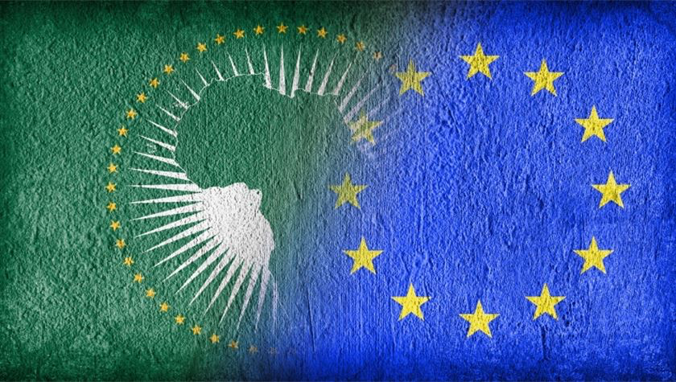

**MAJOR COUNTRIES AND ORGANISATIONS INVOLVED**

**France**

France has historically enjoyed close political, economic, and military ties with Africa and Francophone nations in particular. Through its military action in the Sahel, counter-terrorist operations, and regional stability activities, France is among the most engaged EU member states in African affairs. France is generally a champion of greater EU engagement in West and North Africa and more specifically on security and migration issues.

**Germany**

As the biggest economy in Europe, Germany is among the prominent donors of development aid to Africa. Its focus is on economic growth, good governance, and renewable energy projects. German support for African capacity development is provided through institutions such as GIZ and is one of the key founders of the EU's Global Gateway program. It has a less military but more developmental orientation than the security-biased French policy.

**Italy**

Italy's geographical closeness to North Africa places migration and energy policy at the center of its Africa strategy. It has sought greater cooperation with the AU on the management of migration flows, border control, and combating human trafficking. Italy has also focused strenuously in recent years on energy partnerships, in particular through the importation of North African natural gas as a strategy for diversifying away from Russian supplies.

**Nigeria**

Nigeria is the most populous country and largest economy in Africa and is located at the center of the African Continental Free Trade Area (AfCFTA). It is also the EU's key security partner due to its war against terror and piracy in West Africa. Nigeria is a prime source of oil and energy for European markets and is therefore an important stakeholder in the EU–Africa partnership.

**South Africa**

South Africa is a very influential diplomatic voice on the continent and a member of the BRICS, often becoming a voice of the Global South. It has very strong economic and trade relations with the EU but regularly advocates for greater African agency and autonomy in structuring the partnership. South Africa is also a leading bridging function between Africa and the wider international community, which lends it greater credibility in EU–AU talks.

**European Union (EU)**

The EU is a central actor in shaping Africa policy through its trade agreements, development aid initiatives, and security relations. It negotiates as one entity with the AU but also funds huge projects such as the Global Gateway. Even though individual EU member states pursue distinct national interests, the EU collectively has some cohesion in its strategy towards Africa.

**African Union (AU)**

The AU provides Africa with a unified voice during negotiations with the EU. It encourages greater equality, African leadership of development agendas and continental priorities such as the AfCFTA. The AU has also directed African-led peace and security missions that make it pivotal in determining Africa's engagement with the EU.

**United Nations (UN)**

The UN also has a crucial supporting role with institutions like UNDP and UNECA, which engage in development, governance, and economic analysis. The UN peace missions are also deployed into some African conflict zones, typically with EU funding support or coordination. The UN is thus a neutral multilateral forum where the EU and AU tend to collaborate with each other.

**World Bank and IMF**

The IMF and World Bank provide loans, development assistance, and financial stabilization packages to the entire continent of Africa. Their policies often complement EU development policy, though sometimes accused of exercising conditionality that undermines African sovereignty. Still, they remain central actors in African economic development and in EU–AU structures.

**BLOCS EXPECTED**

Bloc 1: Actively encourages reshaping and reconfiguring EU–Africa relations as development-oriented, mutually beneficial, and balanced. This bloc endorses fair trade, increased investment in African infrastructure, climate action, and more equitable partnership governance arrangements. Good examples include nations such as Germany and Sweden that lean towards sustainable development, climate action, and African-led agendas.

Bloc 2: More protectionist in orientation than strategic reform, it has European integration, migration control, regional security, and economic influence atop its agenda. It favors partnership but not necessarily with essential transformation of the existing power structure or removal of conditionalities from trade and development agreements. One can situate here states like Hungary and Austria that prioritize migration containment and security as EU–Africa relation priorities.

**TIMELINE OF EVENTS**

| **Date** | **Description of event** |
| --- | --- |
| June 23, 2000 | EU and ACP countries sign the Cotonou agreement[12] |
| December, 2007 | The JAES launches, the Joint Africa-EU Strategy[13] |
| March 21, 2018 | 44 African countries sign the AfCFTA |
| December, 2020 | End of Cotonou Agreement; start of negotiations on a new EU-Africa partnership |
| December, 2021 | EU launches its Global Gateway investment initiative |
| February 17-18, 2022 | 6th EU-AU Summit aims at new generation of partnership |
| February, 2022 | EU invests €150 billion to fund Africa under Global Gateway |

**RELEVANT RESOLUTIONS, TREATIES AND EVENT**

**The Cotonou Partnership (2000-2020)**

The Cotonou Partnership (2000–2020) was a landmark in EU–Africa, Caribbean, and Pacific (ACP) relations. It replaced the Lomé Conventions, signed in Benin in June 2000, with a proposed twenty-year validity. The partnership concentrated on three main pillars: development cooperation, political dialogue, and trade. Development aid was, for the first time, made obligatory with democratic government, human rights, and the rule of law. This conditionality was meant to promote accountability and stability but was usually disapproved by African states as a continuity of asymmetrical power relations with the EU having a strong grip over internal governance in return for aid and access to trade. Yet, the Cotonou Agreement did contain a formal architecture of cooperation and is a historical milestone in institutionalizing EU–Africa relations.

**The Post-Cotonou Agreement (2021)**

The Post-Cotonou Agreement of 2021 replaced the framework, which was negotiated to address 21st-century challenges. It was signed in 2021 but remains to be ratified. While its predecessor focused mainly on aid and trade, the Post-Cotonou Agreement broadened the partnership to issues like climate change, gender, youth empowerment, peace and security, digital economy, and migration. It also creates three regional protocols pertaining to Africa, the Caribbean, and the Pacific, offering a more customized solution to each region's agendas. Perhaps most importantly, African leaders are seeking the new framework to reduce the conditionality placed on EU aid, while European negotiators continue to stress standards of governance. If ratified and well implemented, the Post-Cotonou framework can redefine the partnership in a more modern and flexible way.

**The Africa–Europe Alliance for Sustainable Investment and Jobs (2018)**

The Africa–Europe Alliance for Sustainable Investment and Jobs (2018) was launched by the European Commission in reaction to Africa's demographic and economic challenges. With Africa's population set to double by 2050, employment for young people was becoming a cause for concern. The alliance is based on sustainable investment, improving the business climate, improving regional integration, and education and skills. The EU pledged to raise up to €44 billion in investment under this plan, in renewable energy, infrastructure, and digitalization. While ambitious, the programme has faced difficulties in ensuring that projects are effectively delivered and that they help African populations as much as possible and not European firms in search of new markets.

**The EU-AU Summit number 6 (2022)**

The 2022 EU–AU Summit number 6, held in Brussels, was a symbolic reaffirmation of commitment towards a new partnership. African and European leaders reconfirmed shared prosperity, Africa's strategic autonomy, and fair trade. The conference was geared towards addressing lingering criticism that the EU had not engaged Africa as an equal partner. New promises were promised to support Africa's vaccine manufacturing, renewable energy programs, and digitalization. Among the key takeaways from the summit was the EU's commitment to use €150 billion in investment in Africa under the Global Gateway initiative, which Brussels sees as Europe's strategic counteroffer to China's Belt and Road Initiative. The summit thus represented a turning point in that both continents realized the urgent need for a more equal, looking-forward relationship founded on sustainability, parity, and strategic autonomy for Africa.

**PREVIOUS ATTEMPTS TO SOLVE THE ISSUE**

**Joint Africa-EU Strategy (JAES):**

Initiated in 2007, JAES aimed to move beyond the donor-recipient model and establish an equal partnership. It placed eight thematic partnerships like peace and security, democratic governance, migration, and economic development on the priority list. Implementation has, however, been uneven, and funding gaps as well as differing priorities have limited its success.

**Cotonou Agreement and Successor Framework (Post-Cotonou):**

The Cotonou Agreement in 2000 governed EU relations with African, Caribbean, and Pacific countries. Its emphasis on political dialogue and human rights was contentious. The post-Cotonou agreement, which was finalized in 2021, will address modern challenges such as climate change, digitalization, and migration.

**Global Gateway:**

Launched in 2021, this is the EU's response to China's Belt and Road Initiative. It proposes to invest €150 billion in Africa in digital infrastructure, renewable energy, education, and health. As ambitious as it sounds, critics refer to issues of implementation capacity and potential duplication of existing projects.

**EU Training Missions and Security Programs:**

The EU has initiated several military and civilian missions in Africa, such as EUTM Mali and EUCAP Sahel Niger. These are designed to build local capacity, enhance security governance, and fight terrorism. While successful in some areas, they are also faulted for generating dependency and not having clearly articulated exit strategies.

**Migration Compacts:**

It has deals with countries like Niger and Libya to control migration flows. These include border management and return financing. However, there have been allegations of human rights abuses and lack of accountability,which are of moral concern.

**POSSIBLE SOLUTIONS**

Scaling up the Global Gateway Initiative in Infrastructure, Renewable Energy, and Digital Connectivity. The Global Gateway Initiative of the European Union, established in 2021, aims to mobilize up to €150 billion worth of investments in Africa. Scaling up the initiative could allow the EU to expand its presence in African infrastructure, renewable energy, and digital connectivity projects. Delegates could consider whether EU investment should prioritize green energy (solar and wind farms, for example), transportation networks (railways, roads, ports), and digital infrastructure (broadband access, e-governance). Ensuring coherence with the African Union's Agenda 2063 would make these efforts more sustainable because, in doing this, they would be directly supporting African-defined goals of industrialization, innovation, and integration. However, challenges such as debt sustainability issues and competition with other global actors (e.g., China's Belt and Road Initiative) must be addressed.

From Aid Models to Investment Partnership Models. Traditional aid models have often been accused of breeding dependency and reinforcing donor–beneficiary relations. Instead, delegates can examine models where EU and African actors are seated as equal partners, co-designing and co-financing development programs. This would involve the creation of joint ventures in manufacturing, agriculture, and renewable energy with an eye to African nations achieving long-term ownership. Ethical and sustainable principle-based increased European private sector investment would also build trust. A shift towards mutual investment partnerships would help redesign the EU–Africa partnership as a more balanced and sustainable cooperation model.

Revising Economic Partnership Agreements (EPAs) to Promote Value-Added African Exports. The EU has Economic Partnership Agreements (EPAs) with various African regions. Meant to promote trade, the agreements have commonly been reproached for inordinately benefiting European exporters. Renegotiating the EPAs might involve providing African nations with additional policy space to shield infant industries, lessening tariff asymmetries, and promoting value-added exports like processed cocoa, textile, or manufactured products. Delegates are also able to talk about how the EU can support the African Continental Free Trade Area (AfCFTA) in a way that European trade policy complements African economic integration and regional growth.

Establishing Joint EU–AU Intelligence-Sharing and Counter-Terrorism Platforms. Security challenges such as terrorism in the Sahel and instability in the Horn of Africa have direct consequences for Africa and Europe. While the EU has supported African-led security missions, there is scope for further structured cooperation founded on intelligence-sharing and counter-terror training fora. Delegates can consider an EU–AU joint coordination mechanism that ensures accountability and respect for human rights standards. Beyond the use of force, confronting terrorism requires long-term measures that target poverty, weak governance, and climate insecurity as sources of instability.

Deepening EU–Africa Cooperation on Migration Management. Migration remains one of the most sensitive issues in EU–Africa relations. The EU is interested in reducing irregular migration flows, while African countries insist on greater legal mobility and protection of migrants' rights. Among the possible solutions are strengthening border control and anti-smuggling activities while simultaneously opening legal migration avenues, i.e., labor mobility programs, student exchange, and visa facilitation. Cooperation can also mean improving socio-economic conditions in countries of origin so that migration is a choice, rather than a necessity. The task will be to balance the EU's internal political needs with African aspirations for mobility and opportunity.

**BIBLIOGRAPHY**

“A Joint Africa-EU Strategy” European Commission, <https://knowledge4policy.ec.europa.eu/publication/joint-africa-eu-strategy_en>

“African Continental Free Trade Area Agreement” AfCFTA, <https://www.eac.int/trade/international-trade/trade-agreements/african-continental-free-trade-area-afcfta-agreement>

“African Continental Free Trade Area (AfCFTA)”, Tralac, <https://www.tralac.org/resources/our-resources/6730-continental-free-trade-area-cfta.html>

“African Union and European Union Celebrate 25 years of Strengthened Partnership", European Union, <https://www.eeas.europa.eu/delegations/african-union-au/african-union-and-european-union-celebrate-25-years-strengthened-partnership_en?s=43>

“The African Continental Free Trade Area” African Union, <https://au.int/en/african-continental-free-trade-area>

“Cotonou Agreement” European Union, <https://eur-lex.europa.eu/EN/legal-content/summary/cotonou-agreement.html>

“Economic Partnership Agreement”, Wikipedia, <https://en.wikipedia.org/wiki/Economic_Partnership_Agreements>

“Europe and Africa: a partnership of equals” European Union, <https://www.eeas.europa.eu/node/36031_en>

“Global Gateway” European Commission, <https://commission.europa.eu/strategy-and-policy/priorities-2019-2024/stronger-europe-world/global-gateway_en>

“The Joint Africa-EU Strategy” European Parliament, <https://www.europarl.europa.eu/RegData/etudes/STUD/2017/603849/EXPO_STU(2017)603849_EN.pdf>

“Migration Management”, European Commission, <https://home-affairs.ec.europa.eu/policies/migration-and-asylum/migration-management_en>

“Neocolonialism”, Britannica Encyclopedia, <https://www.britannica.com/topic/neocolonialism>

“ Post Cotonou Agreement” European Council, <https://www.consilium.europa.eu/en/policies/cotonou-agreement/#joint>

“The Samoa-Agreement: EU relations with African, Caribbean, and Pacific countries” ECA, <https://ecamaastricht.org/blueandyellow-zoomingin/the-samoa-agreement-eu-relations-with-african-caribbean-and-pacific-countriesnbsp>

“Security Partnership”, European Commission, <https://www.eeas.europa.eu/african-union/european-union-and-african-union-peace-security_en>

“Team Europe”, European Commission, <https://international-partnerships.ec.europa.eu/policies/team-europe-initiatives_en>

“The development at the AfCFTA” Germany Trade & Invest,

<https://www.gtai.de/de/trade/afrika/zoll/ausblick-afrikanische-kontinentale-freihandelszone-afcfta-168504>

“The European Union-African Union Summit - a political gesture or an opportunity to change traditional global interplay?”, The Parliament magazine, <https://www.theparliamentmagazine.eu/partner/article/the-european-unionafrican-union-summit-a-routine-political-gesture-or-an-opportunity-to-change-traditional-global-interplay>

“Global Gateway”, European Commission, <https://wikis.ec.europa.eu/spaces/ExactExternalWiki/pages/170887026/Global+Gateway>

“Trade Liberalization”, Investopedia, <https://www.investopedia.com/terms/t/trade-liberalization.asp>

1. “African Union and European Union Celebrate 25 years of Strengthened Partnership", European Union, <https://www.eeas.europa.eu/delegations/african-union-au/african-union-and-european-union-celebrate-25-years-strengthened-partnership_en?s=43>
2. “African Continental Free Trade Area (AfCFTA)”, Tralac, <https://www.tralac.org/resources/our-resources/6730-continental-free-trade-area-cfta.html>
3. “Economic Partnership Agreement”, Wikipedia, <https://en.wikipedia.org/wiki/Economic_Partnership_Agreements>
4. “Global Gateway”, European Commission, <https://wikis.ec.europa.eu/spaces/ExactExternalWiki/pages/170887026/Global+Gateway>
5. “A Joint Africa-EU Strategy”, European Commision, <https://knowledge4policy.ec.europa.eu/publication/joint-africa-eu-strategy_en>
6. “Migration Management”, European Commission, <https://home-affairs.ec.europa.eu/policies/migration-and-asylum/migration-management_en>
7. “Neocolonialism”, Britannica Encyclopedia, <https://www.britannica.com/topic/neocolonialism>
8. “Security Partnership”, European Commission, <https://www.eeas.europa.eu/african-union/european-union-and-african-union-peace-security_en>
9. “Trade Liberalization”, Investopedia, <https://www.investopedia.com/terms/t/trade-liberalization.asp>
10. “Team Europe”, European Commission, <https://international-partnerships.ec.europa.eu/policies/team-europe-initiatives_en>
11. “The European Union-African Union Summit - a political gesture or an opportunity to change traditional global interplay?”, The Parliament magazine, <https://www.theparliamentmagazine.eu/partner/article/the-european-unionafrican-union-summit-a-routine-political-gesture-or-an-opportunity-to-change-traditional-global-interplay>
12. “Cotonou Agreement”, European Union, <https://eur-lex.europa.eu/EN/legal-content/summary/cotonou-agreement.html>
13. “A Joint Africa-EU Strategy”, European Commision, <https://knowledge4policy.ec.europa.eu/publication/joint-africa-eu-strategy_en>